**The Artifact Box Handout of Carol Conway**

**Haung Ho - China**

**Theme: Regions and People of the Eastern Hemisphere**

**Strand: History**

**Topic: Early Civilizations**

The eight features of civilizations include cities, well-organized central governments, complex religions, job specializations, social classes, arts and architecture, public works and writing. Early peoples developed unique civilizations. Several civilizations established empires with legacies influencing later peoples.

**Content Statement: 2. Early civilizations (India, Egypt, China and Mesopotamia) with unique governments, economic systems, social structures, religions, technologies and agricultural practices and products flourished as a result of favorable geographic characteristics. The cultural practices and products of these early civilizations can be used to help understand the Eastern Hemisphere today.**

**Confucius**

Confucius was a Chinese teacher and philosopher (551 – 479 BC). His philosophy emphasized personal and governmental morality. His principles had a basis in common Chinese tradition and beliefs. Confucius believed in strong family loyalty, respect of elders by children, traditional roles for husbands and wives and ancestor worship.

He is credited with many sayings and teachings that are still applicable today. What we speak of as the Golden Rule (“What you do not wish for yourself, do not do to others.”) was first taught by Confucius.

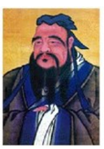

Confucius was regarded as a sage much like Socrates. By the second century B.C. (during the first Han Dynasty) his ideas became the foundation of state ideology. His political beliefs were also based on the idea of self-discipline. He thought a leader need to show self-discipline and to treat his followers with compassion, this way he would lead by positive example.

He also taught that everyone had a clear role in life. He did not consider people to be equal. Each person needed to figure out what their role in life was. There were specific ways to fulfill that role and that would then bring peace, harmony and contentment. Confucius believed that everyone had a great responsibility to make this system work, thus insuring that political discord and disagreement would end if everyone followed their specific code of behavior.

His followers gathered his ideas and teachings into a book entitled *The Analects*. My scroll in the Artifact Box contains a number of sayings by Confucius. A particular teaching of Confucius holds a thought to ponder for educators today, “I hear and I forget. I see and I remember. I do and I understand.”

(n.d.) *Confucius* [Web Photo] <http://www.thechinatourism.com>

**The Development of Paper**

The Chinese actually began recording information in a written form around 1,300 BC. They began by drawing pictograms (small pictures) of what they wanted to say. As time went on the number of pictograms became more complicated as well as numerous. These characters (another name for pictograms) numbered in the thousands. It was during the reign of the First Emperor of China – 221 – 206 BC (Emperor Quin, pronounced *Chin)* that heset a limit on the number of characters allowed in writing.

At first, writing was done on turtle shells, bones and bronze vessels. Later they wrote on bamboo strips (reading not from left to right but from top to bottom). These strips were tied together with string to make a ‘book’. Important documents were written on silk, but it was an extremely expensive material to use. It wasn’t until the Han dynasty – 206 BC – 220 AD – that paper – as we know it today - was invented. The first papermakers used old rags to make their paper. Later they experimented with other materials such as bark and rattan (a vine-like palm).

In 105 AD, T’sai Lun experimented and refined the process of macerating (to soften or break to pieces) the fibers of plants until each filament (strand of fiber) was completely separated. He then mixed these fibers with water in a huge pot and with a screen ‘caught’ these fibers on its surface. When dried, this thin layer of plant fibers became what we now call paper. My Artifacts Box contains an example of handmade paper.

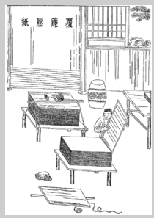

(n.d.) *Ancient Chinese papermaking, by Cai Lun in 105 AD* [Web Photo] <http://www.zencollegelife.com>

**Kites**

The Chinese invented kites about three thousand years ago. No one knows exactly where the idea came from. Some suggest that a farmer’s hat caught a gust of wind and went flying off. Another idea was that a sail got away from a boat. The first formal kites were possibly made by philosopher Mazi and his student Lu Ban. These were constructed with bamboo and silk. They were designed to mimic the hawk (and subsequently other birds and mythological animals). The dragon was a particularly special creature that entranced the Chinese and so many kites became caterpillar (or **Centipede**) in design. These kites were used in religious festivals and were thought to scare off unwanted spirits and promise good crops.

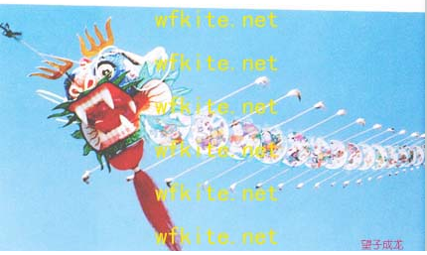

Upon the development of paper, the kites began to be used for practical and military purposes. Soldiers used them to carry messages and to frighten the enemy in battle. They made kites that whistled and wailed in the wind and they would fly them at night over the battle field. They could also be used to determine what the distance was of enemy soldiers by the length of the string. Kites were used for signaling and spying too. Engineers used them to carry bamboo lines across river gorges while bridges were being built. Fisherman used them to carry bait to distant fishing holes. Upon the development of explosives, kites were used in aerial warfare!

There are 4 types of Chinese kites. One being the **Centipede** (like the dragon above), another is the **Rigid Winged**, the **Soft Winged** this one is the **Flat kite**. My Artifact Box contains an example of a Flat kite with particular colors and a notable design.

One of the important elements of this **Flat** kite is its use of the 4 and 4 points (four being a special number in ancient Chinese culture). The particular colors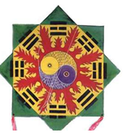

used are also noteworthy as each color has a specific significance. The RED is the color of fire and stands for success, happiness and good luck. The GREEN corresponds to plants and Spring. BLACK is the color for water and was the ‘official’ color of the First Emperor of China. The YELLOW was the color of royalty. No commoner was allowed to wear this color. Lastly, the BLUE signifies immortality. The color WHITE (though a color not on this kite) represents mourning and death.

(n.d.) *Zhiyuan paper glade* [Web Photo] <http://chinatraditonashop.blogspot>

(n.d.) *Flat Kites (2)* [Web Photo] <http://chinakites.org>

**Silk**

Legend says that silk was first made by the wife of the Yellow Emperor 5,000 years ago. The Yellow Emperor (3,000 – 2,070 BC) was one of the mythical ‘Three Sovereigns and Five Emperors’ of Chinese lore. Over the years, the Chinese were able to breed a special kind of silk moth that is unable to fly and was blind. Each moth lays 500 or more eggs in a few days then dies. The baby silkworms (actually the larvae of the moth) are feed a constant diet of chopped mulberry leaves for about a month. These fat silkworms then spin a cocoon around themselves and this is where the silk comes from. Each cocoon is made of a single strand of silk about 875 yards long. 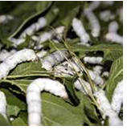

The cocoons are then steamed to kill the worms inside and then dipped in hot water to loosen the silk strand. These strands are unwound and then six to eight of them are twisted together to make silk thread. These threads are then dyed and woven into cloth or other threads for embroidery.

Silk was extremely expensive and greatly valued. It was often used as money. The cloth is beautiful, light and comfortable – cool in the summer and warm in the winter. Silk garments were even worn by Roman Emperors. Because the silk trade was so valuable, Chinese methods were a closely guarded secret, punishable by death for anyone smuggling silkworm eggs out of China. In ancient China, an emperor could often stop an attack by a neighboring army by giving silk as a present! It wasn’t until the

Sui dynasty (581 – 618 CE) that two monks managed to sneak out two silkworms hidden in their bamboo walking sticks. 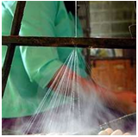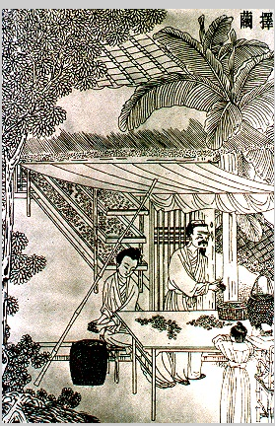

My Artifact Box contains a piece of silk for everyone to handle.

(n.d.) *The History and production of silk … Dharma Records* [Web Photo] <http://records&photodharma.net>

(n.d.) *Silkworms – Vrasoe City English News Flash* [Web Photo] <http://sites.google.com>

**The Terra Cotta Warriors**

In 1974 farmers who were digging a well discovered what is likely the most important archaeological discovery of modern time. What they found was the first of 8,000 terra-cotta (clay) statues of soldiers and horses. These soldiers were made and then placed in the tomb of the First Emperor of China (which is a rough translation of Qin Shi Huangdi). These warriors were intended to protect him in the afterlife. They were equipped with weapons, chariots and horses (all made out of clay) that would enable them to guard the Emperor’s final resting place. Each individual soldier stood over 6 feet tall. They were positioned as if to fight with full weaponry. Basic body parts were made ‘assembly line’ and brought in to be placed together to form the body, but then the artisans took over. Each soldier has distinct and unique facial features. 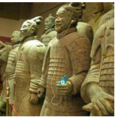 As you look at the warriors, each is different from the next.

Qin Shi Huangdi was actually named Chao Cheng. In 247 BC, at age 13, he became the king of the state of Ch’in. At the time China was divided into seven states, each with their own ruler. Chao Cheng created a powerful army and conquered the other six states. By 221 BC he had united the seven states into one empire. He took then the title “The First Emperor”. Qin Shi Huangdi created a powerful government to rule over his empire. Rather than have individual rulers he had groups of government officials in each state to carry out his decrees. He passed laws to standardize written languages, currencies and weights and measures. By doing so he helped build strong trade and businesses. He also established a single written form of the Chinese language which helped create a unified country.

Although far-thinking, he was a cruel and demanding ruler. While on a journey (in search of the elixir of immortality) Qin died. It is speculated that he ingested a too high dose of mercury and poisoned himself. His prime minister, Li Si, worried that the government would collapse as the Emperor was not a well-liked ruler. He kept the Emperor’s death a secret for two months as they journeyed back to the palace. Folklore has it that Li Si would bring 3 meals a day into the closed carriage and speak ‘with’ the Emperor as if he was still alive. As the summer became hotter, the stench of Qin’s decaying body was covered up by Li Si ordering carts of fish to be carried alongside the Emperors carriage. Li Si also arranged to have a message sent to the oldest son (and legitimate heir to the throne) that the Emperor was displeased with him and the he should kill himself. The eldest son followed his father’s orders and did so. Again, historians speculate that Li Si thought the younger son would be much easier to accept his control and Li Si would be able to establish his own authority as ruler.

The tomb and terra cotta soldiers required huge amounts of man-power to complete. Men who would normally be raising crops instead were forced to work with this and other enormous building projects of Qin Shi. Because the peasants were unable to produce enough food for themselves their anger soon turned against the empire they were forced to build. Shortly after Qin Shi Huangdi’s death they rose up against his son and looted and burned the great palaces and government offices. Only the underground tomb and terra-cotta army survived. My Artifact Box contains a small replica of a warrior.

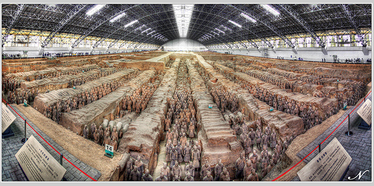

(n.d.) *Terra Cotta Warrior* [Web Photo] <http://blog.travelpod.com>

**Resources**

Ancient China, Archaeology Unlocks the Secrets of China’s Past by Jacqueline Ball and Richard Levey Ball, J. and Levey, R. (2007) Washington: National Geographic Society

Chinese of the Shang, Zhou, and Quin Dynasties by World Book (2009) Chicago: Scott Fetzer Co.

Time Travel Guides: Ancient China by Jane Shuter

Shuter, J. (2007) Chicago: Raintree Publishers

A History of China by John Keay

Keay, J. (2009) New York: HarperCollins

Terra-Cotta Soldiers, Army of Stone by Arlan Dean

Dean, A. ( 2005) New York: Children’s Press, Div. of Scholastic

Han Wu Di and Ancient China by Miriam Greenblatt

Greenblatt, M. (2006) New York: Marshall Cavendish Benchmark

Adventures in Ancient China by Linda Bailey

Bailey, L. (2003) Toronto: Kids Can Press

China, Land of Dragons and Emperors by Adeline Yen Mah

Yen Mah, A. (2008) New York: Random House

The Ancient Chinese World by Terry Kleeman and Tracy Barrett

Kleeman, T. and Barret, T. (2005) New York: Oxford University Press

The Ancient Chinese by Virginia Schomp

Schomp, V. (2004) New York: Scholastic Publisher

Recipe and Craft Guide to China by Joanne Mattern

Mattern, J. (2011) New York: Mitchell Lane Publishers

Excavating the Past, Ancient China by Jane Shuter

Shuter, J. (2006) Chicago: Heinemann Library

<http://silk-road.com/artl/silkhistory.shtml>

*History of Silk*

<http://chineseculture.about.com/library/weekly/aa021201a.html>

*Chinese silk and the Silk Road*

<http://womanshistory.about.com/od.inventions/a/discovery_silk.htm>

*Chinese Empress discovers silk making*

[http://factsanddetails.com/china.php?itemid.342&catid=9%subcatid=63](http://factsanddetails.com/china.php?itemid.342&catid=9%25subcatid=63)

*Facts about Chinese Silk Making*

<http://plato.stanford.edu/entries/confucius>

*Confucius (Stanford Encyclopedia of Philosophy)*

<http://www.quotationspage.com/quotes/Confucius>

*Confucius quotes*

<http://www.biography.com/people/confucius-9254926>

*Biography of Confucius*

<http://www.hqpapermaker.com/paper-history>

*History of papermaking*

<http://silk-road.com/artl/papermaking.shtml>

*Chinese history of papermaking*

<http://www.historyforkids.org/learn/literature/paper.htm>

*History of papermaking*

<http://www.chinahighlights.com/travelguide/cultures/kites.html>

*History of Kites in China*

<http://www.chinatravel.com/facts/chinese-culture-and-history/chinese-arts/chinese-kite/>

*Kites*

<http://suite101.com/articles/the-invention-of-the-kite-in-China-a152536>

*Articles on the invention of the kite in China*

<http://smithsonianmag.com/history-archaeology/On-the-March-Terra-Cotta-Soldiers.html>

*Smithsonian magazine article on the Terra-Cotta Soldiers*

<http://archaeology.about.com/od/china/a/terracotta.htm>

*Terra-cotta warriors*

<http://www.travelchinaguide.com/attraction/shaanxi/xian/terra_cotta_army/>

*Terra-Cotta army*