Tigris and Euphrates (Mesopotamia)
River Civilization
By: Kelly Martin and Natalie Weitz

Ohio Academic Content Standard:
Grade: 6
Theme: Regions and People of the Eastern Hemisphere
Strand: History
Topic: Early Civilizations
Content Statement #2: Early civilizations (India, Egypt, China, and Mesopotamia) with unique governments, economic systems, social structures, religions, technologies and agricultural practices and products flourished as a result of favorable geographic characteristics. The cultural practices and products of these early civilizations can be used to help understand the Eastern Hemisphere today.

Background:
Mesopotamia means the land between the rivers. The two rivers that border this area are the Tigris and the Euphrates rivers. This area is often referred to as the “cradle of civilization” because it is the earliest known place where humans developed into a settled society based on agriculture as opposed to roaming nomadic peoples surviving on hunting and gathering. These ancient people discovered the river valley as to be very fertile, and that they were able to grow themselves the same type of wheat they had previously harvested from the wild. The river valley, also called the “fertile crescent” earned its name due to its location. At the base of mountains to the north, the winter snow at the top of the mountains would melt and trickle into the valley and rivers. The rivers would flood, pulling silt into the valley which provided essential nutrients for farming. As the Sumerians learned to farm, they began to stay in one place, and this transformation brought about a completely new way of life. As described within the artifact descriptions below, many inventions grew out of necessity and efficiency and social constructs developed that built the foundation for government and societies even today.

ARTIFACT #1: ZIGGURAT

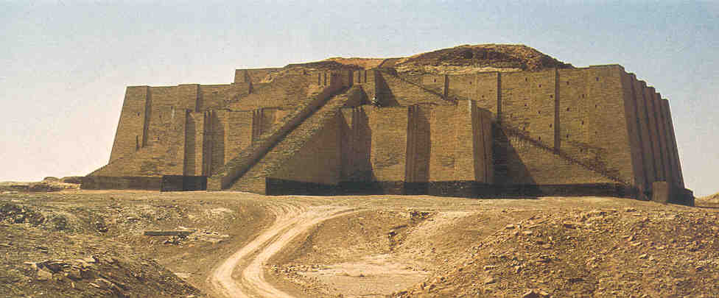

A ziggurat had a core of mud brick and an exterior of baked brick. The clay bricks forming the ziggurat are colored in a way to represent the zones of heaven. It had no internal chambers (though is was sometimes built over other, more ancient structures) and most ziggurats were about
170 ft x 170 ft (square) or 125 ft x 170 ft (rectangular) at the base. An exterior triple stairway or a spiral ramp leads to the top of a ziggurat. The terraces were often adorned with trees and shrubs.

The Ziggurat of Ur, built in the Dhi Qar Province between the years of 2113 – 2096 B.C., was thought to be the home of the Moon God Nanna. At the top of the structure there was a shrine where woman each night would stay with the god. There used to be many ziggurats spread around Mesopotamia but only 25 ziggurats remain today. The Ziggurat of Ur (shown above) is the one that is most preserved but it had to be partially reconstructed by the Iraq government in the 1960s. The Ziggurat of Ur is the most famous due to references to it in the books of the bible: Genesis and Herodotus.

In the classroom, I would provide various materials such as playdoh, legos, cardboard, etc for students to build their own Ziggurat. This would allow the students to practice the vocabulary word and have an hands-on understanding to help them remember what a Ziggurat is and how it was important to the Mesopotamian society.

Resource:
Islamic, A. (n.d.). Iraqi architecture, ziggurat of ur, . Retrieved from
http://www.islamic-architecture.info/WA-IQ/WA-IQ-027.htm

ARTIFACT #2: PLOW
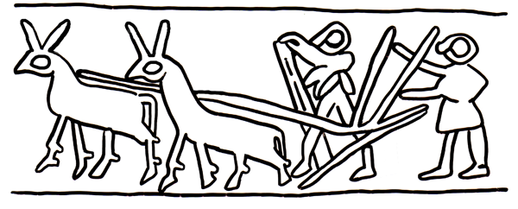

The seeder plow was a major technological achievement that revolutionized agriculture by carrying out the tasks of seeding and plowing simultaneously. The soil was hard from the sun so the seeds did not grow well just being thrown on top of the ground. A seeder plow was invented that contained a blade that cut into the hard soil and turned it over. The seeder plow helped the farmers to grow surplus crops by dropping the seed into the furrow that the plow created. The ancient Mesopotamians believed that the god Enlil created the seeder plow and that the image of the plow could also be seen in the stars.

In the classroom I would have students research how plows were used then and how plows are useful now. I would have students complete a Venn diagram to organize what they learn in comparing what a plow was like for farming practices and why the plow has such an impact on how farmers are successful today.

Resource:
Oriental Institute of the University of Chicago. Ancient mesopotamia: Science and inventions. Retrieved from
http://oi.uchicago.edu/OI/MUS/ED/TRC/MESO/science.html

ARTIFACT #3: CUNEIFORM
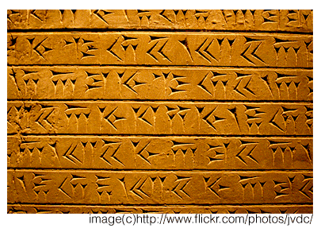
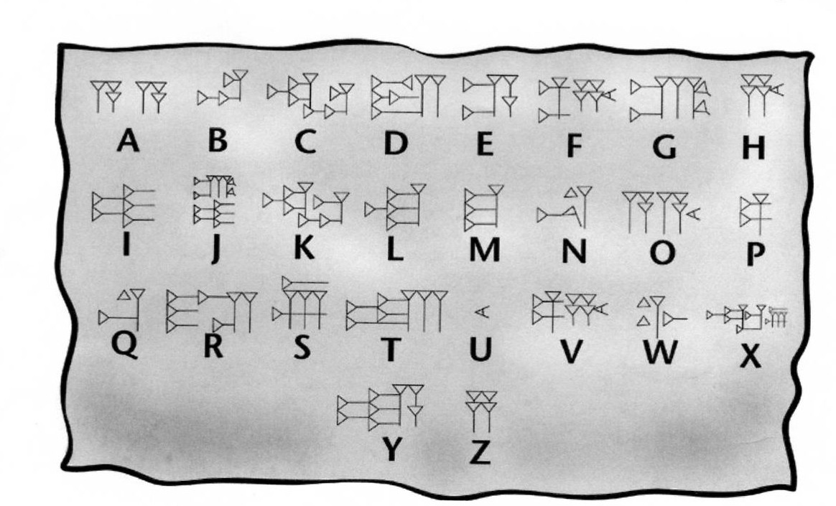

The Sumerians of ancient Mesopotamia invented their own form of writing called cuneiform. Cuneiform was invented around 3000 B.C. as a way of keeping business records. For example, a merchant might have to keep track of how much grain he was trading for lumber. Using cuneiform he would be able to keep accurate records of what he traded and how much he traded. Because clay is a difficult material on which to draw lines and curves, the Mesopotamians eventually reduced pictograms into a series of wedge-shaped signs that they pressed into clay with a reed stylus. Cuneiform made it possible for the Mesopotamians to share information and this invention of writing was the dawn of the information revolution. This great technological advance allowed news and ideas to be carried to distant places. Cuneiform was originally invented for record keeping however it was also used for writing history, stories, letters, accounts, and hymns.

In the classroom I would have students create a picture writing their names using cuneiform as artwork. Also the students could decipher written work using the alphabet shown above.

Resources:
Oriental Institute of the University of Chicago. (n.d.).Ancient mesopotamia: The invention of writing. Retrieved from
http://oi.uchicago.edu/OI/MUS/ED/TRC/MESO/writing.html

Sylvester, D., & Hillam, C. (2006). Ancient Mesopotamia. Santa Barbara, Calif.?: Learning Works.
http://www.myteacherpages.com/webpages/6a/files/cuneiform%20tablets.pdf

ARTIFACT #4: POTTER’S WHEEL
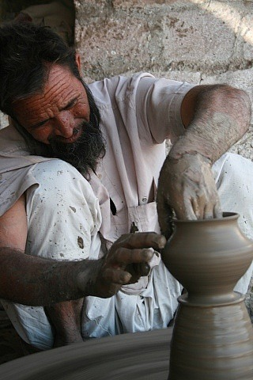
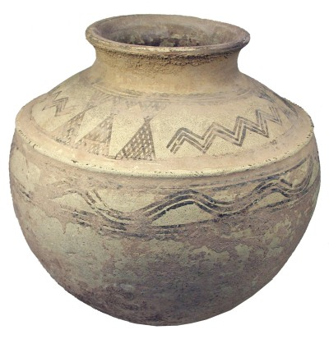

The potter’s wheel was invented in ancient Mesopotamia sometime between 4,000 and 6,000 B.C. As the civilization became more established, people started becoming more skilled so new crafts and occupations emerged. Until the arrival of the wheel, the women usually made the pots by coiling. With so many other responsibilities they could only be part-time potters but the demand for more pots kept growing. With the invention of the wheel, men took over the task of making pottery because the women had too many commitments with child rearing and food preparation. Although one person can make pots more quickly with a wheel, still more full-time labor is needed to decorate, finish and fire the pottery.
A potters wheel works by placing a ball of clay in the center of a turntable or wheel which he rotates. The wheel rotates rapidly while the solid ball of soft clay is pressed, squeezed and gently pulled. The wheel allows the construction of pottery that is more uniform in thickness, therefore providing the ability to fire more evenly, preventing breakage and creates a cylindrical mold of the clay as seen in pots, vases.

In the classroom I would work with the art teacher to build clay pots using a potter’s wheel or using the coiling method. Students could display their artwork in an art show that could raise money through selling the pottery they create.

Resources:
Bryant, V. (n.d.). The origins of the potter's wheel. Retrieved from
http://www.ceramicstoday.com/articles/potters_wheel.htm

The history of the pottery. (2009, February 18). Retrieved from
http://destrier.hubpages.com/hub/pottery-wheel

ARTIFACT #5: FERTILE CRESCENT

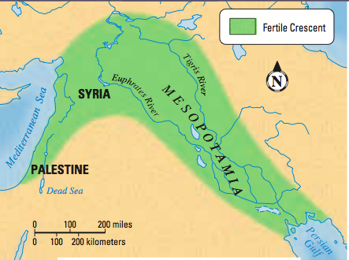

The Tigris and Euphrates rivers made it possible for one of the world's first great civilizations to develop in what was a very dry area. The Fertile Crescent got its name because it had rich soil and was in the shape of a crescent moon. This area was rich with greenery and fresh water, but the water didn't always cooperate so life wasn't always easy. Silt deposits, carried by the rivers made the soil perfect for farming, but the rivers were needed for more than the rich soil they provided. The Fertile Crescent was abundant in a variety of wild plants; two of these plants were wheat and barley, which also became the region’s most important crops. Over time the Mesopotamians learned to use the environment to their benefit. In order to protect themselves from flooding, levees were built to hold back the floodwaters. The floodwaters were then diverted into a series of canals that enabled farmers to irrigate their crops. The flooding was controlled, and the farmers were able to supply their crops with the water they needed to flourish.

In the classroom I would show students different types of soil: fertile soil, rocky soil, and clay soil. We would try to plant a seed of corn in each type of soil, measure and collect data on the progress, and then graph the data. From this we could use math concepts and also learn why the fertile crescent was so important to the economy of being able to grow rich crops.

Resources:
The fertile crescent-mesopotamia. (2010, July 26). Retrieved from
http://kaie-arwen.hubpages.com/hub/The-Fertile-Crescent-Mesopotamia

Ancient mesopotamia and the fertile crescent. (n.d.). Retrieved from
http://petrimoulx.pbworks.com/f/Chapter8section2.pdf

ARTIFACT #6: WHEAT AND BARLEY
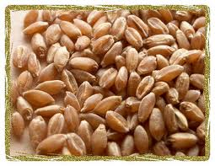
Before settling in Mesopotamia, the Sumerian people were roaming Nomads. As they moved across the land, they hunted for food and collected plants and berries to eat. Eventually, they discovered that they could plant and harvest the same wheat they found growing wild. This discovery led to the formation of a settled civilization in the river valley between the Tigris and Euphrates rivers. The soil here was very fertile since every year, the snow would melt and run down the northern mountains to the valley and rivers below. The rivers would flood, enriching the surrounding soil with nutrients. Because this land was so fertile, the Sumerians were able to settle here and grow crops like wheat and barley.

Some of the greatest Sumerian inventions were birthed of necessity in order to protect or enhance the grain crops. For example, the Sumerians created a 12 month calendar (each month consisting of 30 days) based on the stars and zodiac in order to predict the flood season so they could be prepared for it. The irrigation system consisting of levees and ditches was created so they did not have to depend on the seasons and weather to produce crops. The “invention” of cities themselves came from the abundance of crops. Sumerians soon discovered that not everyone needed to be a farmer since the land was so fertile. Some people could become merchants, craftsmen, and artisans. This developed into the social construct of a village, or city-state.

Grains such as wheat and barley were a staple of the Sumerian economy. They were used to pay taxes in two ways. First, with the grain itself. Many activities (including burials!) were taxed to support the king, priests, and army and make repairs and improvements to the city. Second, Sumerian men were required to pay a burden tx to the king which meant they had to contribute manual labor. Many times, this labor consisted of working in the grain fields. Since wheat was so central to the Mesopotamian economy, it would be interesting to use it as a form of classroom currency in some way throughout the unit. Paper strips could represent wheat bundles and students would have to decide on what would be taxed and how the wheat would be distributed to “pay” for classroom materials, etc. Toward the end of the unit students can brainstorm how the system was effective and difficulties that have transformed this currency into modern day currency.

Resource:
http://player.discoveryeducation.com/index.cfm?guidAssetId=3029357E-9BB7-40D5-93E2-EFFBDCA2AFFE&blnFromSearch=1&productcode=US
ARTIFACT #7: EPIC OF GILGAMESH
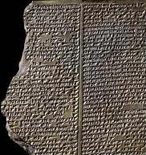

This ancient epic poem was written more than four thousand years ago in Mesopotamia. As with other documents of the time, it was written on a series of clay tablets. The story features two powerful characters- Gilgamesh, King of Uruk, and Enkidu, a wild man created by the gods. The two become friends and have fantastic adventures described throughout the poem. Eventually, Enkidu dies which causes Gilgamesh to search for eternal life. In his quest he comes upon Utnapishtim who survived a great flood after being warned by a god it was coming. Gilgamesh learns from Utnapishtim that everyone’s life must end. Historians have learned a lot about early Mesopotamian life through the tales told throughout the poem. The Mesopotamian lifestyle of farming and herding is reinforced as well as the flooding experienced in the river valley. In fact, there is evidence of increased flooding in the Fertile Crescent at the end of the last ice age which may be connected with the flood described in the Epic of Gilgamesh. It is possible that other flood stories told throughout history, such as the story of Noah and the ark, could be rooted in the Epic of Gilgamesh.

This artifact would be a great way to integrate language arts and social studies. Students could read portions of the translated text (a primary source) and discuss what can be learned about early Mesopotamian life from the document. They could also make comparisons and contrasts to the way in which people thought, lived. and acted then to the way in which we think, live, and act today. Students could write their own “epics” that historians in the future could use to glean information about our modern-day lifestyles.

Resource:
http://www.mrdowling.com/603-gilgamesh.html

Service, P. F. (1999). Mesopotamia. New York: Benchmark Books/Marshall Cavendish.

#8: CODE OF HAMMURABI
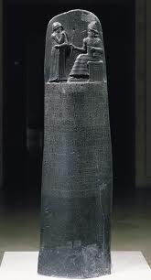

Hammurabi was the king of Babylon from about 1795- 1750 BC. The civilization of Babylon formed upriver from Sumer after Sumer’s soil no longer supported crops. King Hammurabi is most well-known for his code of laws. His 282 laws are known as the earliest example of publicly documented laws that were written down in an organized way for people to follow. The statue they were recorded on was uncovered in 1901. Each law is paired with the consequence to follow if the law was broken. The idea of “an eye for an eye, a tooth for a tooth” is evident here. However, many of the consequences were that of death. For example, if a man built a house poorly, his punishment was death. The code of laws still takes into account the deeply religious nature of the civilization. It begins and ends with prayers to the gods. It also allows for the fate of the accused to be put into the hands of the gods. The accused could jump into the Euphrates River. If he drowned, he was guilty, but if he was able to make it to shore, he was innocent. This belief also tells historians that these people did not know how to swim despite their close connection with the Tigris and Euphrates rivers.

The Code of Hammurabi also outlines three social classes: the amelu, muskinu, and ardu. The highest class was the amelu which included the king and court, higher level officials, and craftsmen. Although this class held full rights and aristocratic privilege, they were also held to a higher standard of responsibility to the people. Their taxes were higher and they were held more liable for wrongdoing. The muskinu were a lower class, however the exact role of this class is largely unknown. They were seemingly free, but perhaps unable to own land. They lived in a different area within the city-state and paid less in taxes and offerings to the gods. Finally, was the ardu class who were the slaves. Although the ardu were not free, they were able to acquire property and even other slaves. They were also able to earn their freedom.

The following links to a three scene play that could be used to help students understand the laws and impact of the Code of Hammurabi:
http://socialstudies.com/c/%405nR.ui9.NU3JM/Pages/article.html?article@JWW951A+af
@donn
This play would be one idea for an activity to teach the Code of Hammurabi. After studying some examples from the code, students could write letters to the king stating their agreement or disagreement with the laws. These letters could be used as part of an assessment to see if students understand the code.

Resources:
http://www.mrdowling.com/603-hammurabi.html
http://www.fordham.edu/halsall/ancient/hamcode.html
Roaf, M. (1990). Cultural atlas of Mesopotamia and the ancient Near East. New York: Facts on File.

ARTIFACT #9: WHEEL
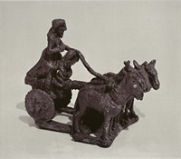

Credit for the invention of the wheel is largely given to the Sumerians. Research indicates it was originally invented for the mechanisms of the pottery wheel. However, Sumerians eventually used this technology so that animals could pull heavy loads and chariots could be used in war. It is thought that this transformation occurred around 3500 BC. These wheels were most likely made of wood. Chariots such as the one pictured above are pictured in cuneiform tablets like the Standard of Ur. Since the chariots and wheels were made of biodegradable materials such as wood and leather, archaeologists have not found any actual wheels as artifacts. This is an excellent example of how the sumerian writing and documentation system proved to be beneficial in recording history.

It is thought that for transportation purposes, the wheel began as a log, or roller, placed under the object to be moved. Ancient people also found objects to be moved more easily when they were placed on a sledge which consisted of two smooth runners. Eventually, they discovered that they could place the sledge on top of a roller, and as the object moved forward, place another roller in front of the first and so on. They found that the sledge would gradually produce grooves in the rollers, making the rollers more efficient. From there, the wheel and axle was developed for further efficiency, which is what we still use even today. These steps involved in the creation of the wheel are outlined at:
http://library.thinkquest.org/C004203/science/science02.htm. This would be a fantastic place in the curriculum to incorporate science and simple machines. Students could be given materials to replicate each step of the process that resulted in the wheel. Students could also brainstorm the ways in which the wheel may have been useful in Mesopotamian times as well as how it is useful today.

Resources:
Roaf, M. (1990). Cultural atlas of Mesopotamia and the ancient Near East. New York: Facts on File.
Service, P. F. (1999). Mesopotamia. New York: Benchmark Books/Marshall Cavendish.
Shuter, J. (2006). Mesopotamia. Chicago, Ill.: Heinemann Library.
http://library.thinkquest.org/C004203/science/science02.htm
ARTIFACT #10: WALLED CITY-STATES
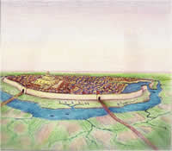

Once roaming nomads were able to settle in one place to produce their own crops, the foundation for city-states was in place. Since several farmers could produce enough food to feed many people, not everyone needed to be a farmer. Therefore, others became merchants, craftsmen, artisans, and priests. All of these people needed to live in a central location so they would be able to trade with one another. They also developed a need for a single ruler that would oversee the trades and security of the area. By 3000 BC, separate Sumerian city-states had been established based on these needs. Each of the twelve city-states was dedicated to a single god or goddess, although Sumerians themselves believed in many gods.

The development of separate city-states led to warfare between them as they competed for land and resources. Because of this, city-states built protective walls around their borders. Although these walls served as protection, they also limited the size of the city-state which became more of a problem as the population of the city-states grew. Research suggests that Sumerians solved this problem in part by learning to build upwards, creating two story structures. Social class also came into play. The “most important” citizens (ruler, officials, priests & priestesses, craftsmen, butchers, bakers, and brewers) lived within the city wall, but as the population grew the less important citizens were forced to live outside of the city walls. These people included the farmers, who also needed to live closer to the river for irrigation purposes.

Within the surrounding wall, city-states included a tell (garbage dump), ziggurat (religious temple dedicated to the god of the city), place for food storage, public square, workshops and homes, and wide main streets with smaller twisting streets connecting them. Many of these city features were carried on in medieval towns and even still today. After learning about the features of city-states, students could create models depicting them. For an even more in-depth study, students could be put into pairs or groups with each pair assigned to research and create a diorama of a specific city-state (of the twelve known). When student present their projects, a discussion could point out the differences and similarities between the various city-states.

Resources:
http://player.discoveryeducation.com/index.cfm?guidAssetId=3029357E-9BB7-40D5-93E2-EFFBDCA2AFFE&blnFromSearch=1&productcode=US
Shuter, J. (2006). Mesopotamia. Chicago, Ill.: Heinemann Library.

