Government Geocaching

ONLS Government Content Statement 10. Governments can be categorized as monarchies, theocracies, dictatorship, or democracies, but categories may overlap and labels may not accurately represent how governments function. The extent of citizens’ liberties and responsibilities varies according to limits on governmental authority.

Description: In this lesson, students will locate hidden objects using a map of the school. Each object represents a specific type of government. The students must use a geography-based approach to apply map reading skills and problem solving techniques to geocache around the school. Students will also use the iPad to take pictures and create a Keynote presentation about their information. These activities can be adapted for different learning levels and provides to connections to other classroom subjects.

Learning Goals:
- Enhance and introduce students’ understanding of global government systems.
- Increase teamwork skills
- Utilize technology to develop typing and researching skills.

Essential Question: How does governmental authority affect citizens’ rights?

Materials:
- iPads with internet access
- Government artifacts (teacher’s choice or suggestions provided)
- QR reader app on iPad
- Government recording sheet
- Map of school building (teacher provided--specific to school)
- Projector and computer with internet access

Preparation:
Teacher will need to determine the prior knowledge of how QR codes work and how to operate Keynote on the iPads. If no prior knowledge is present, then the teacher will need to acquaint students with each application.
- The teacher will need to be familiar with each application.
- The teacher will need to create artifacts for each government form.
- The teacher will need to create a school map and hide artifacts.

Directions:

Introduce students to geocaching
Using the computer and projector, access the website, http://www.geocaching.com/guide/. Be sure to show the students the short Geocaching 101 video. Then click through the various questions to further explain geocaching to the students.

Activity
The teacher will pair students into groups of two. Each group will receive a school map and an iPad. The students will also be given the government recording sheet. Time will begin and students will be allowed to silently explore the school to search for the artifacts. Students must be able to correctly read the map to discover an artifact.

Once students find an artifact, they will record their predictions of what the artifact represents in terms of government. Then students will use the iPad to scan the QR code. Each QR code will lead to a website specific for a type of government. Students will record the information they discover. Finally, students will record their new thoughts of how the artifacts represents that government.

Assessment and Evaluation
As students finish the geocaching, they will gather together in the classroom. They will then be asked to create a Keynote presentation that presents the information they discovered on their journey. Students will be provided with a rubric to understand the teacher’s expectations.

Students will present their Keynote presentation to the class at the conclusion of the activity.

The teacher will look for:
- Students understanding of the different government types.
- Students actively participating in the the teamwork.
- Students understanding of different technology uses.
- Students understanding how to make a connection between an object and a government.

 | 4  Exceeds | 3  Proficient | 2  Nearly Proficient | 1  Not Yet Proficient
Presentation | Well rehearsed with smooth delivery and holds the audiences attention. | Rehearsed with smooth delivery. | Does not appear to be rehearsed and delivery is not smooth in parts. | Not rehearsed with a delivery that is not smooth and can't keep attention of audience.
Content | Content shows complete understanding of forms of government. | Content shows basic understanding of forms of government. | Content shows some understanding of forms of government. | Content shows little understanding of forms of government.
Map Skills | No struggles in reading map and finding artifacts. | Struggles a little bit in reading map and finding artifacts. | Struggles a few times in reading map and finding artifacts. | Unable to read map and finding artifacts.
Research | All forms of government have been fully researched and fully analyzed. | All forms of government have been researched and partially analyzed. | Most forms of government have been researched with little analysis done. | Some forms of government researched with no analysis done.

Artifact: Crown Artifact: Cross
Monarchy QR Code Theocracy QR Code
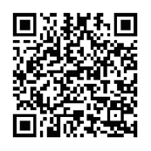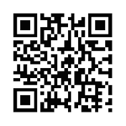

Artifact: Picture of man standing above others Artifact: White House Figurine
Dictatorship QR Code Democracy QR Code
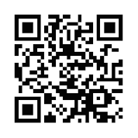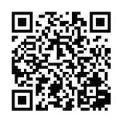

Artifact: Flag Artifact: Globe
Flocabulary Government Video CIA Factbook Types of Government


Artifact: World Map
World Map of Governments
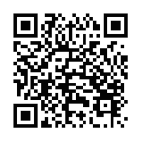

Government Geocaching Recording Sheet

Object | Prediction | Government | Research | Connection

