Ancient Indus River Valley Civilization

Here is the link to my video that I posted on YouTube. <http://youtu.be/PJUxwB-jObE>

Handout

Grade Six

Strand: History

Theme: Early Civilizations

Content Statement 2. Early civilizations (India, Egypt, China and Mesopotamia) with unique governments, economic systems, social structures, religions, technologies and agricultural practices and products flourished as a result of favorable geographic characteristics. The cultural practices and products of these early civilizations can be used to help understand the Eastern Hemisphere today.

Grade Six

Strand: Geography

Theme: Spatial Thinking and Skills

Content Statements: 3. Globes and other geographic tools can be used to gather, process and report information about people, places and environments. Cartographers decide which information to include and how it is displayed.

Grade Six

Strand: Geography

Theme: Places and Regions

Content Statement 5. Regions can be determined, classified and compared using various criteria (e.g., landform, climate, population, cultural, or economic).

Grade Six

Strand: Geography

Theme: Human Systems

Content Statement: 6. Variations among physical environments within the Eastern Hemisphere influence human activities. Human activities also alter the physical environment.

7. Political, environmental, social and economic factors cause people, products and ideas to move from place to place in the Eastern Hemisphere in the past and today.

Introduction:

The Ancient Indus River Valley Civilization is located in present day Pakistan and western India. Between 2500 and 2000 BCE, the Indus River Valley Civilization was at its peak. This civilization is known for its development of an accurate measurement system and the straight lines and right angles used for building. Many of the houses built during this civilization had wells and bathrooms along with an underground drainage system for sanitation. The people of the Indus River Civilization may have also been the first people to use wheeled carts for transportation. They also used small, flat bottom boats for transportation and to trade goods. They had a system of writing, but none of it has been able to be deciphered. Much of the history of this civilization is unknown because they did not build huge monuments, have golden tombs, or mummies. There has not been any evidence of war or any armies found either.

Artifact ideas:

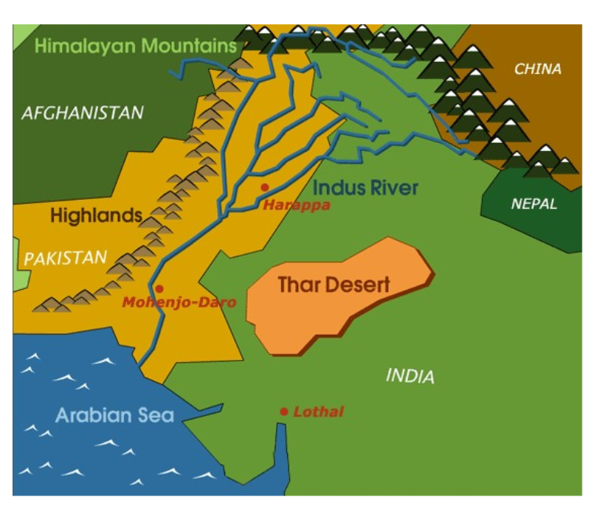

Map – The vast Indus River Valley is located in what is today Pakistan and western India. It has natural borders of mountains and the Arabian Sea, which sheltered the civilization from attack and disease. People of this civilization used water from the river to help fertilize and irrigate crops. Close proximity to the river allowed boats to become a viable transportation option. (location)

Teaching activity: Provide students with this map and have them describe what life was like on this land. Have students make sure to describe what the natural features of the land were like and how they utilized their resources.

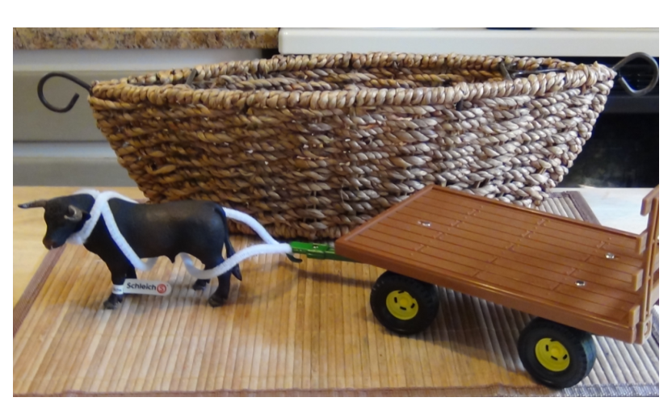

Early boats and carts – The economy depended greatly on trade. Trade was conducted within the civilization as well as with Mesopotamia. Advancement in technology led to wheeled carts and early boats that were used as the main method of trade and travel. (movement)

Teaching activity: You could possibly have students try to build a boat and see which one (if any) floats the best. You could also have some of the students try to build an early cart as well.

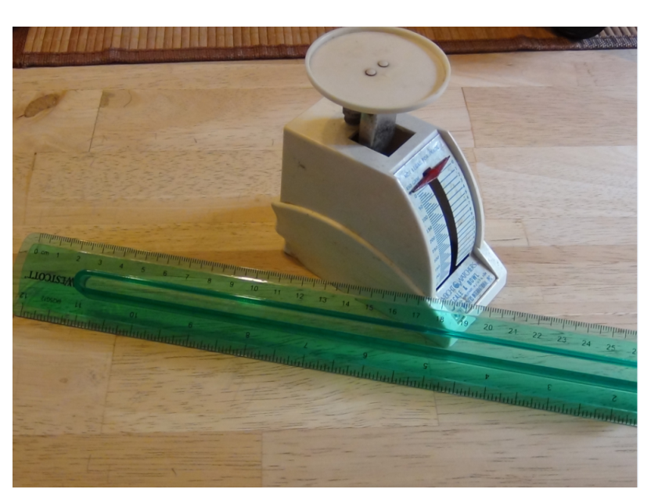

Scale/ruler – The Indus River Valley Civilization was the first of its time to have an accurate form of measuring. Measurement was a huge part of their achievements. They could very accurately measure weight, distance, and time. Their measurements were so accurate that they even had one that was equal to 1.704 mm. A weight chart was created much similar to an ounce, the chart consisted of:  0.05, 0.1, 0.2, 0.5, 1, 2, 5, 10, 20, 50, 100, 200, and 500 units, each unit equaling about 28 grams. Since they were so good at measurements they were able to build great buildings, have straight streets, and line bricks up perfectly what were the same size and weight.-(region)

Teaching activity: You could have students “measure” an item without using any tools. Once all students have measured the item, you can then measure the item with measuring tools to see how accurate their original measurement was. Then discuss why these measuring tools were so important during this time period.

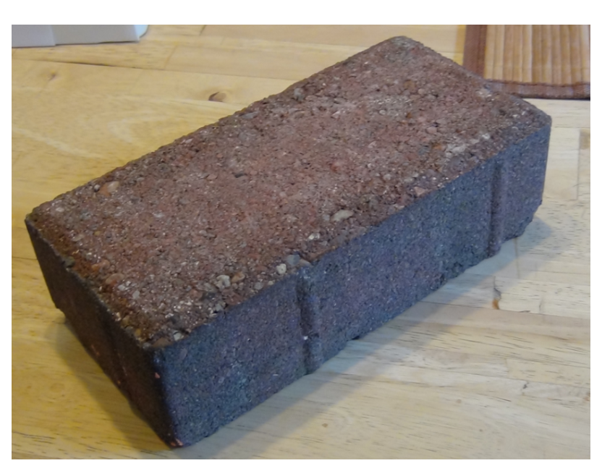

Dry bricks – All buildings were made from dry bricks that were uniform in size. The bricks were very straight, which made it easier to build sturdy houses. Many of the houses were one or two stories high. For protection from seasonal floods and polluted waters, the settlements were built on elevated grounds. There were networks of streets that were laid out in neat patterns of straight lines and right angles. The brick houses of all city dwellers were equipped with bathing areas supplied with water from neighborhood wells. Sophisticated drainage systems throughout the city carried dirty water and sewage outside of living spaces. Cleanliness was obviously very important. They did not build large monuments or other structures, instead they used their resources wisely for the things they needed. (human/environment interaction)

Teaching activity: Provide students with blocks and other materials to build a house. Split students into groups and have the groups build buildings using the materials given to them. Have them decide while building (the one built from uniform size blocks or the one built from other materials) is sturdier?

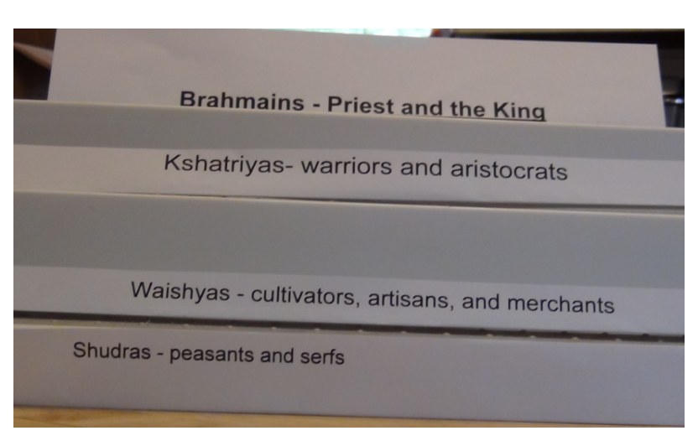

Levels – Caste system had 4 main classes. People were born into these social classes and it could not be changed. At the top of the classes was Brahmins, which were priests and the king. The next class was Kshatriyas, which were warriors and aristocrats. Below that level were Vaishyas, which included cultivators, artisans, and merchants. The lowest level was the Shudras, which were peasants and serfs. (place)

Teaching activity: Assign each student a role based on the caste system. Have students complete a role playing activity modeling what life would have been like during this civilization.

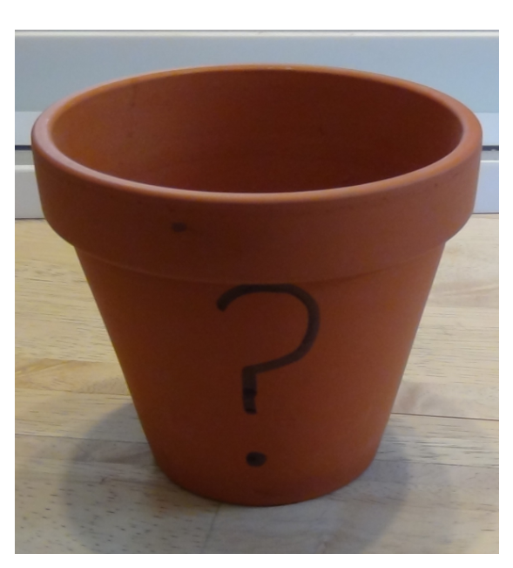

Terracotta pots – communication- The Indus River Valley Civilization had a writing system which today still remains a mystery. All attempts to decipher it have failed. This is one of the reasons why the Indus River Valley Civilization is one of the least known of the important early civilizations. Examples of this writing system have been found in pottery, amulets, carved stamp seals, and even in weights and copper tablets.

Teaching activity: Have students create their own language using symbols (and a key). Have them create a message. Then, have students switch and try to decipher the message without the key to have them understand why the language of this civilization is so difficult to decipher. After that, students can use the key to finish decoding the message for a fun activity.

Resources:

Ancient Civilizations. (2014). *Early Civilization in the Indus Valley.* Retrieved July 13, 2014 from <http://www.ushistory.org/civ/8a.asp>

Ancient History Encyclopedia. (2014). *Indus Valley Civilization.* Retrieved July 14, 2014 from <http://www.ancient.eu.com/Indus_Valley_Civilization/>

AP World History 101. (2014). *Indus River Valley.* Retrieved July 15, 2014 from <http://apworldhistory101.com/history-of-india/indus-river-valley/>

TimeMaps. (2014). *The first great civilization of South Asia was the Indus River Civilization.* Retrieved on July 14, 2014 from <http://www.timemaps.com/civilization/Indus-Valley-civilization#geography>

The River Valley Civilization Guide. (2011). Indus River Valley Civilization. Retrieved July 13, 2014 from <http://www.rivervalleycivilizations.com/indus.php>