|  |  |  |  |  |  |
| --- | --- | --- | --- | --- | --- |
| Drug Name (Active Ingredients) | Usage/ Treats | Dose | Contra-indications | Withdrawal Time till | |
| **Antimicrobials** |  |  |  |  | |
| Mictotil®  (Tilmicoim) | Treats bovine and ovine respiratory disease caused by Man. haemolytica | 10mg/kg given SC in both species | Do not give IV using powered syringes. Fatal in swine. Lactating animals | 7 days for slaughter | |
| Terramycin®  (Oxytertacycline) | Treats Mycoplasma, Pasteurella, Rickettsia, Spirochetes. M. bovis & Chlamydia in calves, beef and non-lactating cattle. May be used in horses with Lyme dz, Potomac Horse Fever, Lawsonia intracellularis in foals. | Cattle:  ~ 20mg/kg SC/IM: Pneumonia.  ~ 11mg/kg SC/IM/ IV: Footrot.  ~ 50mg/kg: resp. tract infections.  Horses:  ~6.6mg/kg IV: Lyme & PHF  ~15 mg/kg PO: Lawsonia  Sheep: 10mg/kg SC | Hypersensitivity reactions to tetracycline. Pregnant animals. Liver and renal insufficient patients. Lactating animals | 7 days for slaughter | |
| Tylosin®  (Tylosin Tartrate) | For chronic colitis in cattle, sheep and swine | Cattle: 17.6mg/kg IM daily. Bronchonpneumonia – 4mg/kg  Swine: 8.8mg/kg IM q12  Sheep & goats: 10mg/kg SC | Patients hypersensitive to it or other macrolides | Cattle:  Meat: 21days for slaughter  Milk: 72hours cattle  48hours (goats)  Swine: 14 days for slaughter | |
| Combikel 40 L.A.®  (Procaine Benzyl- penicillin, Dihydro-streptomycin) | Used against most Gram - negative cocci, bacilli and anaerobes, and Gram – negative bacteria; a broad spectrum antibiotic | Cattle: 0.05-0.1ml/kg.  Horses, Pigs: 0.1ml/kg  IM or SC routes may be used in both | Hypersensitivity and renal insufficiency in patients. | Meat: 72 hours before slaughter | |
| Trisulkel®  (Trimethoprim/ Sulfa-methoxazole) | Used when a single antibiotic is not effective. Treats prostate infections and infections caused by methicillin-resistant staphylococci | Horses: 15-30 mg/kg, PO q12.  Swine: 48mg/kg, IM  Cattle: 25mg/kg, IV, IM, q24. Calves: 48mg/kg IV/IM, q24 | Not to be used in horses with liver parenchymal damage, blood dyscrasis, or history of sulfonamide sensitivity. Not to be used in animals intended for food | Cattle: slaughter – 10days, milking – 96hours.  Not FDA approved for horses intended for food | |
| Amoxicillin  (Amoxicillin) | First drug of choice for suspected infections that have no sensitivity & culture test done | Cattle: 6-10mg/kg  Calves: 7mg/kg PO, q8  Horses: 20-30mg/ kg PO, q6.  Foals: 15-30mg/ kg IV/IM, q6-8 | Hypersensitive patients. Do not use oral route if patient in shock or septicemia present | Cattle: slaughter – 10 days, milking – 60 hours | |
| Cefokel®  (Ceftiofur HCl) | Pigs: Treatment of bacterial resp. dz  Cattle: Treatment of bacterial resp. disease and footrot.  For the treatment of the bacterial component of acute post-partum (puerperal) metritis within 10 days after calving. The indication is restricted to cases where treatment with another antimicrobial has failed. | Pigs: 3mg/kg, IM or 1 ml/16kg at each injection.  Cattle:  Respiratory disease: 1mg /kg, SC.  Footrot: 1mg/kg SC injection.  Acute post-partum metritis within 10 days of calving: 1mg/kg for 5 consecutive days SC  Sheep: 1.1mg - 2.2mg/kg IM | Hypersensitive patients to ceftiofur and other β-lactam antibiotics.  Do not inject intravenously.  If resistance to Cephalosporins or beta-lactam antibiotics has occurred. | Cattle: 3 days for slaughter. Milking – 72hours  Pigs: 4 days for slaughter  None required for sheep | |
| GentaVed®  (Gentamicin Sulfate) | Used against wide variety of bacteria, especially Gram-negative aerobic bacilli and Staph. strains in horses, shhep and pigs. Usually the only effective agent against severe Gram-negative infections. | Horses: 6.6mg/kg, IV/IM (q24). Foals: 11-15 mg/kg q24  Pigs: 5mg/kg, PO/IM in neonates; 1.1mg/kg in weanlings PO. 2.2mg/kg to treat swine dysentery  Sheep: 5mg/kg IM | Hypersensitive patients and patients with renal disease. | Pigs: 40 days for slaughter in piglets, 14 in neonatal swine, 10 days for weanlings and adults | |
| Duphamox LA®  (Amoxicillin) | Broad-spectrum semi-synthetic bactericidal in action for use in cattle and pigs. *In vitro*it is effective against a wide range of Gram-positive and Gram-negative bacteria which include:  *E. coli*, *Klebsiella pneumoniae*, *Proteus*  *mirablis*, some *Salmonella sp, Staphylococcus* sp. and *Streptococcus* sp. (non penicillinase producing). | Cattle and Pigs: 1ml/10kg | Not for use in known cases of hypersensitivity to penicillin or cephalosporins.  Not suitable for intravenous or intrathecal use. | Cattle: Meat – 23 days, milking – 84 hours  Pigs: 16 days for slaughter | |
| Multiject IMM®  (Procaine Penicillin, Streptomycin Sulphate, Neomycin Sulphate, Prednisolone) | Multiject IMM is indicated in the treatment of acute and subacute bovine mastitis in milking cows, accompanied by pain and inflammation caused by bacterial infection sensitive to penicillin, streptomycin and neomycin therapy | The contents of one syringe should be infused into each infected quarter via the teat canal immediately after milking once daily for three consecutive days. | Not to be used in animals being milked or about to be used for meat | Milk - 108 hours.  Meat: 7 days for slaughter | |
| Cifran®  (Ciprofloxacin hydrochloride) | A ‘big gun’ drug used as an alternative to Enrofloxacin as a post antibiotic resort against both Gram-positive and Gram- negative cocci and bacilli, in small animals. | Not indicated in food producing animals or in horses. (Enrofloxacin is used instead) | Hypersensitive patients. Dehydrated patients. Young animals. | N/A | |
| Coprime/ Co-Trimoxazole®  (Trimethoprim/ Sulphamethoxazole) | Used when a single antibiotic is not effective. Treats prostate infections and infections caused by methicillin-resistant staphylococci | Cattle: 25mg/kg, IV, IM, q24. Calves: 48mg/kg IV/IM, q24  Horses: 15-30 mg/kg, PO q12.  Swine: 48mg/kg, IM | Horses with liver parenchymal damage, blood dyscrasis, or history of sulfonamide hypersensitivity. Food animals. | Cattle:  Meat: 10 days still slaughter  Milking: 96hrs  Not FDA approved for horses intended for food | |
| Scourban Plus®  (~Sulphadimidine  ~ Sulphadiazine,  ~ Streptomycin,  ~ Neomycin sulfate,  ~ Hyoscine hydrobromide,  ~ Kaolin/pectin) | Prevention and treatment of intestinal infections of bacterial origin in horses, cattle, goats and pigs. Prevents and treats scours.  Soothes and protects the gut. Contains electrolytes and glycine to restore fluid balance. | Calves, Pigs & Horses: 30ml/25kg orally  Piglets: 1 - 2 ml  Sheep/Goats: 13ml/25 kg | None specified | MEAT: 14 days till slaughter  MILK: 35 days | |
| Metricycline®  (Chlotetracycline hydrochloride) | Prevents endometritis and also used to treat uterine infections in cattle and pigs | Pigs & Cattle: 6 – 10 mg/kg, IV, IM or 10 – 20 mg/kg PO (both species) once daily | Pregnant patients and patients hypersensitive to tetracycline | Meat: 10 days till slaughter | |
| **Anaesthetic Drugs** |  |  |  |  | |
| Ketamine®  (Ketamine HCL) | Rapid acting general anesthetic which may also be used for pain control | Cattle: Analgesia – 0.4 -1.2mg/kg/hr.  Sedation – 2mg/kg, IV after xylazine  Horses: 2.2-2.75mg/ kg IV after xylazine  Pigs: Anesthesia – 11mg/kg IM with atropine. For additional analgesia, give 2-4mg/kg IV  Sheep: 2mg/kg IV, then 4ml/minute at 2mg/ml | Patients having: hyper-sensitivity, head trauma or increased CSF, heart problems, seizures, major surgery (not to be used alone) | Meat: 3 days till slaughter  Milk: 48 hours | |
| Bomacaine®   (Lignocaine hydrochloride monohydrate) | Bomacaine is a local and topical anaesthetic, used in horses and cattle for epidural nerve block and infiltration local anaesthesia. | **Epidural anaesthesia**: Horses and Cattle: 5 - 10mL Pigs: 1 - 10mL  **Infiltration anaesthesia:** Horses, Cattle: 20 - 100mL Sheep, Goat Pigs: 10 - 20mL  **Dehorning and Develveting**: Per nerve site 2 -10mL | Heart diseases and hypersensitive patients | Milk and Meat: Nil | |
| Bomazine® 2%  (Xylazine HCL) | Sedation, analgesia and muscle relaxation of large and small domestic and wild animals. | Cattle:0.25-0.75 ml/ 100kg IV. 0.5-1.75 ml/100 kg, IM  Horses:0.25-0.5 ml/ 10 kg IV  Sheep: 0.01 mg/kg IV or 0.2mg/kg IM | Avoided in weak and debilitated animals | Meat: 2 days till slaughter  Milk: 7 days | |
| Bomazine 10%  (Xylazine HCL) | Same purpose but only used in horses and cattle. | Doses are calculated based on the higher concentration of this drug | Sheep and goats | Same as above | |
| Atropine®  (Atropine Sulphate) | Preanesthetic to prevent resp. tract secretions. Treat sinus bradycardia and incomplete AV blocks. Antidote for Cholinergic drug overdoses, organophosphate (OP), carbamate and blue-green algae intoxication. Reverses bronchoconstriction. | Cattle:  Preanaesthetic: 0.06 -0.12 mg/kg, IM.  Cattle, Sheep and Goats  Cholinergic Toxicity Tx:  0.5 mg/kg (1/4th IV, rest IM or SC)  Horses:  ~Bradyarrhythmias: 0.01 -0.02mg/kg IV.  ~ Bronchodilator: 5mg/450kg IV  ~ Organophosphate Tx: 1mg/kg IV  Pigs:  ~ Preanesthetic: 0.04 mg/kg IM.  ~ OP Tx: Same as horses | Hypersensitive patients. Patients that have myasthenia gravis | Cattle, Sheep, Pigs:  Meat: In the UK, 28 days when used as an antidote and 14 days when used as an anti-muscarinic drug,  Milk: 6 days when used as antidote and 3 days when used as an anti-muscarinic. | |
|  | | | | |
| Tolazine®  (Tolazoline Hydrochloride) | Reverses the effects of sedation and analgesia induced by Xylazine in horses | Horses: 4mg/kg or 1 ml/25kg IV to reverse Xylazine effects | Stressed, debilitated, cardiac disease, sympathetic blockage, hypovolemia or shock. Hypersensitivity | Not for use in food producing animals | |
|  |  |  |  |  | |
| **Sedatives, Anesthesia, Euthanizing Drugs** |  |  |  |  | |
| Yobine®  (Yohimbine HCL) | Reverses the effects of Xylazine and some of the toxic effects associated with other agents. Prophylactic for amitraz dips | Cattle: 0.125mg/kg IV  Horses:  0.075mg/kg IV | Hypersensitivity.  Renal disease | Meat: 7 days till slaughter  Milk: 72hours | |
| Natrium Pentobarbital® 20%  (Pentobarbital Sodium) | Barbiturate leading to immediate depression of the cerebral cortex, subcortical structures, vital cerebral centres and the cardiac muscle. Overdoses can be used for euthanasia | Cattle: 30mg/kg IV for Hydrocarbon toxicity. Sedation:  1-2 g IV. Calves: 15-20mg/kg IV (anesthetic).  Horse: 15-18 mg/kg IV  Pigs: 30mg/kg IV.  15-30mg/kg as anesthetic  Sheep and Goats: 20-30mg/kg IV (adults) Lambs: 15-26mh/kg IV | Hypovolemia, anemia, cardiac and respiratory diseased animals | N/A | |
| Buscopan®  (Butylscopolamine bromide + Metamizole) | Controls pain associated with simple equine colic and as a diagnostic aid in more severe equine colic. Controls diarrhoea in cattle and horses particularly when pain or abdominal discomfort is present.  For the control of pain associated with urinary obstruction in horses. | Horse & Cattle: 5ml/100kg IV. IV route use only for horses. IM and IV routes may be used in cattle. | Paralytic ileus in horses.  Hypersensitive patients.  Pregnant animals | Horses: 12 days till slaughter  Cattle:  Meat: 9 days after IV injection. 28 days after IM injection.  Not to be used in milk producing cows | |
| Thiopental® 1g  (Thiopental Sodium) | Induction agent for general anesthesia used with other anesthetics or by itself for short procedures. | Cattle: 8.14 - 15.4 mg/ kg IV. Calves under 2 weeks: 15-22 mg/kg IV  Horse: With pre -anesthetic tranquilizer: 8.25mg/kg IV  Pigs: 5.5-11mg/kg IV  Sheep: 9.9-15mg/kg IV  Goats: 20-22mg/kg IV | Absence of suitable veins for IV. Heart diseases, shock, myasthenia gravis, asthma, intracranial pressure.  Hypersensitivity. | N/A | |
| Combistress®  (Acepromazine maleate) | For neuroleptanalgesia in combination with analgesics. As a pre- anaesthetic before the general anaesthetic. For the sedation of excited, irritated, aggressive animals. As a spasmolytic: spastic colic in horses | Cattle, horses, sheep, goats:  0.05 mg/kg or 0.125 ml/50 kg I.V.  0.05 - 0.1 mg/kg or 0.125 - 0.25 ml/50 kg b.w. I.M.  Swine: 0.1-0.2 mg/kg IV, IM, SC | Cardiac disease, hypovolemia, hypotension or shock. Coagulopathies or thrombocytopenia | Meat: 7 days till slaughter  Milk: 48 hours | |
| Euthatal®  (Pentobarbital Sodium) | Used for the humane euthanasia of animals not to be used for food | 150 mg/kg IV in all large animals | Animals used for food | N/A | |
| Stresnil®  (Azaperone) | Aggression control when dealing with pigs weighing up to 36.4kg. Also a general tranquillizer and a pre-operative agent prior to general anesthesia or C – section with local anesthesia | 2.2mg/kg IM deeply | No reported contraindications when used as directed. Avoid using in cold environments | Meat: 10 days till slaughter | |
|  |  |  |  |  | |
| **Ectoparasite Treatment** |  |  |  |  | |
| Supatraz®  (Amitraz) | Controls ticks. Kills lice and mange mites on cattle only. | Use at the rate of 2 parts SUPATRAZ 125 to 1000 water. Spray on skin with dilution followed by Ca(OH)2 | Unclear | Meat: 21 days till slaughter | |
| Eprinex®  (Eprinomectin) | Topical anti-parasitic used for a variety of L4 GI roundworms, lice, mange mites, horn flies and lungworms in cattle and horses. | Cattle: 1mL for each 10kg of liveweight.  Horses: Psoroptic mange Tx: 0.5mg/kg once weekly for 4weeks | Avoid oral administration | Meat: Nil  Milk: Nil | |
| Cypertick®  (Cypermethrin) | Non systemic, topical  [ectoparasiticide](http://parasitipedia.net/index.php?option=com_content&view=article&id=2405&Itemid=2669): insecticide, acaricide, tickicide, louisicide, larvicide for horse and cattle. | Add 2ml per litre water.  Use 3-5 litres mixture per animal | Treatment of animals in hot weather | 3 days for both meat and milk | |
|  | | | | |
| **Endoparasitic Treatment** |  |  |  |  | |
| Bomectin® pour on  (Ivermectin) | Targets Ivermectin-sensitive internal and external parasites of cattle and pigs. These include lungworms, GI roundworms, sucking lice, eyeworms, mites, and Cattle Tick in cattle. In pigs, will work against GI roundworms, kidney worms, lungworms, lice and mites. | 1ml/20kg bodyweight applied along the backline of the animal in a narrow, continuous strip extending from the withers to the tail head. | Very young animals | Meat: 42 days till slaughter  Milk: nil | |
| Vetrimec® 1%  (Ivermectin) | Injectable treatment and control of species of GI roundworms, lungworms, grubs, sucking lice, and mange mites in cattle and pigs. | Cattle: 1mg/5kg SC only in front or behind the shoulder  Pigs: 1mg/34kg SC in neck  (Added info. Ivermectin use not Vetrimec  Sheep/Goat: 3ml/11.8kg) | Not to be used in young | Cattle & heep:  Meat: 35 days till slaughter  Milk: Not yet established  Pigs:  Meat: 18 days | |
| Dectomax®  (Doramectin) | The treatment and control of GI roundworms, grubs, lungworms, eyeworms, sucking lice and mange mites in swine and cattle: beef, pregnant cows, newborn calves and bulls. | Cattle: 0.2mg/kg SC (in front of or behind shoulder) or IM (neck)  Pigs: 0.3 mg/kg IM in the neck  (Pour on: 1mL/10kg along midline of back) | None | Cattle:  Meat: 45 days.  Milk: Not to be used on dairy cattle  Swine:  Meat: 24 days | |
| Equitak Excel®  (Abamectin, Praziquantel + Oxfendazole) | Treat and control GI worm parasites: large and small strongyles, large roundworms, (Ascarids, both sensitive and resistant to Abamectin), lungworms, pinworms and stomach bots, and tapeworms in horses. | Horses: 1g/20kg | None specified | Meat: 28 days | |
| Bomatak® Paste  (Oxfendazole) | Treatment and control of gastrointestinal roundworms, large and small strongyles and pinworms in horses. Has the advantage of being usable in cold climates. | Horses: 1ml/18kg | None specified | Meat: 63 days till slaughter | |
|  | | | | |
| **Theriogenology Drugs** |  |  |  |  | |
| Ventipulmin®  (Clenbuterol HCl) | Bronchodilator, used to manage horses affected with airway obstruction, such as which occurs in chronic obstructive pulmonary disease. Used also as an adjunctive uterine relaxant for dystocia treatment. | Horses:  As bronchodilator:  8x10-4 mg/kg twice daily for 3 days orally  Dystocia adjunctive Tx: 0.3mg/500kg IV slowly. For emergency 10mls on arrival for treatment | In food producing animals.  Horses with cardiovascular impairment. | N/A | |
| ECP®  (Estradiol Cypionate) | Used to enhance estrus behavior and receptivity in mares and to treat estrogen – responsive incontinence. Was once used as an abortifacient in cattle but has since been made illegal | Horses:  Enhance estrus behavior 5-10mg IM once  Estrogen responsive incontinence Tx:  0.004 - 0.01mg/kg IM daily, for 3 days | During pregnancy, may cause fetal malformation.  Food producing animals | N/A | |
| Lutalyse®  (Dinoprost Tromethamine Prostaglandin F2α) | Used in cattle as a luteolytic agent for estrous synching, unobserved estrous in lactating dairy cattle, pyometra and as an abortifacient in non - lactating dairy cattle. It can induce parturition in pigs and controls estrus time in mares and inducing estrus in “difficult to breed mares” (DTBM, however it is only approved for use in cattle | Cattle:  ~ Estrus Synch: 1shot 25mg IM given twice, 11 days apart.  ~ Silent estrous and Pyometra/Endometr-itis Tx: 25mg IM.  ~ Abortifacient: 25-30mg IM at day 5-150 of gestation  ~ Induce Parturition: 25-30mg IM  Horses:  ~ DTBM & estrus control: 1mg/45kg IM.  ~ Abortifacient: 5mg IM (< 12days), 1mg/45kg IM (> 4 months pregnant), 2.5mg q12, 4 times.  Swine:  ~ Estrus synch: Day 15-55 of gestation, 15mg IM, then 10mg IM 12 hours later.  ~ Abortifacient: 5-10mg IM.  ~ Induce Parturition: 10-25mg IM 2-6 days before expected parturition | Pregnant animals not intended to abort. Animals with broncho-constrictive respiratory disease. Do not administer IV. Mares with acute or subacute disorders of the vascular system, GI tract or reproductive tract. | Meat and Milk: nil | |
| Fertiline®  (Gonadorelin acetate) | Treatment of ovarian follicular cysts in dairy cattle. Reduces time between calving to first ovulation and increase the number of ovulations within the first 3 months of calving. Used in cows with retained placentas to increase fertility. | Cattle: 0.1mg IM or IV  Sheep and Goats: 0.1mg daily for 4-5 days o induce ovulation | None specified | Meat and Milk:  nil | |
| Receptal®  (Buserelin acetate) | For infertility of ovarian origin and improvement of pregnancy rate in cows. For the synchronization of estrus in dairy cows and for reducing the calving to conception interval in these cows when used with a PGF 2α. Synchronize ovulation more closely with mating in mares.  Induces ovulation in gilts after estrus synchronization in order to facilitate a single fixed time artificial insemination program. | Cattle**:** Oestrus Syching in dairy cows: Day 0 Receptal (2.5 ml). Day 7 Prostaglandin (at luteolytic dose). Day 9 Receptal (2.5ml)    Horses**:** Synchronize ovulation more closely with mating: 10 ml first day on which the follicle has reached its maximum size.  Repeat if ovulation has not occurred within 24 hours.  Pigs: Estrus synching: 2.5ml/ pig | None specified | Meat and Milk:  nil | |
| Oxyvet® Inj  (Oxytocin) | Stimulate uterine contractions: During parturition: partus induction in mares and uterine inertia in sows. Promote uterine involution (uterine atonia, after reposition of uterine prolapse, aid in the removal of retained placenta, for the reduction of retained placenta in cows). Aids in the treatment of endometritis (for removal of intrauterine fluid) in mares. Promotes milk letdown: (post-partum agalactia in heifers, maiden mares and as an adjunctive treatment of MMA in sows) and for the removal of residual milk (supportive therapy in case of mastitis). | Cattle: ~ Retained placenta: 2-3 ml IM q2h.  ~ Metritis: 1ml IM, 3- 4 times per day.  ~ Augment contractions: 1.5ml IM. ~ Obstetrics: 5ml  ~ Milk let down: .5- 1ml IV  Horse: ~ Initiate contractions: 0.125- .25ml IV every 20 minutes.  ~ Prevent luteolysis: 3ml IM at 7-14 days post-ovulation.  ~ Remove retained placenta: 1ml IV, IM every hour, 4 hours prior to foaling.  ~ Metritis: 1ml IM 3-4 times a day for 2-3 days.  Pig: ~ Agalactia Tx: 1.5-2mls IM  ~ Retained placenta: 1 - 1.5ml, q2-3h  ~ Augment contractions: 0.5ml IM every 30mins  ~ Milk let down: 0.25-1ml IV  Sheep & Goats: Retained placenta Tx: 10-20 Units  Metritis Tx: 5-10 Un IM 3-4x/day for 3days | Animals with dystocia, that are hypersensitive to it, non- relaxed cervix | Meat and milk: nil | |
| Oxytokel®  (Oxytocin) | Same as above | By IM or SC: **Obstetrics**: Pigs: 1-3ml.  Cows and Mares: 4- 6ml.  **Agalactia**:  Pigs: 0.25-1ml  Cows and Mares: 1-2ml. If given IV its 1/3 to ½ of abovementioned dose.  Ewes, goats: 1ml/50kg IM | Animals with dystocia, that are hypersensitive to it, non- relaxed cervix | Meat and Milk: nil | |
| Progesterone 5%  (Progesterone) | Hormone for use in habitual abortion, threatened abortion, nymphomania, sterility, mammary underdevelopment and oestrous control in farm animals and mares | Cows and Mares**:**  50 - 100mg IM per animal daily  Pigs**:** 15 to 25mg IM per animal daily, as needed.  Sheep and goats**:** 10 to 15 mg per animal daily, as needed | Liver or kidney dysfunction | Meat and Milk: nil | |
| **Vitamins and Supplements** |  |  |  |  | |
| Injectable Iron  (Iron Dextran) | Prevention and treatment of iron deficiency anemia in neonatal food producing animals, namely pigs | Pigs: At 2- 4 day old give 100mg or 1ml IM | Hypersensitive animals. Any anemia other than iron deficiency. Acute renal infections. Do not use in conjunction with oral iron supplements. | nil | |
| Adedrikel® 300  (Vit. A, D3, E) | For prevention and treatment of vitamin A, D and E deficiencies in cattle and pigs at early ages, during stressful periods & pregnancies | Cattle: 3 - 5 ml  Calves: newborn animals: 1 ml; young animals: 2 - 3 ml  Pigs: 2 - 3 ml.  Piglets, Lambs: 0.25 - 1 ml | None specified | Nil | |
| Addrikel® 100  (Vit. A, D3, E) | For prevention and treatment of vitamin A and D deficiencies. | Calves, foals, lambs, growing pigs: 1 ml/10 - 20 kg IM or IV  Adult cattle, horses and pigs: 2.5 ml/100 kg IM or IV  Adult Sheep and Goats: 1 ml/25 kg IM or IV | None specified | Nil | |
| Hepavikel®  (Vitamins B1, B2, B6, B12) | Treatment of deficiencies of vitamins of the B group. The product is also of value during periods of high performance, especially in young  animals. It is useful in case of anorexia, growth retardation and during the recovery period from diseases such as enteric infections, parasitic infestations, anaemias of whatever origin, liver diseases and also in nervous diseases. | Foal, Calf, Piglet:  1 ml/5-10 kg IM, SC  Adult Pigs: 1 ml/20 kg IM, SC | None specified | Nil | |
| Vit-Plex®  (Cobalt Gluconate, Copper Gluconate, Ferrous Ammonium Citrate, Liver Extract, Nicotinamide, Soluble Vitamins: B1, B12, B2, B3, B5, B6) | Supplemental vitamins and minerals for newborns | Calf: 5 ml per new born, as soon as possible. Repeat as necessary.  Piglets: 0.5 ml per newborn piglet per day. | None | Nil | |
| Hipravit- SE  (Vitamin E and Selenium) | Used for Vitamin deficiencies in pigs and sheep. Used also in sheep to prevent placenta retention. In cattle: Placenta retention (prevention), myopathies and vitamin deficiencies. | Cattle: 25ml/adult animal; Calf: 15 ml. Generally, administer 1 ml/10 kg. Normally one application is sufficient  Pigs: 5 -15ml/adult; Piglet: 1 to 2 ml  Sheep: 5 - 8 ml/adult; 1 to 2 ml/lamb | None | Nil | |
| Vitaminacid®  (Calcium Chloride, Casein Hydrolysate, Dextrose, Magnesium Sulfate, B3, B5, B6 Potassium Chloride, Sodium Acetate, Sodium Glutamate, Vitamin B1, B12, B2) | Used for Calcium, Magnesium, Potassium, Sodium and Vitamin B deficiencies and supplementation | Not specified | Thrombo-embolism, erythremia, erythrocytosis, increased sensitivity to cyanocobalamin. | Nil | |
| Dextrose 50%  (Dextrose monohydrate) | For use as an aid in the treatment of uncomplicated ketosis in cattle and sheep. | Cattle: 100 to 500 ml IV  Sheep: 50ml/45kg IV | Dehydrated animals unless being given along with fluids | Nil | |
| Cal-Plus®  (Calcium borogluconate, Sodium Hypophosphite, magnesium Chloride Hexahydrate, Dextrose) | As an aid in the treatment of milk fever and other calcium, glucose, magnesium and phosphorus deficiencies of cattle, horses and swine. | Cattle and Horses: Adult: 250-500 mL  Sheep and Pigs: 50-125 mL | None specified | Nil | |
| Vitamin B Complex  (Vitamins B1, B2, B6, B12) | As a supplemental source of B complex vitamins for use in the treatment of deficiencies of these vitamins in cattle, sheep and horses. | 1-5 ml/45kg | None specified | Nil | |
|  | | | | |
| **NSAIDs** |  |  |  |  | |
| Banamine® Injectable Solution  (Flunixin meglumine) | Indicated for the control of pyrexia associated with bovine and swine respiratory disease, endotoxemia and acute bovine mastitis. It is also indicated for the control of inflammation in endotoxemia. Alleviates pain and inflammation associated with musculoskeletal disorders in the horse. It is also recommended for the alleviation of visceral pain associated with colic in the horse. | Cattle: ~ Pyrexia & Endotoxemia: 1.1 - 2.2 mg/kg IV once a day.  ~ Bovine mastitis: 2.2 mg/kg IV  Horse: 1 mL/45kg IV or IM once daily  Pigs: Pyrexia: 2.2mg/kg IM once daily in neck (10ml max per site) | Horses with hypersensitivity to it | Cattle:  Meat: 4 days  Milk: 36 hours  Pigs:  Meat: 12 days  Horse: Not to be used in horses intended for consumption | |
| Metacam®  (Meloxicam) | Used for dehorning and castration pain relief. For inflammation associated with musculoskeletal disorders or colic pain. For use in acute respiratory infections in cattle. Reduce symptoms of lameness and treatment of puerperal septicemia and toxemia in pigs. | Cattle: 0.5mg/kg SC, IV or in combination with antibiotic therapy (resp. infections)  Horse: 0.6mg/kg IV, orally  Pigs: 0.4mg/kg IM or in combination with antibiotic therapy | Dehydrated, hypovolemic or hypotensive animals | Cattle:  Meat: 15days  Milk: 120 hours  Pigs: 5 days  Horse: 5 days | |
| Red Udder® Ointment  (Methyl salicylate,  DVL Phenol, Eucalyptol, Camphor, Glycerin Pet amber) | A soothing and protective ointment for treating surface cuts, wounds, abrasions of the teats and mammary glands of all farm animals. Also effective in the prevention of cracked and chapped teats and udders and chapped skin. | Rub ointment liberally into the affected area twice daily until the condition improves | Not for use in deep wounds or punctures | Nil | |
| Phenylbutakel®  20  (Phenyl-butazonum) | Control infl­ammation, subsequent tissue damage and associated pain. Relieves acute inflammatory conditions associated with musculoskeletal system and lameness.  Particular uses: arthritic conditions, luxation, tenosynovitis, tendinitis, bursitis, muscular strains, myositis, laminitis in cattle and horses, lymphangitis in horses, soft tissue reactions and pain associated with wounds, fractures, bruises, etc. | Cattle: 1 ml/60 kg deeply IM daily for 5 days. Calves: 1 ml/50 kg with 2-days intervals  Horse: 1 ml/50 kg IV or deeply IM once daily for max. 4 days | GI lesions, cardiac, hepatic and renal insufficiencies, dehydration, hematologic disorders. In many countries not used in food producing animals. | Cattle:  Meat: 1 dose -30 days, 2 doses – 35 days, 3 doses – 40 days.  Milk: 96 hours | |
| Phenylbutazone®  200mg Tablets | Indicated in dogs of 20kg and over for the treatment of osteoarthritis, acute musculo-skeletal trauma, spondylitis, bursitis and inflammation of ligament, rheumatoid and other arthritic diseases. | 20mg/kg orally daily for 7 days | Not to be administered to dogs weighing less than 20kg bodyweight. Animals suffering from cardiac, hepatic or renal disease, where there is the possibility of GI ulceration or bleeding, where there is evidence of blood dyscrasia or hyper-sensitivity to the product. Avoid use in dehydrated, hypovolaemic or hypotensive animals, as there is a potential risk of increase renal toxicity. | N/A | |
|  | | | | | |
| **Glucocorticoid** |  |  |  |  | |
| Dexakel®  (Dexamethasone sodium phosphate) | Treats ketosis in cattle and puerperal toxaemia in sows, non-infectious processes, especially acute musculoskeletal inflammations. As an aid in acute infectious diseases in combination with suitable anti-infectious therapy. Allergic conditions. Stress- and shock conditions. Also  Induces parturition in ruminants during the last stage of pregnancy. | Cattle & Horses: 2.5 - 5 mg/100kg IV or IM  Calves: 2 -4 mg/50 kg IV or IM  Pigs: 1 -10mg/kg IV or IM | Cardiac and renal insufficiencies, hypercorticism (Cushing’s Syndrom), diabetes, osteoporosis, viraemia, simultaneous vaccination. |  | |
| **Vaccines** |  |  |  |  | | |
| Covexin®  (Clostridium Chauvoei-Septicum, Haemolyticum- Novyi- Tetani-Perfringens (C & D)Bacterin- Toxoid) | For the active and passive immunization of cattle from 2 weeks of age against disease associated with infections caused by *C. perfringens* Type B, *C. perfringens* Type C, *C. perfringens* Type D, *C. chauvoei*, *C. novyi* Type B, *C. septicum*, *C. haemolyticum* and against tetanus caused by *C. tetani*. | Cattle & Sheep: 5ml SC initial dose followed by a second 5ml dose 6 weeks later in cattle and 2ml follow up in sheep. Revaccination should be done every 12 months. | None specified | Nil | | |
| Tetanus Antitoxin  (Cl. tetani toxin) | Used in all large farm animals for the prevention and treatment of tetanus. | 1500 units SC, IV or IP, minimum, if injected within 24 hours of exposure. Increase dose relative to the lapse of time following exposure to as much as 30,000 to 100,000 units in animals which are showing symptoms. | Not specified | Meat: 21days | | |
|  | | | | | | |
| **Miscellaneous Drugs** |  |  |  |  | | |
| Aluspray®  (Aluminum powder) | Keeps dirt or insects from infecting wounds  while allowing wound to heal and breathe in small and large animals by coating it with a layer of aluminum. Used post castration, after dehorning and on teat ends in dry cows. | Spray directly on to cover entire wound with a thin layer of powder | Animals with known hypersensitivity to any of the ingredients,  suffering from severe renal impairment. On teat injuries in lactating animals producing milk for human consumption | Nil | | |
| Babex Injection/ Imidofin®  Injectable  (Imidocarb Dipropionate) | Treats and prevents equine piroplasmosis: *Babesia caballi* and *B. equi*, Anaplasmosis and Babesiosis in cattle. Only Imidofin is used in cattle for this purpose. | Cattle and Calves:  **Babesiosis:**  Treatment - 1ml/100kg SC. Prevention – 2.5ml/100kg SC  **Anaplasmosis:**  Treatment- 2.5ml/100kg SC  Eliminate carrier state: 4ml/100kg SC  Horses:  *B. equi* Tx: 3.5ml/ 100kg, 4 times at 72-hour intervals  *B. caballi* Tx: 2ml/ 100kg IM once daily for 2 consecutive days | Animals exposed to pesticides or cholinesterase-inhibiting drugs. Animals with impaired renal or liver function. IV administration. | Meat: 90  Milk: 21days | | |
| Nobloat®  (Dimethicone) | Treatment of severe frothy bloat in cattle while it improves appetite and digestion and eases flatulence, constipation and hiccups. | 100ml orally or intraruminally in cattle using a cannula or a long needle | Hypersensitivity of animal to active ingredient | Nil | | |
| Urolix Diuretico®  (Furosemide) | Fast acting diuretic that reduces edema that result from kidney, liver, heart and affectations that are caused by burns; to increase water diuresis with sodium, potassium and chloride ions are removed, their action is of great help in the treatment of poisoning and is useful for preventing epistaxis. | Cattle: 2.2 – 4.4 mg/kg IV, q12  Horses: ~ Diuretic: 1-2mg/kg IM or IV, q6-12h  ~ Epistaxis: 500mg IV 4hours prior to racing  Pigs**:** 5ml/50 kg | Hypersensitive patients.  Liver and renal disease | Cattle: Meat and Milk: 48hurs  In horses and pigs there are no restrictions | | |
| Udder Balm  (Vitamin A 1000 IU, Vitamin D2  500 IU, Vitamin E  1 IU, Aloe Vera) | Protection against the effects of extremes in weather, low humidity, warm and cold temperatures. Daily application aids in soothing and softening chapped and irritated skin. Recommended for use on teats, udders, and other skin areas that are exposed to frequent washing & temperature changes. | Apply to entire teat and udder area after each milking, coating also teat orifice. | None specified | Nil | | |

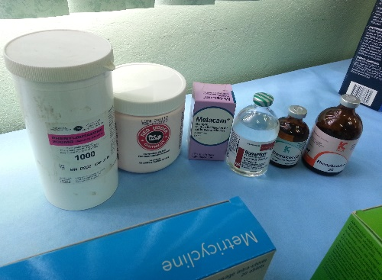 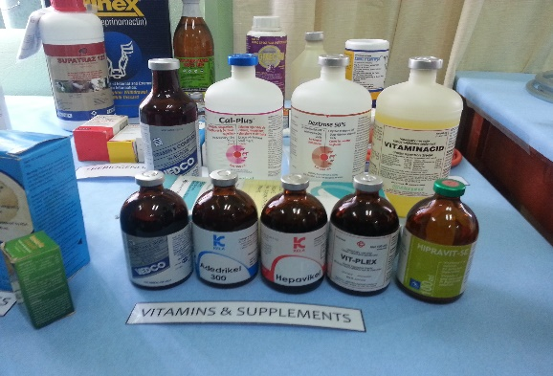 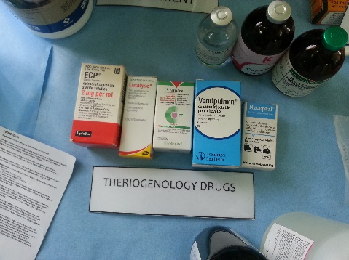 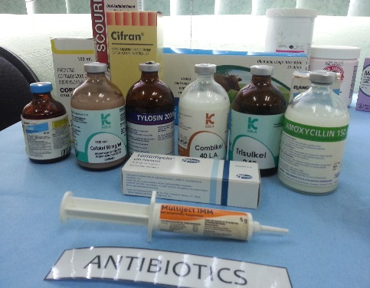 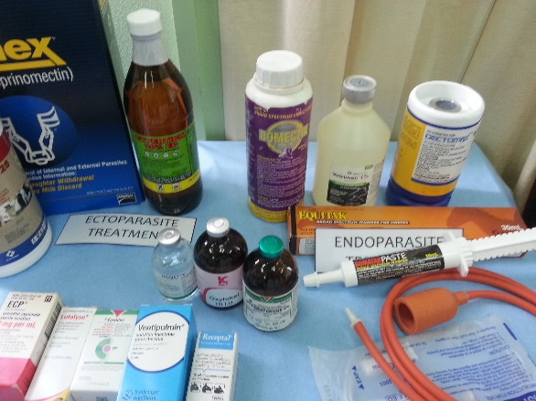 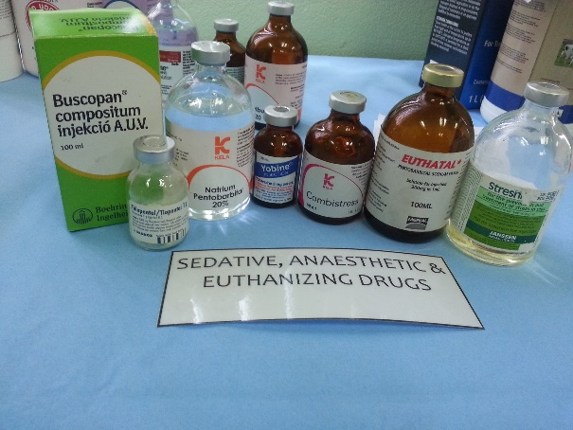 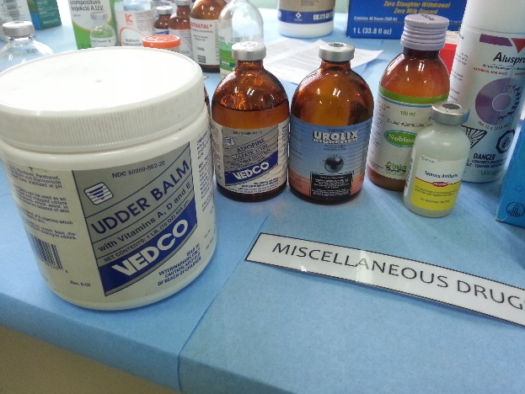

**REFERENCES:**

<http://loudoun.nvcc.edu/vetonline/vet121/sutureMaterialsAndPatterns.htm>

<http://www.emap.usask.ca/>

<http://emap-projects.usask.ca/vsac205/Lab4/suture/lab4_2.5.2.6_prolene.php>

<http://www.veterinarysurgery.8m.com/rich_text_6.html>

<http://kela.ibrochure.be/ibrochure.pdf>

<http://www.bayeranimal.co.nz/products/bomatak-paste.aspx>

<http://www.msd-animal-health.co.uk/products_public/receptal/090_product_datasheet.aspx>

Principles of Veterinary Suturing Marcel I. Perret-Gentil, DVM, MS University Veterinarian & Director Laboratory Animal Resources Center The University of Texas at San Antonio

Small animal surgery Theresa Welch Fossum

Sonsthagan, Theresa A. (2011), Veterinary Instruments and Equipment: A Pocket Guide 2nd Edition, St Louis, Missouri: Elsevier Mosby.

Plumb, Donald C. (2011), Plumb’s Veterinary Drug Handbook 7th Edition, St Paul, Minnesota: PharmaVet Inc.