Materials and Apparatus:
Size 20 Scalpel Blade 5ml Syringe 20 Gauge 1.5” Needle
Size 4 Scalpel Holder Dye (substitute for Lidocaine) Nylon 1
Needle Holder Forceps Hemostat
Curved Needle Vicryl Curved Mayo Scissors Povidone lodine solution Metzenbaum scissors

Drugs- Formula (Dose*Weight/Concentration)
Xylazine- Alpha 2 agonist, sedative with analgesic and muscle relaxing effect
Lidocaine- Local anesthetic
Flunixin- NSAID, analgesic and antipyretic
Penstrep- Antibiotic

Nerve Blocks
- Peterson- 10 cm, 18 gauge needle inserted at caudal angle between supraorbital process and zygomatic arch, direct posterior and walk off coronoid process anteriorly, advance to pterygopalatine fossa. Inject 15-20 mls of lidocaine
  - Complications: apnea, death
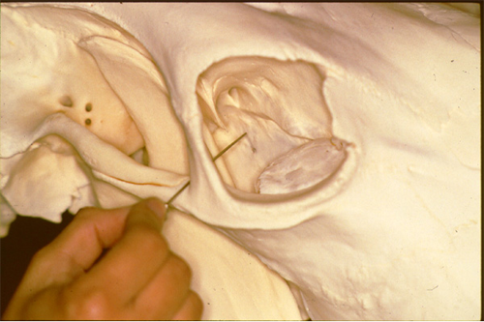
- Four-point” block- 6 mm needle inserted transconjunctivally adjacent to globe at 12, 3, 6, 9 o’clock positions. Inject 5-10 mls of lidocaine at each site

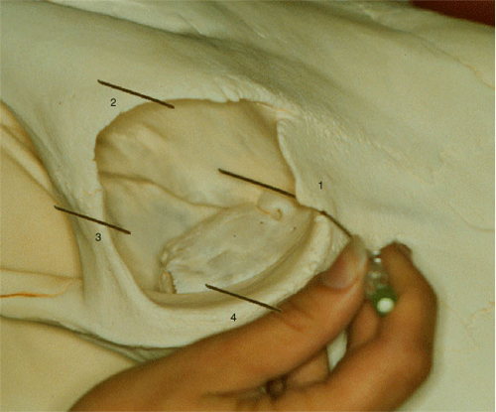
- Auricular- Eyelid akinesia (motor block)
No analgesia: globe retraction and third eyelid movement unaffected
Lidocaine injected SC 5-7cm caudal to supraorbital process, where nerve crosses zygomatic arch
