**Step 1. Trim toe 'length'** **to 7.5 cm (more or less in some cows)**

For hind feet, trim the inner claw (most normal)

For front feet, trim the outer claw (most normal)

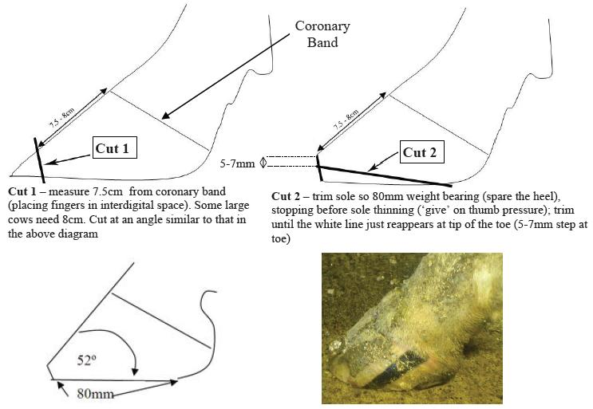

Reference;

1. Nadisorguk. 1. Nadisorguk. [Online]. Available from: http://www.nadis.org.uk/bulletins/lameness-control-in-dairy-herds/part-1-practical-foot-trimming-(dutch-5-step-method).aspx [Accessed 11 October 2015].

In-text citation: (1)