**BIRTHING TOOLS:**

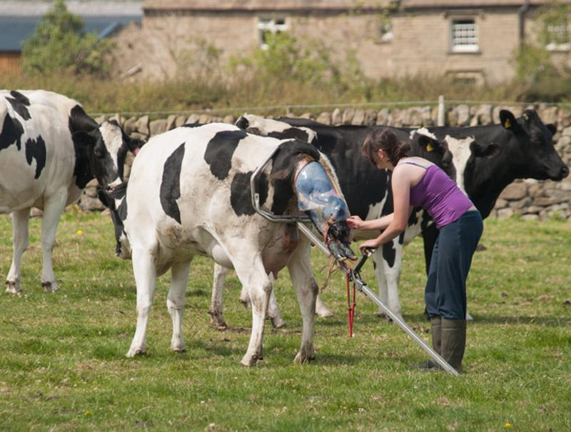

Fig 1: Calf puller and jack.

[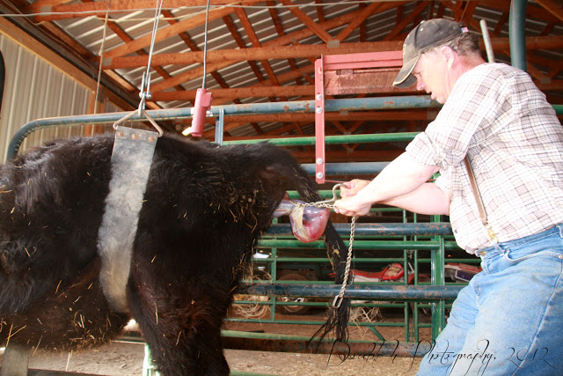](http://4.bp.blogspot.com/-H90OM_mJcpM/T2-yRGD541I/AAAAAAAAD9s/xSs6X4HbZBg/s1600/IMG_4621+copyright.jpg) [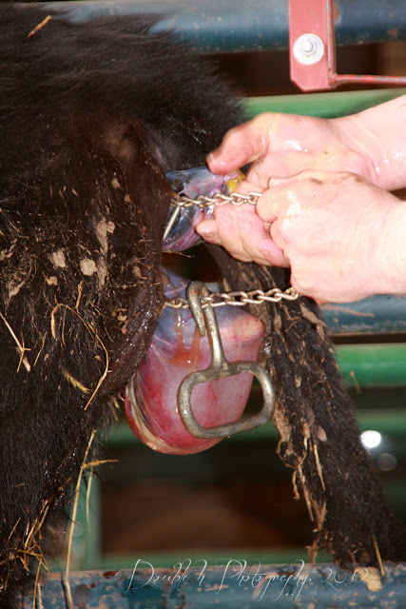](http://2.bp.blogspot.com/-28_UQ89D4xc/T2-y4aM5OiI/AAAAAAAAD90/rkwEAIL5Icc/s1600/IMG_4625+copyright.jpg)

Figs 2 and 3: Calving chains and hooks.

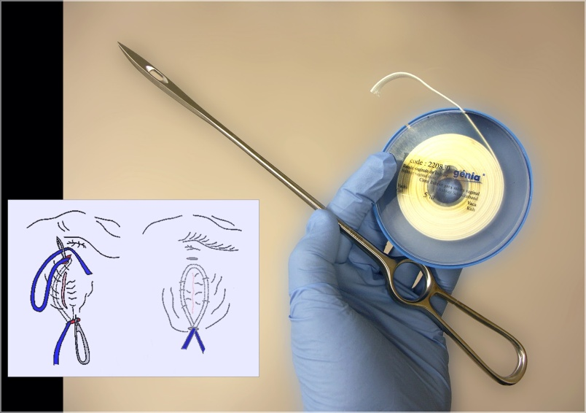

Fig 4: Buhner needle and tape.

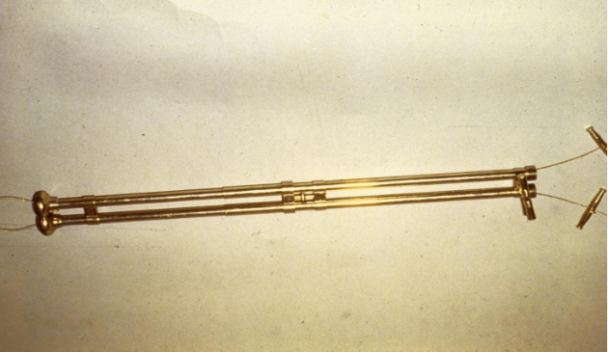

Fig 5: Fetotome.

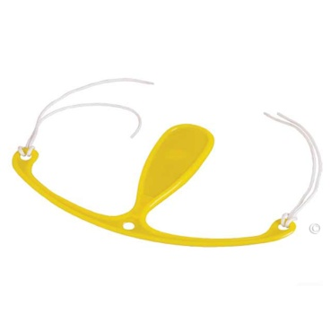

Fig 6: Prolapse retainer.

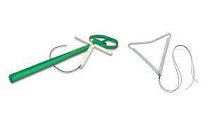

Fig 7: Progesterone Releasing Devices.