**CAUDAL EPIDURAL NERVE BLOCK IN CATTLE:**

**ABOUT THE NERVES:**

When the anesthesia is injected within the canal but outside the dura matter, it is called epidural anesthesia. In epidural anesthesia there is desensitization of the first sensory nerves followed by sacral, parasympathetic, sympathetic and motor nerves. Depending on the site of injection, epidural anesthesia can be caudal epidural anesthesia, lumbosacral epidural anesthesia and lumbar segmental epidural anesthesia. Caudal epidural anesthesia mostly produces the desensitization of sacral region, tail, anus, vulva, perineum, and caudal

aspect of the femoral region. It doesn’t affect the motor response of hind limb.

**USES OF THE CAUDAL EPIDURAL NERVE BLOCK:**

* Used routinely for suturing tears in the perineum or vulva, perineal reconstruction, retraction of the uterine cervix, reduction of uterine prolapse and embryotomy.
* Adjunctive treatment in control of tenesmus associated with perineal, anal, rectal or vaginal irritation.
* Provides excellent perineal [analgesia](http://wildpro.twycrosszoo.org/S/00Ref/KeywordsContents/a/Analgesia.htm) and muscle relaxation, minimal cardiovascular and respiratory effects, and rapid recovery.
* Provides bilateral analgesia of dermatomes supplied by the caudal, caudal rectal, perineal, pudendal and caudal cutaneous femoral nerves.

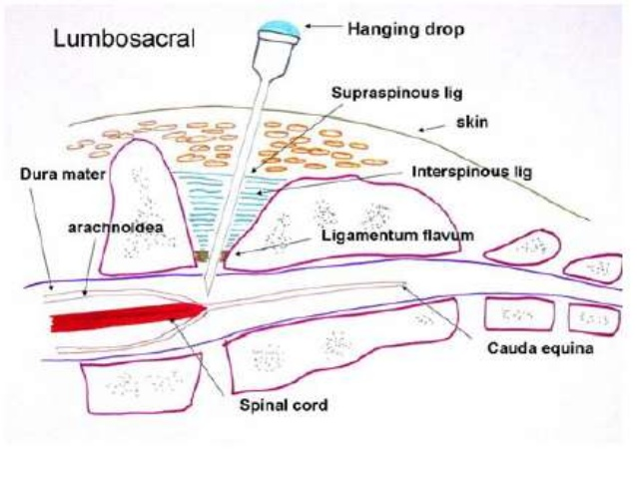

FIGURE 1: DIAGRAM SHOWING THE EPIDURAL ANAESTHESIA METHOD IN A COW.

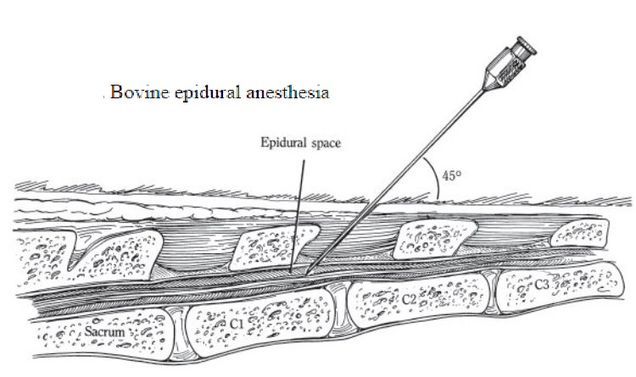

FIGURE 2: DIAGRAM SHOWING THE ANATOMICAL AREA FOR BOVINE EPIDURAL ANAESTHESIA PROCEDURE.

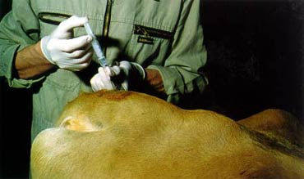

FIGURE 3: PICTURE OF BOVINE EPIDURAL ANAESTHESIA BEING PERFORMED.

**PROCEDURE OF THE CAUDAL EPIDURAL NERVE BLOCK:**

1. This nerve block was successfully administered at 2:42 p.m.
2. If possible, the hair should be clipped and the skin scrubbed.
3. Standing alongside the cow, the tail should be moved up and down to locate the fossa between the last sacral vertebra and the first coccygeal vertebra or between the first and second coccygeal vertebrae.
4. An 20-gauge, 1.5 inch needle, with no syringe attached, is directed at a 45 degree angle to the skin surface.
5. Then the needle is pushed down till it contacts the floor the vertebral canal.
6. The syringe should be fitted and aspirated slightly to check for the presence of blood. If blood is present, the needle is taken out, blood clot cleaned and reinserted.
7. If the needle is in correct position there is practically no resistance felt during injection. If resistance felt, slightly adjust the needle and then inject.
8. Finally, the dosage volume of 3.78 ml of Lidocaine 2% was administered.

**SIGNS OF A SUCCESSFUL CAUDAL EPIDURAL NERVE BLOCK:**

Onset of effect is seen within few minutes, by flaccidity of the tail. The duration of the nerve block is 45 minutes.

**COMPLICATIONS OF THE CAUDAL EPIDURAL NERVE BLOCK:**

* Permanently paralyzed tail
* Loss of motor control of hind limb (ataxia)
* Infection resulting in draining tracts at the site

**PRECAUTIONARY MEASURES:**

[Since haemorrhage](http://wildpro.twycrosszoo.org/S/00Ref/KeywordsContents/h/Haemorrhage.htm) and infection can occur if a venous sinus is punctured, sterility must be maintained during the procedure.