**CHEMICAL DISBUDDING OF CALVES**

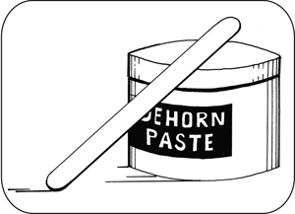

FIGURE 1: Chemical disbudding paste.

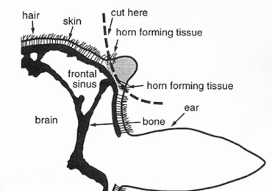

FIGURE 2: Diagram of the anatomical area of interest in disbudding of young calves.

**SPECIAL REQUIREMENTS:**

* The calf must be less than seven days of age.
* Not clipping hair is preferable, because the hair keeps the caustic paste in place and thus, reduces the risk of irritation to other facial skin of the calf.
* Personnel involved with the procedure must wear protective gloves and clothing, as the caustic paste causes severe irritation on contact with skin.

**TECHNIQUE:**

1. Ensure that the cornual nerve block is properly executed and tested.
2. Next, expose the horn bud (about the size of a 5-cent piece) by pushing the hair back.
3. Apply a layer of Vaseline around the base of the horn to act as a barrier for the paste-covered area.
4. Apply a thin layer of the caustic paste to the horn button, using a wooden applicator.
5. Re-position the hair over the paste and horn bud - i.e., cover the horn bud.
6. Finally, allow the calf to rest, in areas out of the rain and away from other animals.

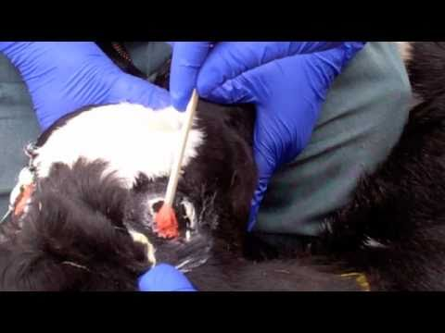

FIGURE 3: Pictures of caustic disbudding paste being applied to the horn bud of a calf.

**ADVANTAGES OF THIS METHOD OF DISBUDDING:**

* Bloodless.
* Minimal open wound.
* Less likely to cause infection due to flystrike.

**DISADVANTAGES OF THIS METHOD OF DISBUDDING:**

* Significant irritation and tissue damage can be sustained if the paste gets on unintentional areas besides the horn bud.
* Due to the possible dangers, this method is prohibited in many countries, due to welfare concerns.
* Requires pain control measures.
* Scurs can occur with improper technique or application.

**COMPLICATION OF THIS METHOD OF DISBUDDING:**

This method can lead to severe caustic paste irritation, burns and tissue damage, since the product used is a non-specific caustic agent. This can lead to injury, not only to the personnel involved in the procedure, but also to the animals.