**THERMAL DISBUDDING OF CALVES**

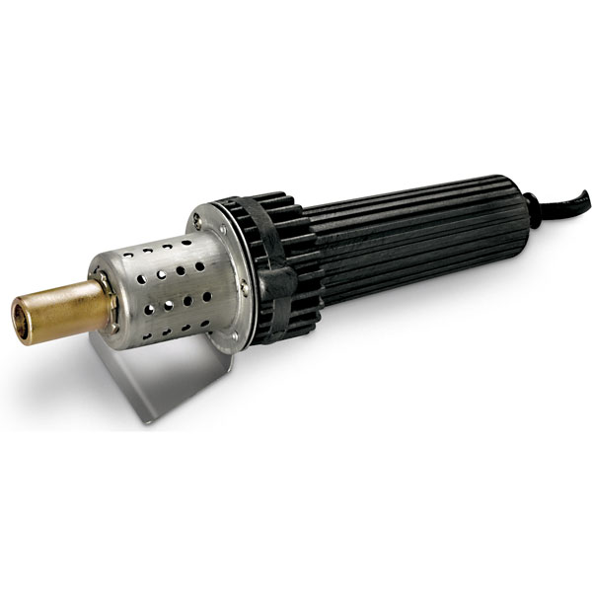

FIGURE 1: Thermal Cauterizing Iron.

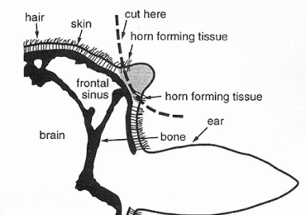

FIGURE 2: Diagram of the anatomical area of interest in disbudding of young calves.

**SPECIAL REQUIREMENTS:**

* The calf must be less than six weeks of age.
* The animal must be properly restrained to avoid the risk of injury to both the calf, as well as the person performing the procedure.
* Always ensure that both horn buds are desensitized from the corneal nerve blocks, by test-pricking the skin around the horn with a needle a couple of times and observing the animal’s reaction.

**TECHNIQUE:**

1. Once the cornual nerve block is properly executed and tested, the hair around the horns is shaved using clippers.
2. Next, the iron is applied straight onto the horn bud for 10 seconds, while angling it and moving the angled iron through 3600, ensuring that the entire circumference at the base of the horn gets enough cauterizing.
3. Then check that the horn-producing germinal tissue is destroyed by looking for the 'copper ring' around the edge of the burnt area. If not, re-apply the iron to those sites - again for not more than 2-3 seconds.
4. Finally, apply anti-biotic spray to the area, followed by anti-miaisis spray.

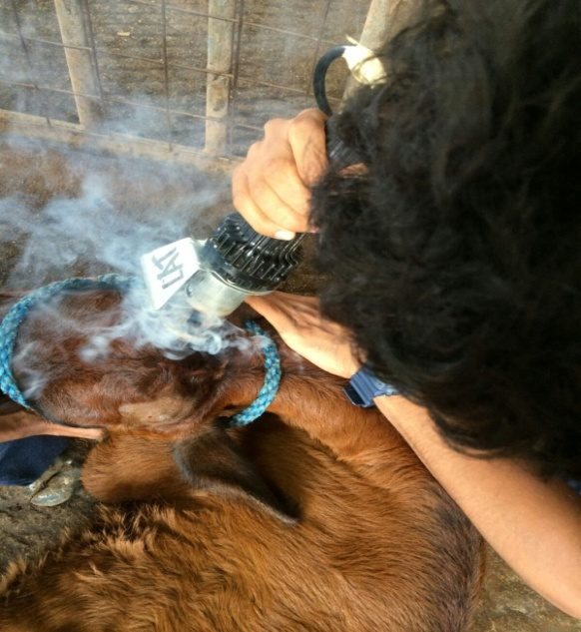 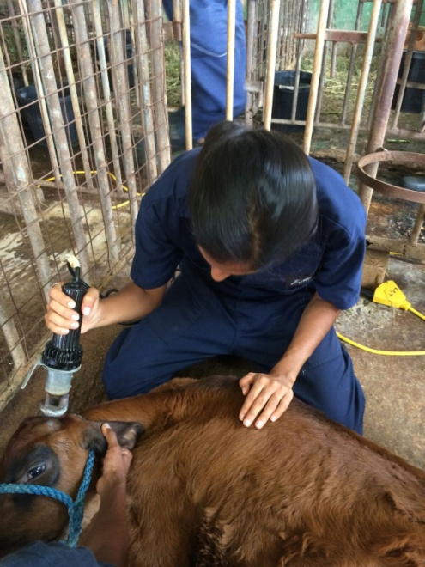

FIGURES 3 & 4: Pictures of group members using the hot iron cauterizer on the lab day.

**ADVANTAGES OF THIS METHOD OF DISBUDDING:**

* Bloodless.
* Least painful method.
* Less likely to cause infection due to absence of an open wound.

**DISADVANTAGES OF THIS METHOD OF DISBUDDING:**

* Unreliable when done incorrectly, leads to scurs (partial horn growth).
* Requires expertise.
* Brain damage in the calf.

**COMPLICATION OF THIS METHOD OF DISBUDDING:**

This method can lead to cerebral infarction and meningoencephalitis in the calf, if the hot iron is held against the horn bud too long. This is because the skull of the calf is not as thick as the adult at this age.