Palpation and Manipulation

Body part | Description | Image
Hoof | Note the size and shape. Compare the normal with the abnormal (hoof wear, ring formation, heel bulb contraction, wall cracks, swellings, asymmetries. Take note of the  hoof – pastern angle and the angle of the heels relative to the dorsal  hoof surface (under-run heels). Palpate the coronary band for heat, swelling and pain on pressure. Palpate the coffin joint. Have available a hoof pick, a hoof knife and hoof testers. Clean out the sole of the foot and search for any abnormalities, including frog atrophy, flat -footedness, or puncture wounds. Use hoof testers on the entire sole and frog region of the foot. Try to localize any hoof sensitivity or signs of laminitis. A hammer test (percuss to identify pain in the hoof wall or sole). | 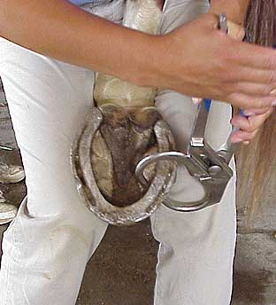
Pastern | Palpate the soft tissue structures of the pastern. Note any heat, swelling or sensitivity. Note any digital sheath effusion at this level. Palpate dorsally to check for fractures and enthesophytes. Check the interphalangeal joint (assess effusion - ballottement; bony swelling - ring bones; subluxation - suspensory desmitis). Palpate the distal DFT & Sesamoidean ligaments (palmar compression; rotation movement) Compare any suspected abnormalities with the opposite pastern. Check for any thickening of the tendons. Rotate the joint medial to lateral to test for pain in the collateral ligaments. | 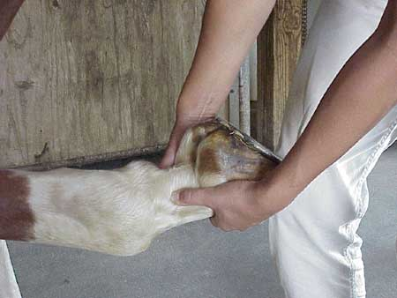
Fetlock | Palpate both the dorsal and palmar aspect for any thickening and swelling of the joint capsule, fractures, enthesophytes. Check the metacarpophalangeal joint (assess effusion - ballottement; check synovial or bony proliferation - osselets; palmar pouches - usually mild effusion). Palpate the superficial and deep digital flexors for heat, pain or swelling. Palpate the sesamoid bones and percuss if necessary. Rotate and flex the fetlock to check the collateral ligaments and range of motion. Note any reactions to these movements. | 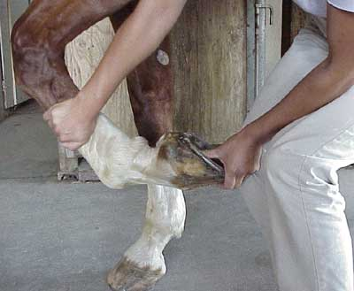
Metacarpus/tarsus | Palpate the tendons on both the dorsal and palmar surfaces for any swelling, pain or heat. Also, palpate the length of MC3/MT3 and the splint bones looking for abnormalities. Palpate the flexor tendons, suspensory ligament, splint bones and dorsal cannon bone while the horse is weight bearing. Lift the leg and while supporting the limb with one hand palpate the same structures again.Separate the superficial and deep flexor tendon.Squeeze firmly on the superficial and deep flexor tendon, the suspensory ligament, the inferior check ligament and the splint bones. Note any reaction the horse may have and compare this reaction to the other leg. | 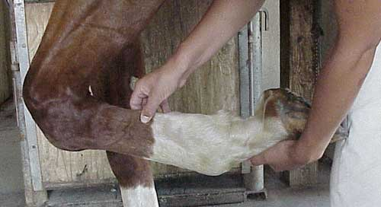  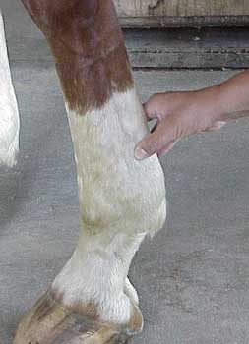
Carpus | Visualize for swelling on the dorsal and palmar surfaces. Try to associate any swelling with particular joint spaces. Is the swelling diffused or local? Palpate all the regions individually. This evaluation is most effective while the carpus is flexed. Elevate the limb and support its weight between your knees while facing forward.Using both hands palpate the radiocarpal and middle carpal joints, the distal radius and proximal row of carpal bones. Flex and extend the carpus.Also, note the degree of flexion and any associated pain. Evaluate the individual carpal bones and accessory carpal bone with thumb pressure. | 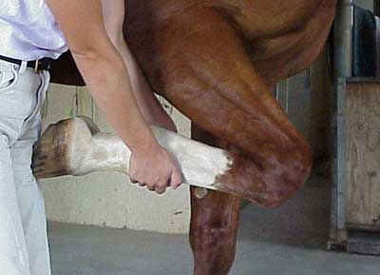
Antebrachium | Evaluate all the soft tissues for any swelling and inflammation. Also, palpate the bones of the region (i.e. radius) for any fractures. | 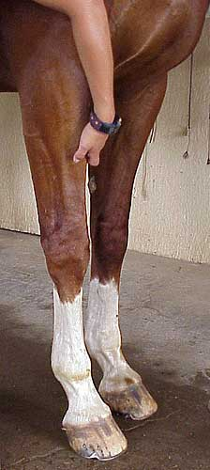
Elbow | Palpate the soft tissues of the elbow joint. One can use a stethoscope to auscult for any crepitation. Abduct the elbow and carpus to place stress on the medial support structures looking for pain. Flex and extend the elbow. Palpate the olecranon, collateral ligaments, and distal humerus. | 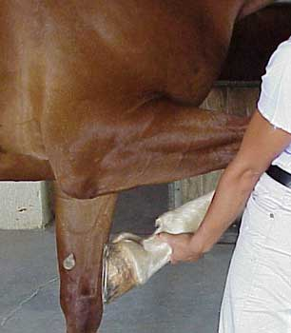
Shoulder | Palpate all the soft tissue of the scapulohumeral joint and look for atrophy or swelling. Palpate the bicipital bursa region. Flex, extend, abduct and adduct the shoulder looking for abnormalities. Look for any atrophy in the region of the scapula. | 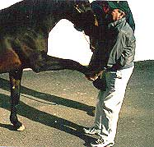
Tarsus | Evaluate the tarsocrural/tibiotarsal joint for any distension, thickening of the joint capsule, bone proliferation of the distal tarsal joints, distension of the tarsal sheath, inflammation or luxation of any ligaments, or any other abnormalities. Also, look at the distal intertarsal and tarsometatarsal joints. Do a hock flexion test (spavin test) where the metatarsus becomes approximately parallel to the ground. A change in degree of lameness or gluteal rise would indicate a positive result. Also, while in that region, observe the tibia for any swelling or pain. | 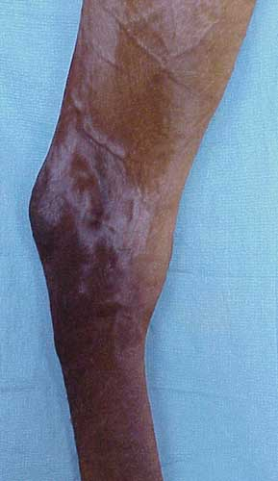
Stifle | Appreciate any changes in the femoropatellar joint or distension of the joint. Observe the associated muscles for atrophy or swelling. Palpate the patellar ligaments. Note the location of the patella itself, looking for any luxation. Manipulate the stifle with a patellar displacement test (pushing the patella upwards and outwards in an attempt to engage the medial patellar ligament over the medial trochlea), a cruciate test (evaluating any abnormal cranial or caudal movement of the tibia), and an evaluation of the medial collateral ligament by trying to abduct the limb. | 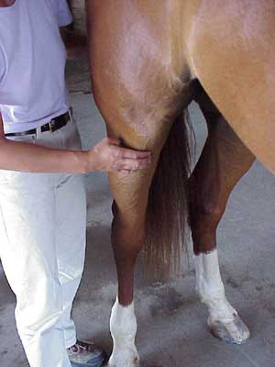
Femur and hip | Examine the muscles of the region for inflammation and/or atrophy. Check the femoral artery for the quality of pulsation. Put pressure on the greater trochanter to check the trochanteric bursa for inflammation. Palpate the femur looking for fractures. Examine the hip for asymmetry and muscle atrophy. Measure the distance from the tuber ischiadicum to the greater trochanter, and the tuber sacrale to the greater trochanter. With any luxation of the hip there may be disparity in these measurements. Flex and auscult for crepitation. | 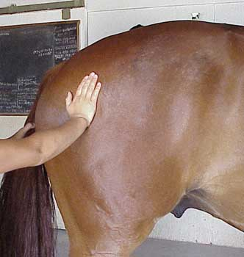
Back | Palpate the withers and the epaxial musculature. | 