**NEUROLOGICAL EXAMINATION**

Horses with neurologic disease often move and carry themselves abnormally causing painful orthopedic conditions as the horse attempts to compensate. Neurological diseases such as Wobbler Syndrome and Equine Protozoal Myeloencephalitis can be misdiagnosed since they present with signs similar to those seen with lameness due to inflammation, etc. Horses, particularly those with chronic problems, may develop compensatory gait abnormalities to deal with the primary problem making diagnosis more difficult. This may complicate the lameness evaluation and possibly its treatment. Therefore, it is important to have both the lameness and the indications of any neurological problems evaluated as soon as they are recognized.

***Neuro exam***

First, palpate the low back and sacrum area with your hands. You want your horse to flinch or drop away from the pressure. Many horses will turn and look at you as well. If your horse acts like he doesn’t feel the pressure this may be a sign of neurologic impairment.

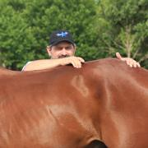

Palpation of acupuncture meridians to look for painful responses can be helpful. Take a needle cap or pen and apply medium pressure running down along the lower part of the neck and then onto the chest. Next, brush the needle cap from the point of the hip up and back to the sacrum. Finally, run it down the middle of the hind leg down past the stifle. If you elicit painful twitching or your horse gives you a warning look upon palpation of the chest, hip or stifle, this may indicate immune and/or nervous system compromise.

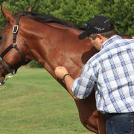     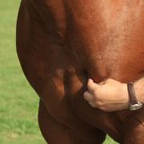     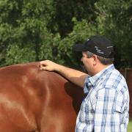

Take a piece of hay and lightly touch the side of the barrel in multiple areas. You are trying to mimic a fly walking on your horse. Also do this along the hip and stifle. Look for the skin to twitch to rid itself of the ‘poking’ from the hay piece. Check both sides, as there maybe asymmetrical dysfunction.

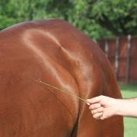

Move to the back of your horse, and grasp the tail about two hand widths down from the dock. Pull the tail up and poke the underside of the tail with your finger. Your horse should try to clamp its tail back down into a normal position. If it I easy to hold the tail up in the abnormal position, this is referred to as weak tail tone.

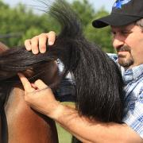

While standing next to a hind leg, facing the tail, pick up the near foot and place it away from you to cross in front of the off hind foot. If it takes longer than 5 seconds for your horse to bring its foot back into a correct square position, it flunks the placing test. Again, do this with both hind feet as sometimes the deficit is worse on one side than the other.

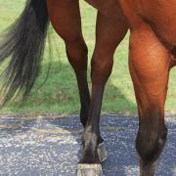

The final part of the exam is the sway test. While facing your horse, take the tail, and wrap it around your hand one time. Step to the side and draw the tail towards you, trying to pull your horse off balance. It is common that you will be able to do this the first time with little to no resistance. During the second attempt, your horse should resist you and lean against your pressure. If you find you can repeatedly pull your horse’s feet your direction, this demonstrates weakness in the hind end.

