**Horse Cradle**

A device, consisting of narrow strips of wood connected by leather straps, placed about a horse's neck to prevent him from turning his head sideways.

One way that this comes in handy when you use bandages to immobilize a limb to prevent the horse from bothering the bandages)

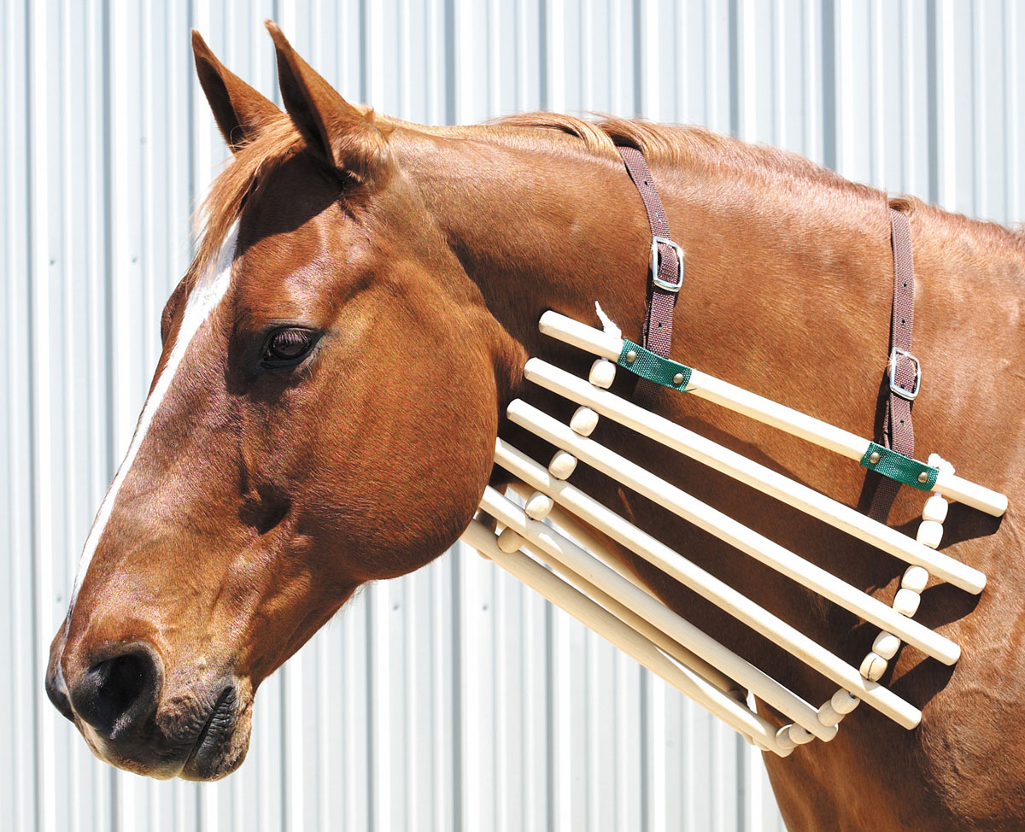

Reference: <https://www.wordnik.com/words/horse-cradle>