**Shipping Bandages**

As the name implies, shipping bandages are used to protect and support a horse’s legs during transport. While similar to standing bandages in materials and technique, shipping bandages should extend farther down the leg to cover the pastern and coronary band, which are particularly vulnerable to injuries while trailering. For this reason, it is important to use pillow or quilted wraps that are long enough to cover the leg from just below the knee or hock all the way down to overlap the coronary band by one inch. If your horse has longer cannon bones and you cannot find wraps of adequate length, you may need to pair regular standing wraps with bell boots to protect the coronary band. Depending on the horse, some owners may prefer that the shipping bandages also cover the knees and/or the hocks.

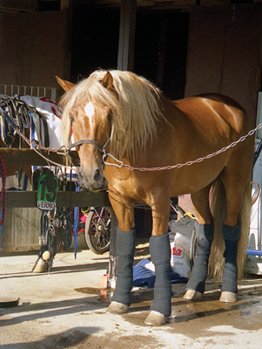

Reference: <https://www.horsejournals.com/horse-care/illness-injury/prevention/equine-first-aid-bandaging-horse>