**Distal Splint Bone Fractures- Removal**

Typically treated by surgical excision of the bone fragments. General anesthesia or standing with local anesthesia can be used as it should a relatively short procedure.

Radiographs should be assessed closely to find the areas of interest to properly plan the procedure.

A tourniquet can be placed proximally to the area of interest to reduce bleeding however splint bone removal should not cause significant blood loss.

1. An incision is made directly over the metacarpal/tarsal bone, cutting down to the bone surface over the length of the fragment (hence the importance of knowing the fragment location).
2. The distal tip of the fracture can then be grasped with a tissue forceps and elevated.
3. The attachments between splint bone fragment and the 3rd metacarpal/MT should be severed with a heavy curves scissors.
4. Apply upwards traction to the fragment to displace the fragment and callus proximally and it is removed.
5. 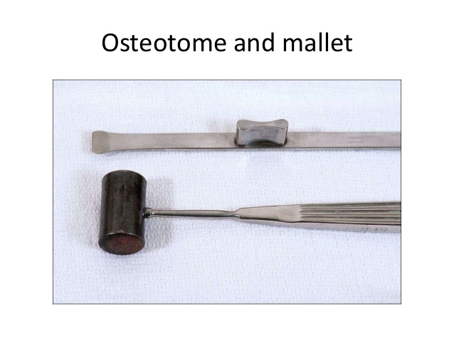The remaining protion of the splint bone is transected obliquely in a proximal abaxial and distal axial direction using a bone chisel (osteotome) and if needed a mallet. This is done to taper the edge to prevent further damage of surrounding soft tissue structures.

Osteotome and Mallet

1. And fragments or jagged edges are removed with a curet or rongeurs.

Curet Ronguers

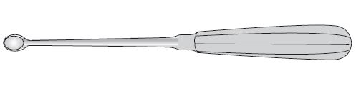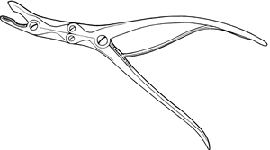

1. The method of closing the wound varies depending on if it was an open or closed fracture. If it was an open fracture the surgeon should change his gloved before proceeding. The lavage the wound with copious amount of dilute chlorhexidine then place a penrose drain for 48hrs- if the wound seems healthy enough and granulating properly after this time it can be closed primarily.
2. A pressure bandage can then be placed using a sterile adhesive elastic bandage. A padded bandage can also be placed for added security and to lessen the chances of bleeding into the dead space of the wound.

Prognosis depends heavily on if it was an open or closed wound and on which MT or MC bone was affected.

MTIV/MCIV can be completely removed if need be, the horse will typically regain most of not all of its performance abilities. MTII/ MCII however, if more than 50% of the splint bone is removed, horses often experience lameness or carpometacarpal instability. MCII particular bears a substantial axial load.