**OTHERS**

**Exercise bandages:** these require a layer of padding underneath them, eg gamgee, foam or pads. The bandages are made from a stretchy crepe-like material for support and protection of the leg from the fetlock up to the knee. Care must be taken not to apply these too tightly.

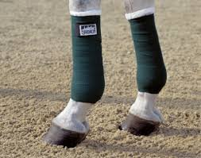

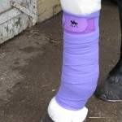**Stable bandages:** these are slightly wider than exercise bandages and are usually made of thicker wool-type material. They have some give but are not stretchy like the exercise bandages. They are also designed to support and protect the leg from the coronet up to the knee or hock.

**Tail bandages:** these are made from similar material to exercise bandages. Tail bandages are mainly used to protect the tail while travelling. They can also be used to smooth the top of the tail before a show.

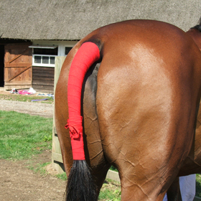

**LEG WRAPS**

Wrapping your horse’s legs the proper way can help soothe existing leg problems and provide support when your horse is being worked, hauled, and stalled. However, wrapping a leg incorrectly can create serious problems. Wrinkles in the wraps, a wrap that is applied too tightly, or uneven pressure from the wrap can all cause tendons damage or pressure sores.

**Polo Wraps** - Support the flexor tendons during workouts with a single roll of soft fleece, cotton, or slightly elastic material

Wrap Application:

●Prep legs by removing any debris so the wrap will not create any pressure

points or irritation

●Start directly below the knee placing the wrap on the outside of the leg.

●Roll the wrap towards the back of the leg starting from just below the knee,

going down the leg to just above the fetlock, and then back up towards the knee.

●You will roll the wrap counter-clockwise on the left legs and clockwise on the

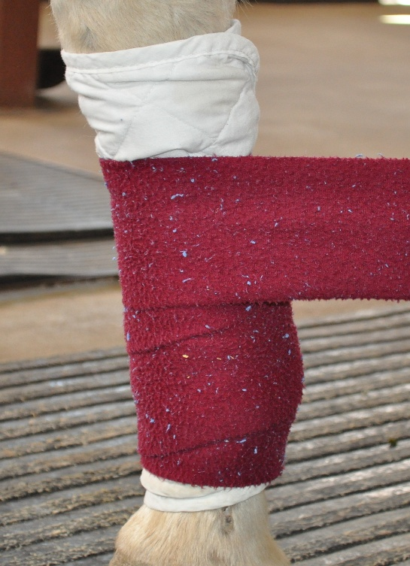 right legs.

●You will overlap the wrap evenly (1/2 -3/4 width of the wrap) with EVEN AND

CONSISTENT pressure.

●If when you reach the top and there is enough fabric leftover to go around the leg once more, remove the wrap and start over

●Do not use wraps that are wet

**Standing Wraps** - Provides warmth & support to tendons and ligaments, cushions legs against bumps, & helps prevent stalking up (Fluid accumulation due to inactivity, usually following standing after a workout) Wrap consists of Pillow wrap and bandage often accompanied with a poultice or linament application.

Wrap Application:

●Prep legs by removing any debris so the wrap will not create any pressure points or irritation

●Start directly below the knee placing the pillow wrap on the outside of the leg

●Roll the wrap towards the back of the leg placing the top of the pillow wrap

just below the knee.

●You will roll the pillow wrap counter-clockwise on the left legs and clockwise on the right legs.

●Use a bandage/wrap and roll over the pillow wrap leaving about 1/2 inch of the pillow wrap showing on top and bottom

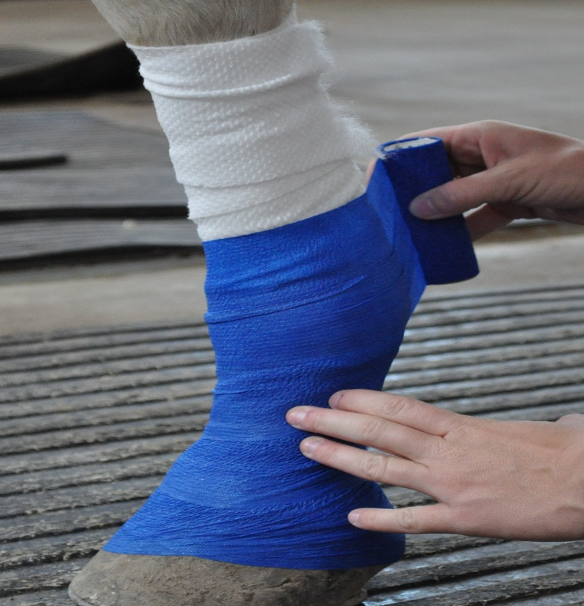

**Sweat Wraps** - Helps reduce swelling in legs from injury, stress from being worked, or poor circulation. Nitrofurazone ointment (often with DMSO), surpass, or other ointments recommended by your veterinarian, are applied to clean, dry legs. Plastic wrap, cotton roll, and vet wrap are applied on top of the ointment.

