**COMMERCIAL DEVICES**

**Exercise Boots**

          Ankle or Fetlock Boots are designed to protect the sesamoid bones during jumping or galloping.  They are usually made of leather or neoprene and have a padded cup which fits inside the fetlock joint.

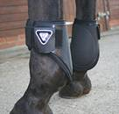

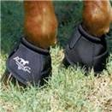          Bell or Over-Reach Boots are used when a horse has a tendency to over-reach with his hind feet and interfere with the front.  These horses tend to pull of the front shoe.  Bell boots are also used if the shoes have studs.  They protect the opposite foot in case the horse takes a misstep and interferes with himself.  Many stable managers will also put bell boots on a horse before turning them out for exercise or lunging.

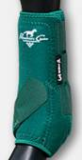          Combination Boots provide more complete protection, acting as both an ankle boot and a splint boot.  These boots also provide support which slows the decent of the fetlock, helping to prevent hyperextension.  A bell boot can be added for more protection.

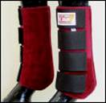          Galloping or Cross Country  Boots supposedly provide protection for a horse while doing fast work.  They reach from just below the knee to below the fetlock.  They are usually fleece or felt lined.

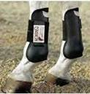          Open Front Boots are open in the front so the horse will feel it when brushing a fence; the back is closed to protect the tendons from an accidental kick from a hind leg when the horse is jumping.   The boots attach by means of narrow straps that criss-cross the front of the leg.  If not properly applied, the straps can cause injury to the leg.

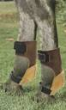          Skid Boots apply protection for the back of the fetlock joint of the rear legs when a reiner or working cow horse slides.  The boots are cupped to fit over the fetlock joint, but care must taken to insure they are not too loose or too tight.

          Splint or Brushing Boots are popular with trainers and riders of young horses since they protect the inside of the leg where the horse is most likely to strike himself with the opposite front leg, or an overreaching hind foot.

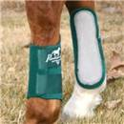          Usually the boots are molded to prevent slipping and provide a good fit.  Put the boots on so the padded section is to the inside of the leg and the shaped cup fits over the inside of the fetlock joint.  Fasten on the outside.  The boot should fit snugly, but not tightly.

         Splint boots seldom prevent splints which most often occur from stress, not the striking of the leg.  The splint boots does nothing to diminish bone stress.

**Shipping boots** come in all kinds of configurations. They come in all colors and convenient sizes.

          Shipping boots are generally fleece-lined, well padded and fasten with Velcro strips, so 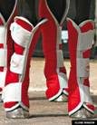they are easy to put on and take off.  The best boots, from the horse’s point of view, have a flap across the back of the heel which protects the bulbs of the heel when the boot is in place-- extending below the coronet band.  There are shipping boots for front legs and shipping boots for hind legs.

          Poorly made or poorly fitted commercial shipping boots can become loose, allowing them to slip and slide off.  It would be better to use nothing at all, instead of having a shipping boot dangling from a horse’s leg.

          Bell boots may also be used in shipping to protect the horse from pulling off his front shoes and to protect the heels or bulbs of the hoof.