Respiratory diseases are extremely common illnesses that limit performance horses, probably second only to lameness. Respiratory diseases can be viral, bacterial, immune mediated (allergies), or mechanical in nature. They can be transient or chronic, serious or inconsequential. Some are highly contagious while others are limited to the affected individual horse. While some diseases can affect both the entire respiratory system, most are categorized as either upper airway disorders or lower airway disorders. Disorders of the upper airways are generally mechanical in nature while those of the lower airway are often the result of infection. This article will provide you with an overview as well as treatment and prevention strategies for three common respiratory diseases: equine influenza (flu), strangles, and heaves.

**Equine Influenza (flu)**

Equine influenza (flu) is the most common viral respiratory disease in horses. It affects the upper and lower respiratory tract of horses and is highly infectious, with an incubation period of 1 to 3 days. After contracting the virus, horses can remain contagious for up to 10 days. Clinical signs are similar to other respiratory infections, making it difficult to distinguish equine influenza from other diseases without laboratory tests. However, if the illness spreads rapidly in a barn and certain symptoms are present, that is usually indicative.

**Symptoms**

Symptoms can include:

* fever
* dry, hacking cough
* slight enlargement or tenderness of the sub-mandibular lymph nodes
* clear discharge from the nostrils and eyes
* loss of appetite or depression

The virus is easily spread by particles released into the air when an infected horse coughs, but it can also be transmitted by contaminated items such as brushes or clothing. Horses that are frequently exposed to new horses, such as those that travel to shows, are at greater risk of contracting the disease than are those who have never been vaccinated and those without previous exposure to the virus.

Fortunately, equine influenza is generally not a serious health hazard for adult horses, though it can be quite dangerous for foals. In most cases, horses will fully recover within 2 to 3 weeks, though complications such as secondary bacterial *pneumonia*, *myocarditis*, or *pleuritis* can occur.

**Treatment**

Treatment for uncomplicated equine influenza generally requires little more than rest. The general rule of thumb is to rest the horse one week for every day of fever it had. *NSAIDs* may be given if the horse’s fever rises above 104 degrees; but since the disease is viral in nature, antibiotics are not indicated unless symptoms suggest a secondary bacterial infection.

**Prevention**

Vaccines are available and recommended for the control of equine influenza. While they do not necessarily prevent a horse from becoming infected, immunized horses tend to recover more quickly with fewer complications. Horses that are exposed to new horses frequently should be vaccinated every 6 months. Hygiene is also important for the prevention of the spread of equine influenza. Equipment and tack used on an infected horse should not be used on other horses. Handlers of sick horses should wash their hands with soap and water and change their clothes and shoes before entering areas housing uninfected horses.

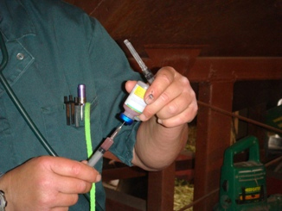

*Vaccinating horses will help prevent the contraction of infectious respiratory*

*diseases and the severity of the infection. Vaccinating horses that are*

*exposed to many different horses at horse shows, boarding stables, and*

*breeding barns may be beneficial.*

**Strangles**

Streptococcus equi (S equi) infection, commonly referred to as strangles, is an unpleasant and highly contagious disease. Though most horses recover from strangles, it is a serious disease that can occasionally be fatal.

**Symptoms**

The following symptoms are characteristic of strangles and typically appear in the following order:

* sudden fever
* nasal discharge that starts out watery but soon becomes thick and sticky with mucus and pus
* depression, difficulty swallowing and/or standing with neck outstretched, lack of appetite
* about a week after infection: acute swelling in the lymph nodes between the jaw bones and at the back of the throat, and possibly swelling in other lymph nodes as well

The swollen areas are often hot and clearly painful if touched. Once mature, the abscesses often rupture, releasing a sticky, creamy pus. If the lymph nodes become very enlarged, they can partially obstruct the horse’s airway or even suffocate the animal, which is how “strangles” came to be the name of this condition.

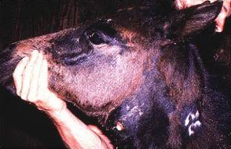

*Swelling in the lymph nodes will occur about a week after a strangles infection. Source: Dr. Hal Schott*

The discharge from horses with active, recovering, or “invisible” strangles is a major source of infection for other horses. Invisible strangles occurs when a horse that has apparently recovered from strangles actually has a chronic accumulation of S equi containing pus in the guttural pouch area and is thus able to infect other horses. These carriers appear healthy and are one of the reasons why strangles continues to spread.

Diagnosis of strangles involves culturing, or a clinician may also use PCR (polymerase chain reaction) testing, which is faster than culturing but requires a culture as followup. Diagnosis of ongoing guttural pouch infection is best achieved by endoscopy.

**Treatment**

Treatment for strangles usually requires little more than rest, though horses having difficulty swallowing should have soft, moist food. Immediate treatment with antibiotics in the early acute phase of the illness may get rid of the infection and prevent abscessing. Veterinarians remain divided about this practice, however, because antibiotic treatment at this stage prevents a horse from developing natural immunity to the disease and thus leaves the animal vulnerable to reinfection. Natural immunity is still the best protection against repeated infection.

**Prevention**

There are two types of vaccines available for the prevention of strangles. One is an injectable (IM) vaccine and the other is an intranasal (IN) spray. Neither has proven very effective at actually preventing infection, though they may make an infection less severe.

If a case of strangles is confirmed or suspected at your barn, there are a number of things you can do to help contain the outbreak. Some of these are as follows:

* No horses should leave or come to the property.
* Horses with strangles and their contacts should be separated from other horses in a well-marked quarantine area.
* Rectal temperatures should be taken at least once daily, and horses with fever moved to the quarantine zone. New cases may be treated, if a veterinarian advises.
* Strict hygiene measures should be implemented, including limiting people who have contact with sick animals, changing of clothes and shoes before moving between quarantine and disease-free zones, disinfecting of hands, disinfecting of water buckets daily, disinfecting of all surfaces after removal of organic material, using separate cleaning tools, halters, brushes, etc. for quarantine and disease-free areas.
* Compost manure and waste feed from infectious horses in a remote area.
* Rest pastures used by infectious animals for 4 weeks.
* Thoroughly clean and disinfect anything that might have come into contact with an infectious animal at least once – twice if possible.
* Horses should be cultured and PCR-tested weekly for at least 3 weeks after recovery. When they consistently test negative, they can leave quarantine.
* If horses appear healthy but tests positive, endoscopy of the upper respiratory tract and guttural pouches should be performed.

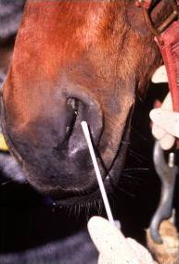

*Horses should be cultured 3 weeks after recovery before leaving quarantine.*

**Heaves**

The respiratory illness commonly known as “heaves” or “broken wind” was until recently termed chronic obstructive pulmonary disease (COPD) in the medical literature. It has recently been renamed recurrent airway obstruction (RAO) to indicate that it is not the same condition as COPD in humans.

RAO is an episodic disease triggered by exposure to poorly-cured, moldy, or dusty feeds; confinement to a stable environment; inadequate stable ventilation; dust; or, in some cases, pollen. The precise cause of the disease is not known, but research suggests that the characteristic inflammation of the small airways results from an allergic response to dust, mold, or other trigger factors.

**Symptoms**

Symptoms of RAO include:

* chronic coughing which may produce mucous
* labored breathing and elevated respiratory rate
* increased abdominal movement during breathing
* flared nostrils while resting
* nasal discharge
* exercise intolerance
* depression

RAO is diagnosed through history (especially of recurrent coughing episodes), physical examination, and bloodwork, and may also include radiography, endoscopy, bronchoalveolar lavage (BAL), and pulmonary function testing.

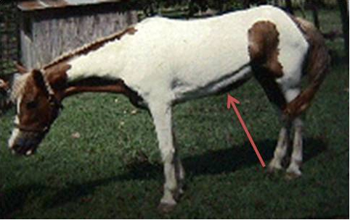

*The arrow in this photo is pointing to a heave line.*

*Source: Photo courtesy of Louisiana State University Equine Health Studies Program.*

**Treatment**

Treatment of RAO often requires management changes in diet and environment, and a clinician may also prescribe medications. The primary goal is to reduce a horse's exposure to organic dust. Hay should be thoroughly soaked or replaced with a dust-free source of fiber, and horses should be kept outdoors as much as possible. Horses with RAO often improve dramatically when removed entirely from an indoor barn environment. Dusty riding rings can also trigger episodes and should be avoided. Corticosteroids may be prescribed to reduce inflammation, and bronchodilators may be given to relieve spasms in the airways. Properly managed, horses with RAO can lead normal lives; but they may remain permanently sensitive to various trigger factors.