#### **Surgical Castration**

Surgical castration is the most certain method of castration because the testicles are removed completely. It is best performed before or after fly season and when calves can be turned into a dry area after the surgery. Surgical castration can be performed on any age calf. It is easier to learn on calves with larger testicles. However, larger and older calves experience more stress and usually bleed more than younger calves.

Good restraint is essential to minimize the risk to calves and operators.

Instruments for surgical castration include the Newberry knife, scalpel (Figure 5) and emasculator.

Figure 5. Scalpel.

**Figure 5**. Scalpel.

#### Technique

1. Wash and clean your hands and surgical equipment using an antiseptic solution. Position yourself at the side or rear of the calf and reach forward between the hind legs.
2. Make sure the scrotum is clean. You may use a mild surface disinfectant (such as iodine) to prepare the incision sites.
3. Make an incision to open the skin of the scrotum using Method A or B.

##### Incision Method A

* Make the incisions on the outside of the lower half of each side of the scrotum (Figure 6).
* If you are right handed, use your left hand to force one testicle to the bottom outside of the scrotum. Once the testicle is in the proper site, hold it there and use a scalpel to make a generous incision over the testicle. The incision may extend into the testicle itself.

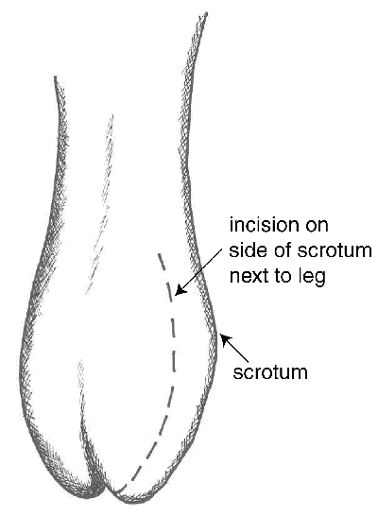

**Figure 6**. Incision method A.

##### Incision Method B

* Use one incision to remove the bottom third of the scrotum. To do this, first push the testicles up toward the body so the lower third of the scrotum is empty.
* Grasp the tip of the scrotum between your thumb and forefinger. Use a sharp scalpel to cut across the scrotum just above your thumb and finger. This cut will completely remove the tip of the scrotum and the testicles will fall down or can be pulled down by reaching up into the open scrotum (Figure 7).
* After making the incision, the remainder of the castration is similar.

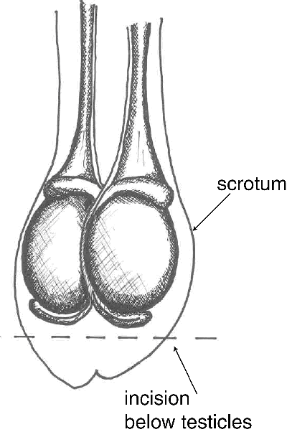

**Figure 7**. Incision method B.

1. Pull the testicle through the incision. It will be covered with a thin, but tough, white membrane. Separate this from the testicle by pulling it away near the tip of the testicle.
2. The remaining tough cord contains the artery, veins and spermatic cord.
3. In older calves, use an emasculator (Figure 8) to crush and cut both blood vessels and spermatic cord at the same time. An emasculator lessens the risk of bleeding. (The emasculator must be placed on the cord correctly in order to crush the cord properly).
4. In younger calves (<3 months), it is common to separate the blood vessels from the vas deferens. Shave through the vas with the scalpel. Gently pull the vessels until the strand breaks.
5. Repeat on the other side.

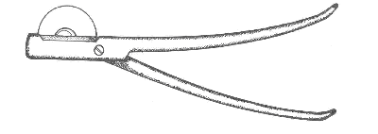

**Figure 8**. Emasculator.

There should not be any tissue hanging from the scrotum once the castration is complete.

If using incision Method B, the castration is complete. If using Method A, once both testicles have been removed, make an incision completely through the bottom half of the median septum to ensure good drainage.

Pain:

* local anaesthesia plus a non-steroidal anti-inflammatory drug eliminate acute pain caused by surgical castration
* acute pain caused by surgical castration is greater than that caused by Burdizzo clamps

Advantages and Disadvantages:

* not bloodless, bleeding is a risk
* sure castration because the testicles are removed
* more time to perform than banding
* risk of infections because of open wounds
* not recommended for castrating bull calves at a feedlot with wet, muddy conditions
* greater reduction in weight gain after castration compared to Burdizzo
* surgical wounds heal more quickly than those from rubber ring
* risk of injury to the surgeon

### Aftercare

* Provide a clean, dry environment for calves after castration.
* Inspect the cattle closely for two weeks after castration. With latex bands, the scrotum should drop off within seven weeks after castration.
* Look for swelling, signs of infection, tetanus and abnormal gait.
* Treat wounds as needed.
* Get professional help when calves show swelling, severe pain or infection.

### Welfare Significance

1. Physical castration causes pain and side effects.
2. Young calves recover quicker and have fewer complications than older calves.
3. Acute pain caused by Burdizzo methods is less than that caused by surgical, rubber-ring or latex-band castration.
4. There is no evidence to show young calves experience less pain than older calves.
5. Local anaesthesia eliminates acute pain caused by rubber-ring or latex-band castration.
6. Local anaesthesia combined with a systemic analgesic, such as the non-steroidal anti-inflammatory drug ketoprofen, eliminates pain caused by Burdizzo or surgical castration.
7. Ketoprofen alone may not eliminate pain-induced behaviour seen during the castration process.
8. Castration of older males without anaesthesia is deemed inhumane and unethical.
9. Use of pain relief is an additional cost for producers. Pain relief may be limited by the availability of drugs for farmers to use and the scarcity of veterinarians in farm animal practice.
10. In Ontario, auxiliaries employed by veterinarians may administer local nerve blocks and castrate cattle less than two months of age while under immediate, direct or indirect supervision of a veterinarian. They may castrate cattle greater than two months of age when under immediate or direct supervision.

### Anaesthesia and Pain Relief

Choices in anaethesia and pain relief include:

* short-acting, local anaesthetic (e.g. lidocaine) with an effect for about 45-90 minutes
  + an epidural injection designed to block pain in the hind quarters and testicular region
  + local injections into the testicles, incision site or spermatic cord
* alpha-2 agonist (xylazine) given alone or in conjunction with a local anaesthetic will provide analgesia for a few hours
* non-steroidal anti-inflammatory drugs (NSAIDS) such as ketoprofen used alone, with local anaesthetics or with xylazine

Reference: <http://www.omafra.gov.on.ca/english/livestock/beef/facts/07-029.htm>