**SUBCONJUCTIVAL FOR ENTROPION (Injection)**

Eyelid disorders may be associated with facial and orbital abnormalities, specific breeds, and adjunct skin diseases, as well as with many systemic diseases.

**CONFORMATIONAL ABNORMALITIES**

**Entropion** is an inversion of all or part of the lid margins that may involve one or both eyelids and the canthi. It is the most frequent inherited eyelid defect in many canine and ovine breeds and may also follow cicatrix formation and severe blepharospasm due to ocular or periocular pain. Inversion of the cilia (or eyelashes) or facial hairs causes further discomfort, conjunctival and corneal irritation, and if protracted, corneal scarring, pigmentation, and possibly ulceration. Early spastic entropion may be reversed if the inciting cause is quickly removed or if pain is alleviated by everting the lid hairs away from the eye with mattress sutures in the lid, by subcutaneous injections (eg, of procaine penicillin) into the lid adjacent to the entropion, or by palpebral nerve blocks. Temporary stay sutures or surgical staples left in place for 2–3 weeks may be used to treat entropion in very young puppies. Established entropion usually requires surgical correction.

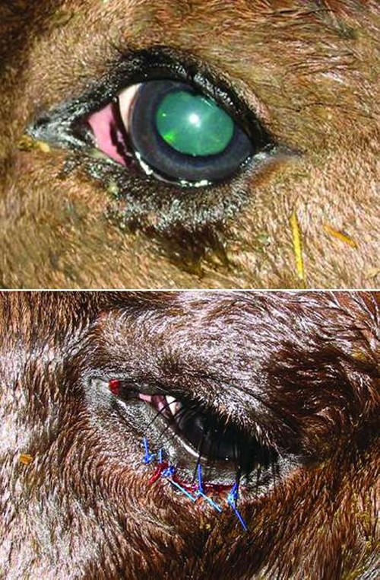

Entropion in a foal before (above) and after (below) treatment.

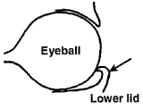 **Entropion**

**Incidence and signs**

* low incidence, more common in some beef breeds
* involves and lower lid more frequently than upper lid
* often bilateral to varying extent
* occasionally congenital, usually acquired
* signs include mild blepharospasm, conjunctivitis, keratitis, and corneal ulceration if not corrected early
* conservative non-surgical treatment often successful e.g. manual eversion, injection of saline into lid, horizontal mattress tacking suture in eyelid

**Indication**

* correction of congenital or acquired inversion of upper or lower lid

**Techniques:**

**Sub- conjunctival Injection**

In some minor cases of entropion, correction can be made by injecting 1-2 mLs of a long-acting, slowly absorbed antibiotic (procaine penicillin) under the skin of the affected lid. This will help distend and roll the eyelid outward into a proper position and help alleviate some of the irritation.

NB: (Sometimes staples, suture, or clips are applied to the skin surface of the problem eyelid. In these cases, the tension of the clip or staple alone may pull the lid into proper placement. In many of the younger animals, these procedures are often all that is needed to correct the problem).

**(Hotz-Celsus procedure)**

* estimate length and width of skin to be resected by pinching to produce approximate skin fold to correct inversion of lid margin
* linear s.c. infiltration of anaesthetic solution parallel and 2 mm distant to lid margin
* scalpel incision to remove ridge of skin previously measured (see Figure 2.6)
* close wound margin with single continuous or mattress absorbable suture e.g. PDS (avoiding need for later removal)
* complications unlikely, though under-correction may necessitate second surgery

See pic below:

