**INSTRUMENTS AND MATERIALS USED IN OCULAR SURGERY LAB**

Metzenbaum scissors: Used to undermine skin and incise extra-ocular muscles and tissues

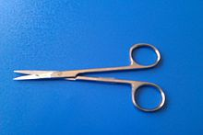

Rochester-Carmalt: Used to clamp optic nerve and rupture blood vessels (hemostasis)

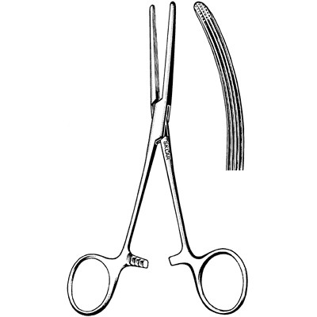

Scalpel blade and handle : Used to make initial incision in skin 5mm to eyelid margin and to sever optic nerve

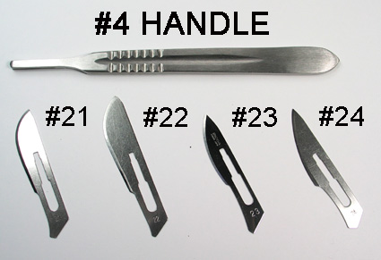

Gauze: Absorbs blood. Used to stuff eye-socket before closure

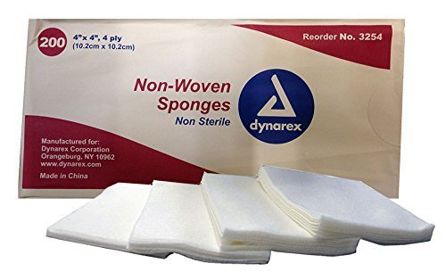

Hypodermic needle: Used to suture eyelid shut and perform final suturing to close skin over socket (optional procedure)

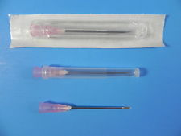

Rat-tooth thumb forceps: Used to hold tissue when suturing or cutting

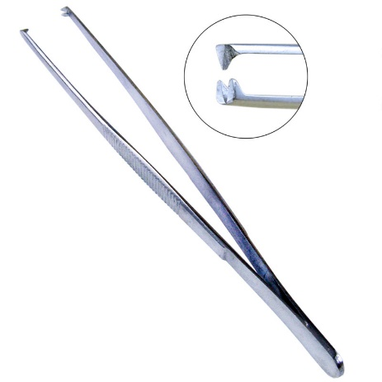

Suture material: Used for the apposition of the eyelids (Transpalpebral enucleation and exenteration) and closure of skin over eyeball socket. Non-absorbable nylon suture was used in lab.

