**DOMESTIC FARM ANIMALS EYE AND RETINAL DIFFERENCES**

Goat: Have a rounder optic disc shape; Optic disc typically in tapetal fundus and may be surrounded by a ring of colour.

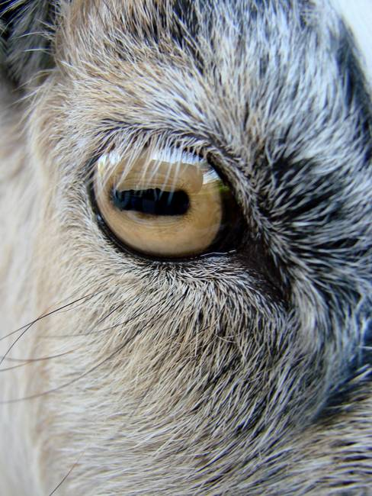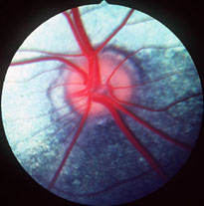

Cattle: Optic disc oval and typically located within the non-tapetum. Superior artery and vein may twist on each other.

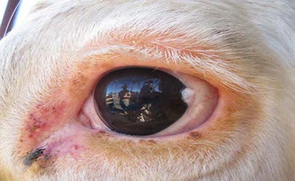 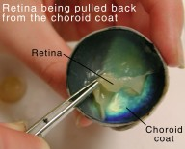

Sheep: Similar to that of cattle

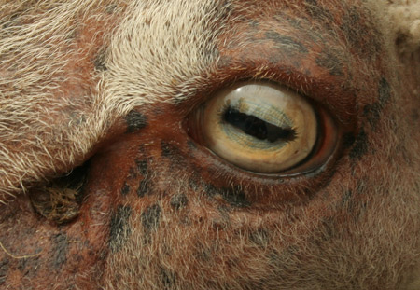 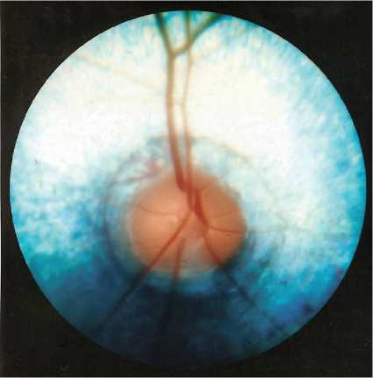

Pig: No tapetum; optic disc horizontal and margins sharply defined

