**HOOF SURGERY AND TRIMMING EQUIPMENT/INSTRUMENTS:**

Hoof Trimming:

Merlin Electronic Hoof knife: Used to remove excess hoof from non-weight bearing hoof surface. Can also be used to cut around hoof ulcers.

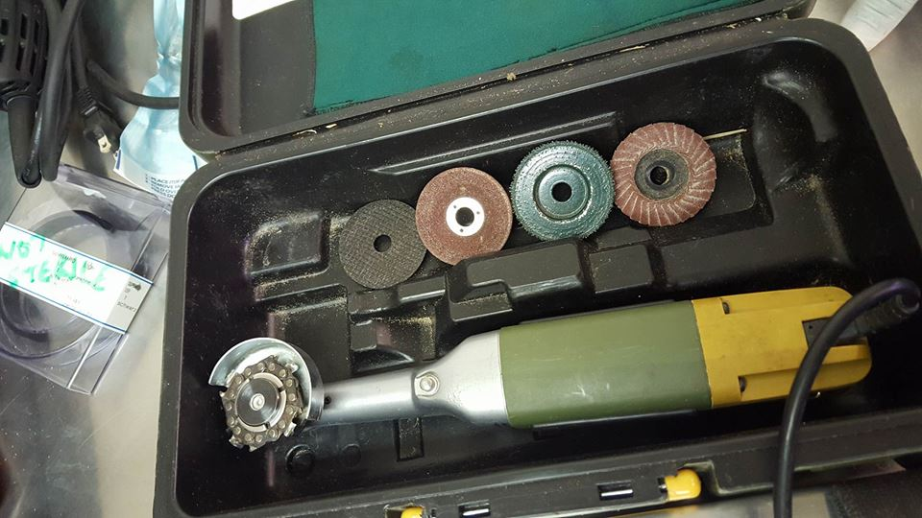

Electronic Hoof Cutter: Used to cut off excess hoof keratinization. A much more powerful tool compared to hoof grinder. Pieces of hoof taken off in larger pieces. Great care needs to be taken when using this device. Used on weight bearing surface to create an even appearance.

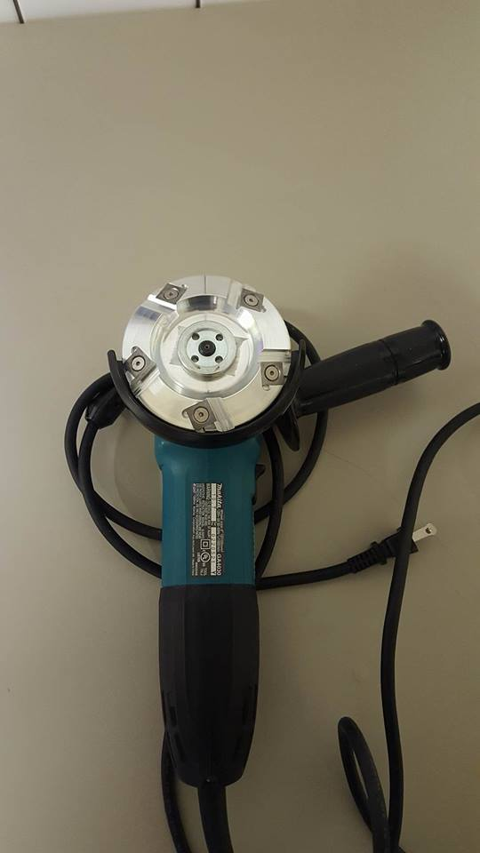

Hoof grinding disc attachment of hoof grinder used to grind excess hoof keratinization. The Hoof grinder files down weight bearing surfaces of the hoof to make them even and smooth.

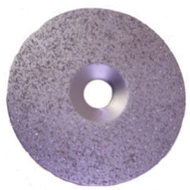

Hoof Knife: Used to cut away excess hoof material. Sharpe edge can also dig away unwanted material inside hoof crevices. Available in left-handed and right-handed options.

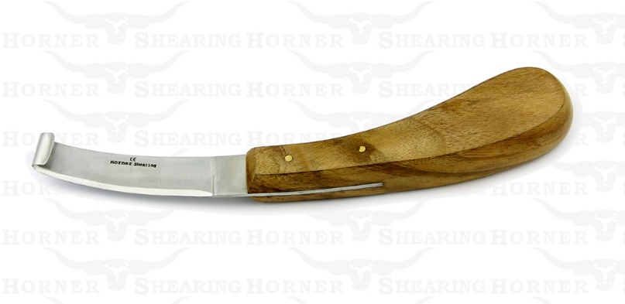

Hoof Rasp: Used to file down hoof surface. Manual version of hoof grinder.

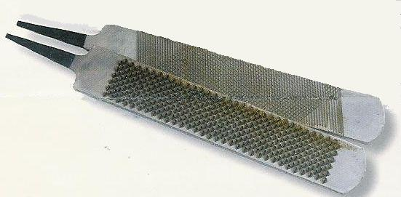

Hoof Nipper: Used to clip off excess hoof at cranial margin.

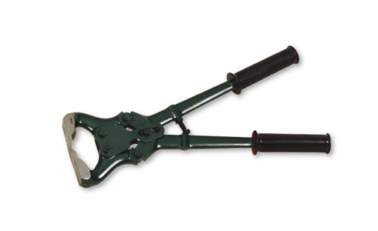

Hoof Tester: Used to test for hoof lameness and pain.

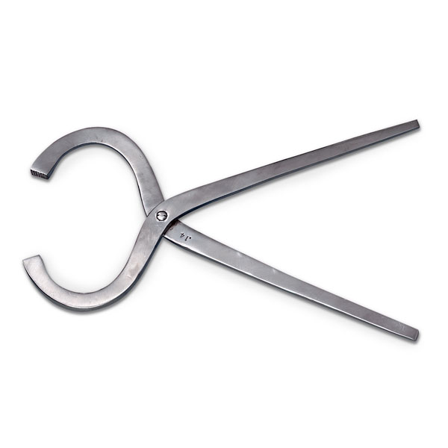

Hoof Trimmer: Used to trim off excess curved hoof at medial and lateral hoof margins. Used mostly in small ruminants.

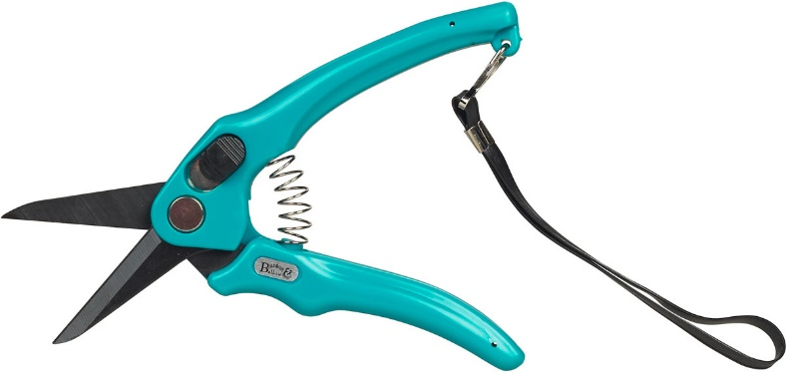

Hoof Pick: Used to remove debris, mud, rocks, from the hooves before examining them.

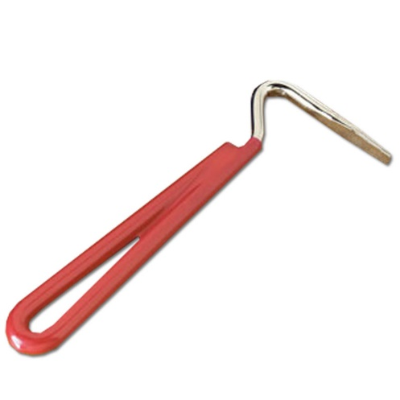

Hoof Protection:

Cow Boots: to protect hoof that has lost either part or all of hoof

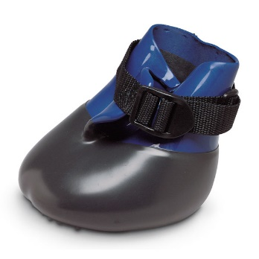

Hoof Blocks: to assist cow that has injured a hoof by protecting the injured hoof.

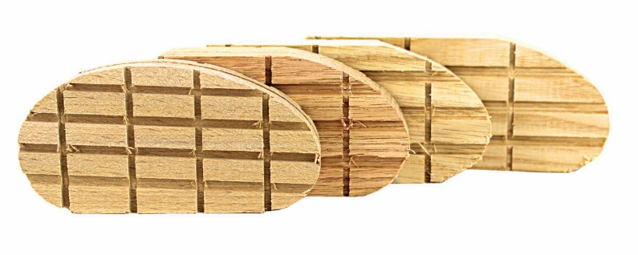

Hoof Surgery

Scalpel blade and handle: Used to make incisions in hoof

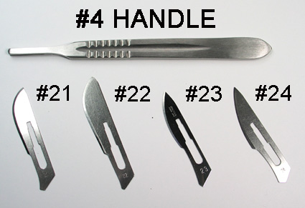

Gigli wire: Used to cut away bone in hoof, particularly in digit amputation

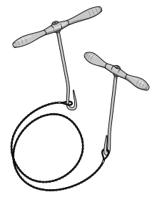

Hemostatic forcep: Used to isolate deep digital flexor tendon for tenotomy.

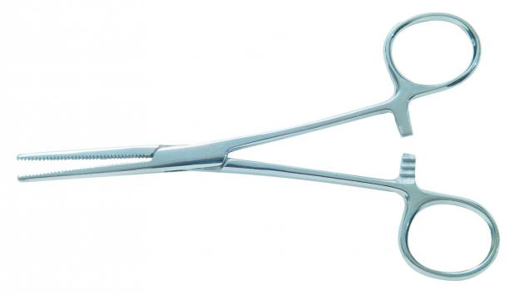

Rat-tooth forcep: Used to hold skin, tissue for surgery

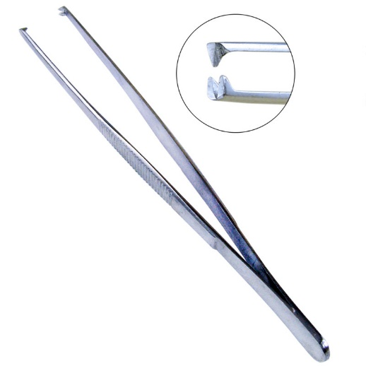

Buhner Needle and umbilical tape: For hoof surgery, the Buhner needle is used to pass the umbilical tape through the digit amputation incision made. The umbilical tape is then tied. Used to facilitate drainage of the limb. These equipment are usually used for vaginal prolapse correction in cows.

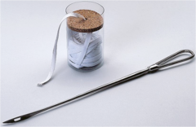

Suture Material and needle : Used to close wound incisions to facilitate wound closure by primary intention.

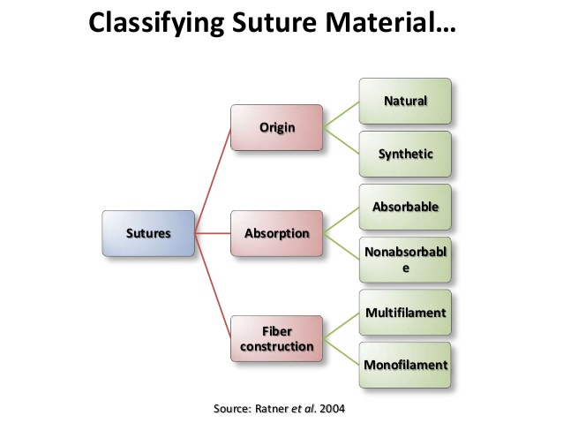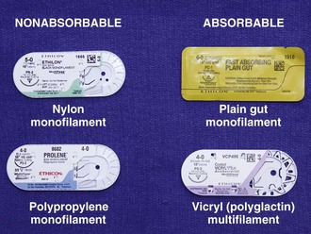

Hypodermic Needle: Can be used instead of suture needle to stitch incision site. Used as a cannula with suture material.

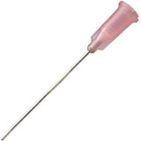

Bandaging material:

Gauze: Soaks up excess blood and fluid-Used in primary bandage layer.

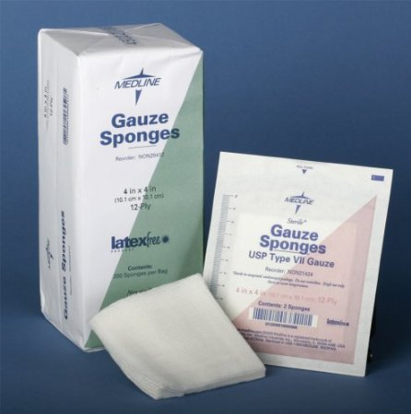

Conforming bandage: Used to keep gauze and cotton attached to wound.

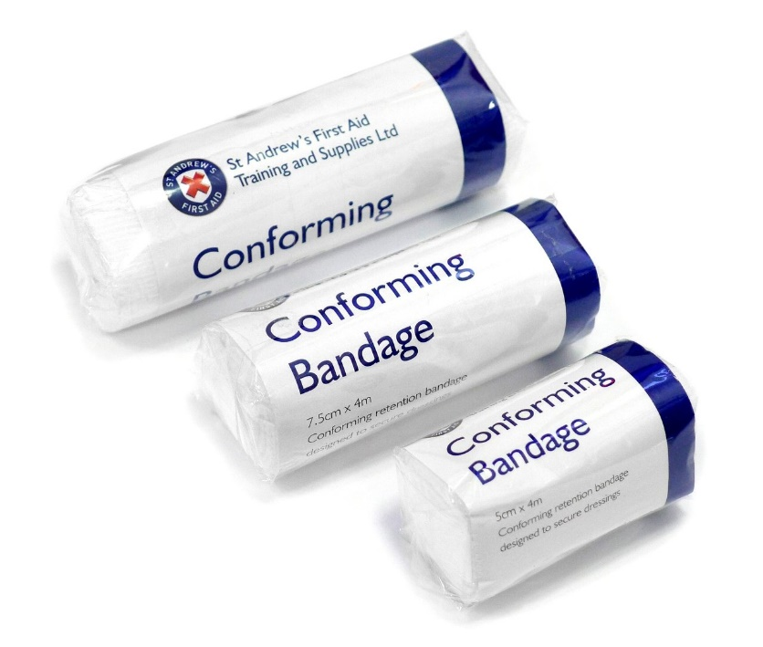

Cotton Roll: Provides padding for wound. Secondary layer

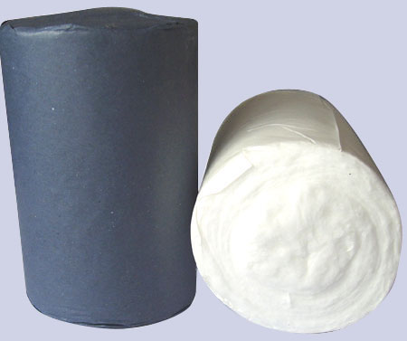

Vet wrap: Used to keep entire bandage together-Tertiary layer

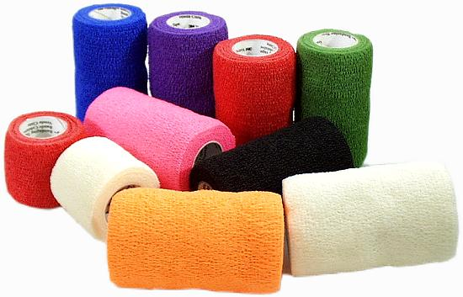

Bandage Tape: Used to secure entire bandage

