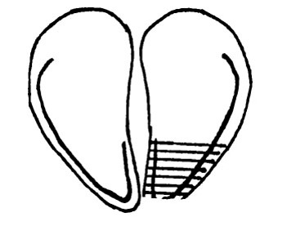**Hoof Trimming Basic Procedure**

1. Use hoof knife to flatten walking surface of the toe.  The walking surface is where the white line starts on the axial part of the hoof.

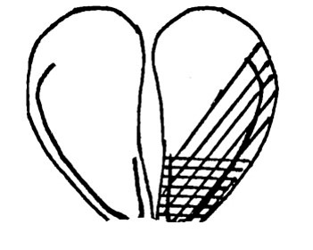

2. Use hoof knife to blend-in the lateral aspect of the sole over the white line.  Remember to keep it as flat as possible. Try to stay away from the heel area.  It is important to conserve as much heel as possible.

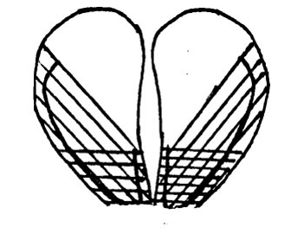

3. Now that a blueprint has been made with the first claw trimmed, use this blueprint to start trimming the opposite claw. Again, tip the toe off at 3 inches.

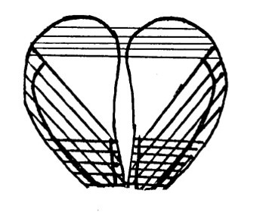

4. Balance the heels. Make sure not to over trim and remove too much heel.

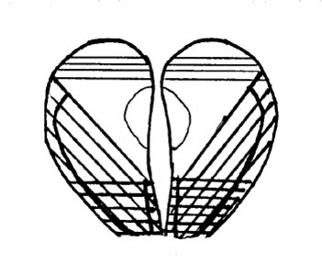

5. Open the toes by trimming away sole near the interdigital space of the heel. Make sure not to remove too much sole by concaving a wide area.