**COMMON TEAT/UDDER ABNORMALITIES/INJURIES**

**Congenital anomalies:**

**1- Absence of the udder:**

Is exceedingly rare and only met with in cases of hermaphrodism.

**2- Supernumarary glands:**

Occurs only in multi - parous animals.

**3- Absence of the teat.**

**1-   Supernumerary teats**

This may occur and can be present anywhere on the udder but are most frequently seen posterior to the last two normally - placed teats. These additional teats may or may not have adjacent glandular tissue that will become functional. If there is a glandular tissue that has a functional potential, it will atrophy if not milked.

**Treatment-** It is better to amputate the accessory teats when that animal is a young heifer, before the gland becomes active. It is essential that care must be taken to assure that only the supernumerary teats are removed and not those which are normally-placed. It may be desirable to remove the supernumerary teats for cosmetic reasons or because some may be so close to normally placed teats that they interfere with milking procedures.

**Procedure-**  Infiltrate the base of the teat by means of a local anesthetic. An elliptical incision is made including the necessary teat. Crush the tissue and the skin is then sutured in an interrupted pattern.

**2- Contracted sphincter or teat orifice "hard milker"**

The condition may be congenital in origin or may be acquired as a result of trauma to the end of the teat and resulting scar formation. There is a small stream of milk, and the stenotic teat orifice results in prolonged milking time. There may be loss of milk due to incomplete milking or trauma to the teat due to attempts to obtain more rapidly by strenuous milking methods.

**Treatment-** Local infiltration anesthesia or instillation of a local anesthetic into the teat canal will provide anesthesia. The orifice should be cleansed, antiseptic applied, and the orifice enlarged without damaging the sphincter muscle. The enlarging procedure may be accomplished by the inserting of a Lichty teat knife or a teat bistoury. The opening in the sphincter is maintained at the desired size by inserting a Larson teat tube and leaving it in place for 5 - 7 days. Milking is accomplished by removing the cap of the tube.

**3- Enlarged teat orifice "Free Milker" or (Leaker):**

This condition is due to a relaxed or a traumatized sphincter. Milk leaks from the teat at times other than milking and results in milk loss.

**Treatment-** The condition may be helped by injecting minute amounts of sterile mineral oil or Lugol's solution around the orifice to reduce its size to the desired effect. This may have to be done more than once to obtain the optimal size for milk flow. If it is overcorrected and result in stenosis, handle as a contracted sphincter or orifice.

**4- Occlusion of the teat orifice:**

This is a congenital anomaly characterized by the occlusion of the teat orifice; it may be acquired as a result of trauma at the teat orifice that results in healing with occlusion.

**Treatment-** A small amount of local anesthetic is injected into the area. Insert a septic hypodermic needle where the opening should be located. Insert the needle into the teat canal until milk flows out; then withdraw the needle and enlarge the opening as described for contracted sphincter.

**Acquired surgical affections:**

**Udder and Teat Wounds**

Lacerations of teats and or udder that do not peneterate suffeciently to allow milk to flow from the wound may be handled as any other laceration, keeping in mind that large amounts of scar tissue or flaps of skin may interfere with milking or have an undesirable cosmetic effect. Lacerations or trauma in the area of the teat sphincter may lead to stenosis. If there are flaps of skin that protrude, they should be sutured or removed. Portions of nonviable skin should be trimmed back to conform to the normal contour of the teat.

Sutured wounds may be protected by a wrap of an adhesive elastic bandage such as Elastoplast or Elasticone. The insertion of a Larson-type teat tube to facilitate milking is of value to the person milking as well as to the animal because of zzthe pain associated with the trauma. Replacing the cap on the tube after milking will reduce the possibility of mastitis.

**Teat Fistula**

The term, teat fistula (milk fistula), refers to an opening in the wall of the teat, connecting the exterior to the pre-existing channel, the teat canal is characterized by persistent outflow of milk. Such a fistula may be congenital or acquired. It is mostly acquired as a result of a penetrating wound that extends to the teat canal or cistern and fails to heal completely (by second intention) because of the continuous drainage of milk. Fistulae will vary in size from that one which is so tiny, it is difficult to locate to large ones through which the mucous membrane may be seen.

**Treatment:**1. Anesthetically block the teat.  
2. Make a full elliptical incision along the wound margin.  
3. Debride necrotic, purulent and fibrous tissue.  
4. Close the 3 layers as with a teat laceration.  
5. If the cow is lactating, insert an indwelling catheter to prevent pressure breakdown of the wound.

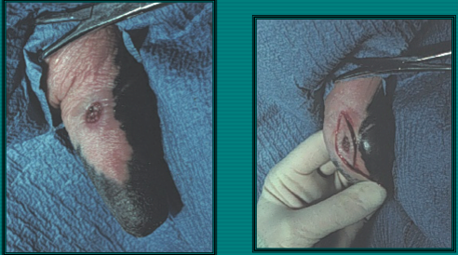

**Haematoma Of The Udder**

Haematoma of the udder is relatively common in cattle having pendulous udder as a result of contusion and rupture of a subcutaneous blood vessel. The condition is characterized by its sudden onset . A septic puncturing the swelling may be necessary to confirm diagnosis, but this is not preferable. If the haematoma is subcutaneous, it can be palpated out; if parenchymatus it cannot be detected by visual examination and the diagnosis in such cases depends upon the sudden onset of bloody milk.

**Treatment-** Small haematomas of the udder should never be opened immediately. Opening the haematoma is after a week post occurrence. The blood clot is removed and the cavity is painted with tincture of iodine. The cavity is then packed tightly to guard against further bleeding.

Large haematomas in front of the udder should not be opened till the blood is clotted, usually after 10 days and proceed as before.

**Lactiferous Calculi (Milk Stones)**

Milk stones which are found in the udder may result from accumulation of lime salts of milk over a point of crystallization. The latter may be desquamated epithelium. Sometimes, these calculi are freely movable in the teat canal if their sizes relatively smaller than the diameter of the canal. When being larger in size, they obstruct the lumen of the teat canal.

**Treatment**- If the calculi are of small size, they can be removed by manipulation during milking. Larger calculi obstructing the teat canal can be crushed by means of alligator forceps. In other cases of milk stones, it may be necessary to enlarge the opening at the end of the teat by cutting through the sphincter of the teat canal one or more times.

**Abscess of the Udder**

Abscesses of the udder may develop beneath the skin as a result of infection of a haematoma. It may occur in the parenchyma of the udder as a result of chronic mastitis especially in goats. It may also occur as a result of supramammary lymphadenitis. Generally, abscess formations most commonly occurs secondary to the traumatic wound.

**Treatment-** Following confirmation of diagnosis, the treatment should be done on the general principles for treatment of abscesses. If there are multiple abscesses, mastectomy (partial or total) according to the involvement of one quarter or more on  the entire udder, is then indicated. If there is involvement of the supramammary lymph node( lymphadenitis) it should be extirpated.

**Gangrenous Mastitis**

A result of certain bacterial infections, e.g. some strains of Staph aureus. It is an acute or peracute condition involving 1 or more quarters of the udder, which occurs infrequently but the mortality is usually high. The result is a patchy blue discolouration, coldness of the tissue, and leaking of blood serum through the skin.

**Treatment:**

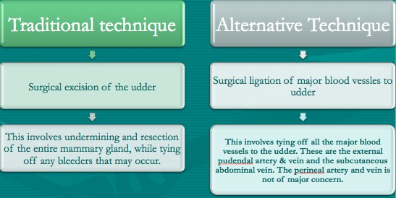

The traditional technique, i.e. amputation has been somewhat left behind due to the high occurrence of shock and death.