Udder and Teat Surgery Specialty Instruments

Cornell Teat Curette
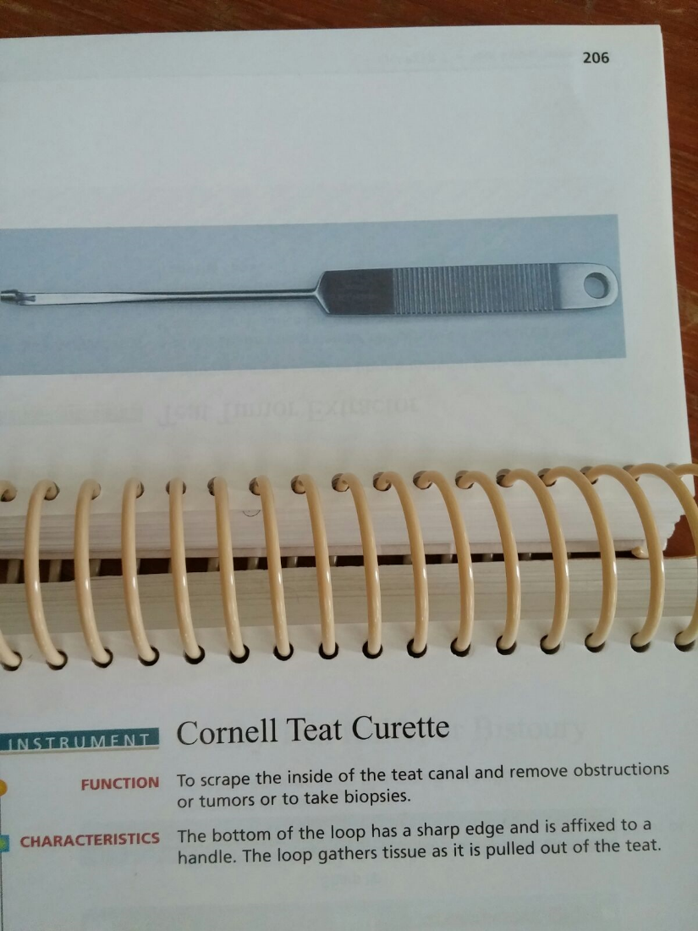

Lichty Teat Knife or Bistoury
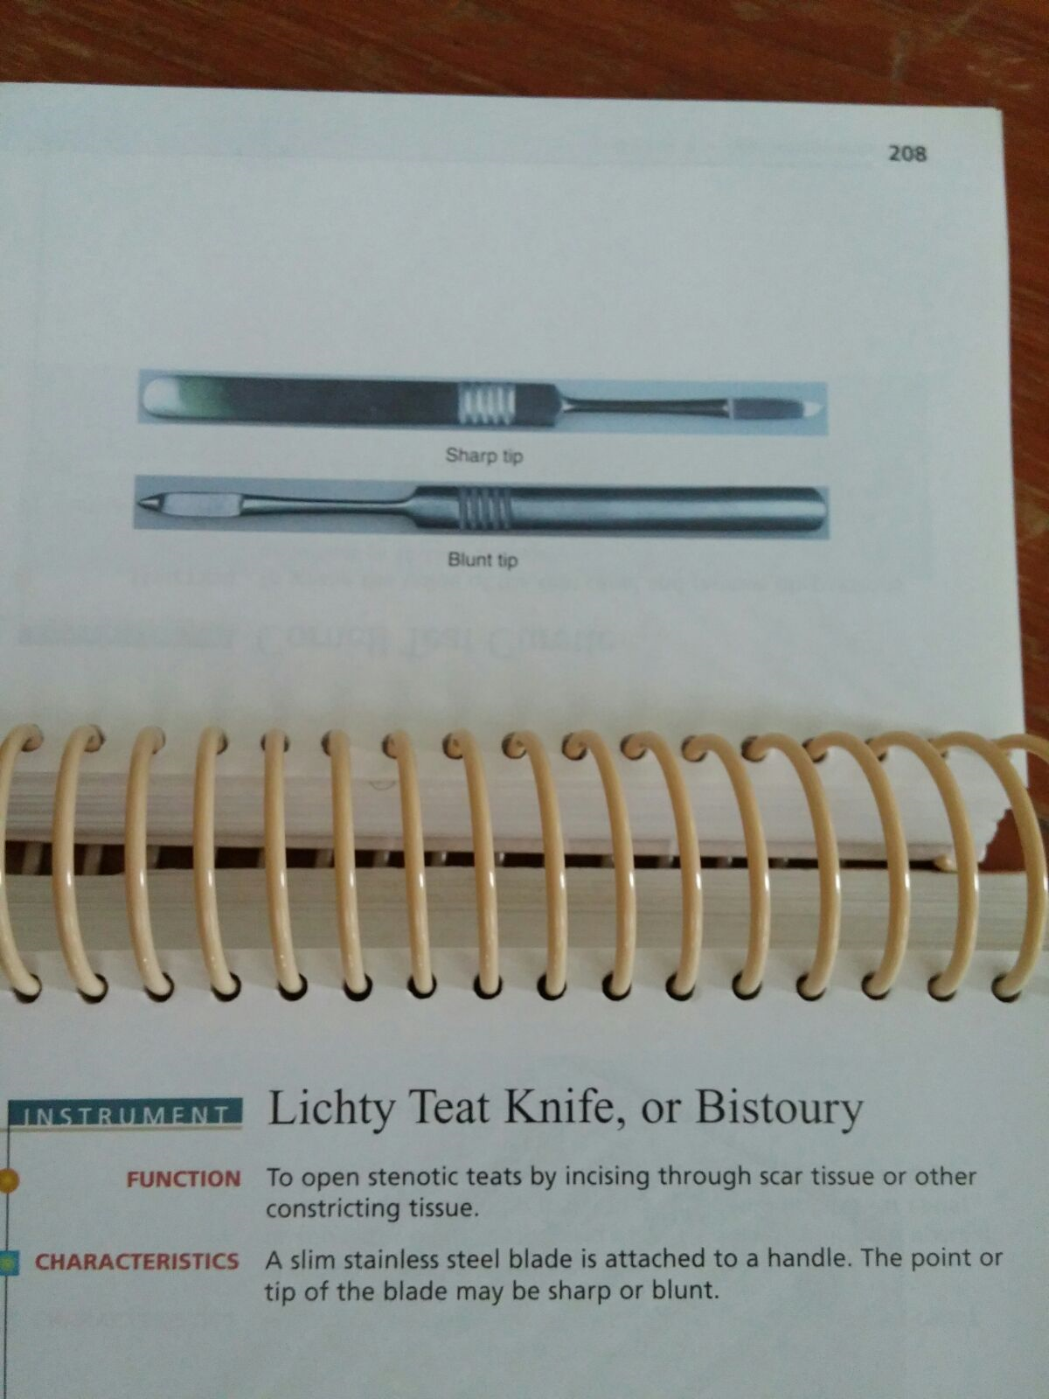

Milking Tubes
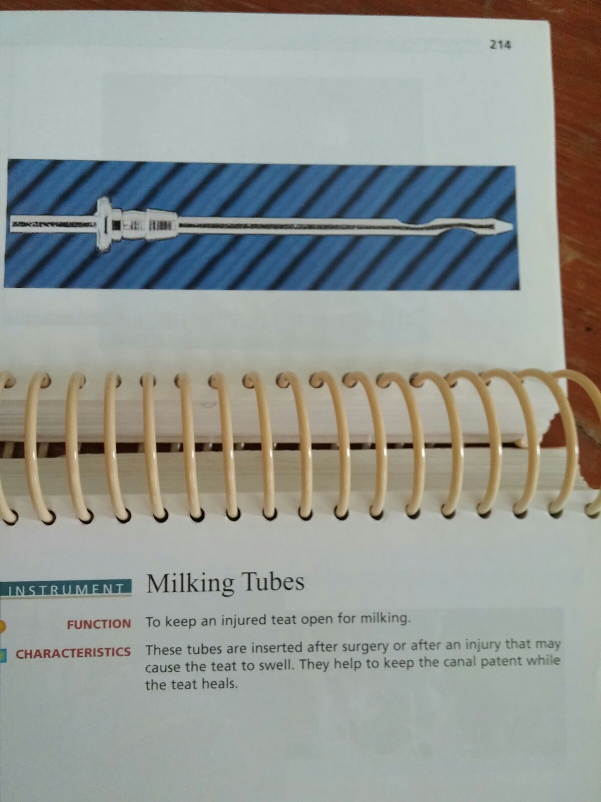

Teat Dilator
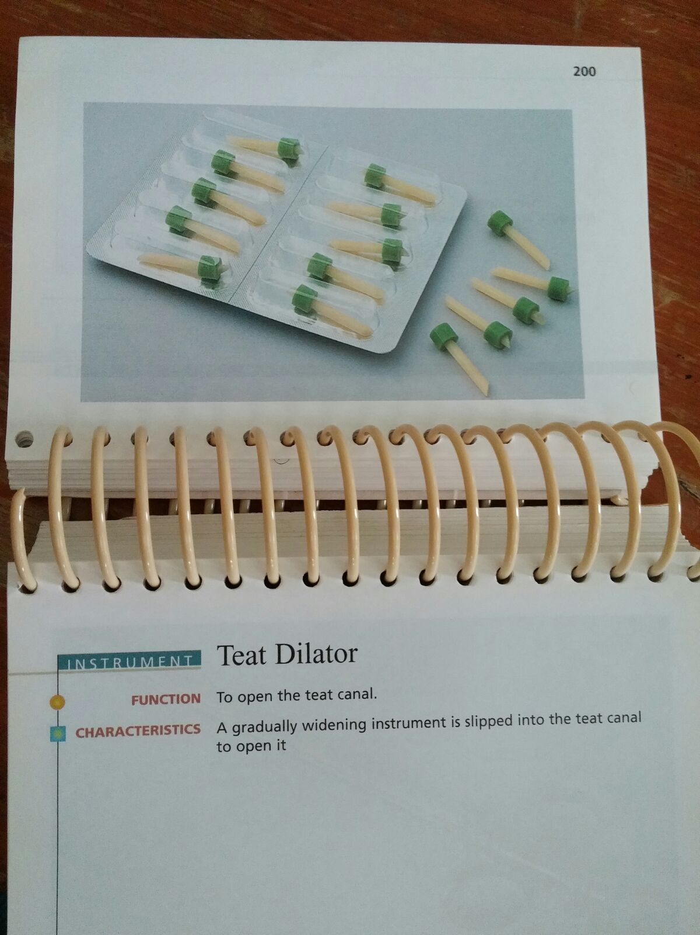
Teat Slitter
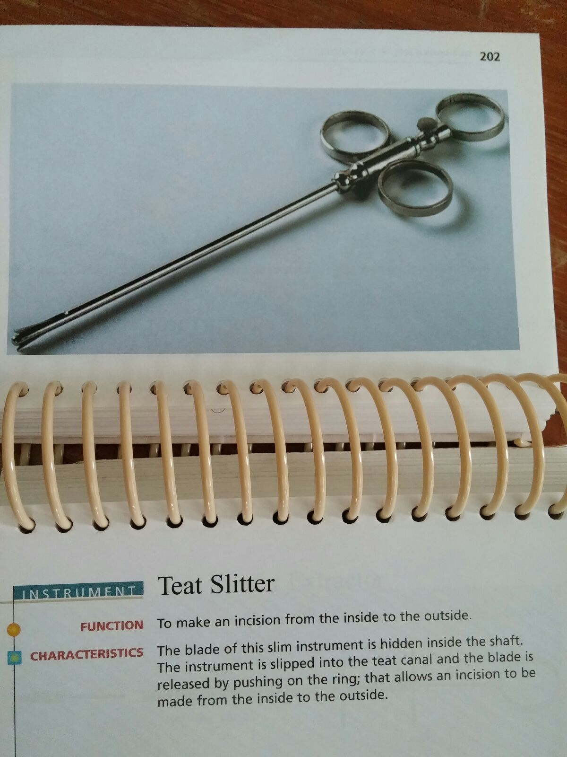

Hug’s Teat Tumor Extractor
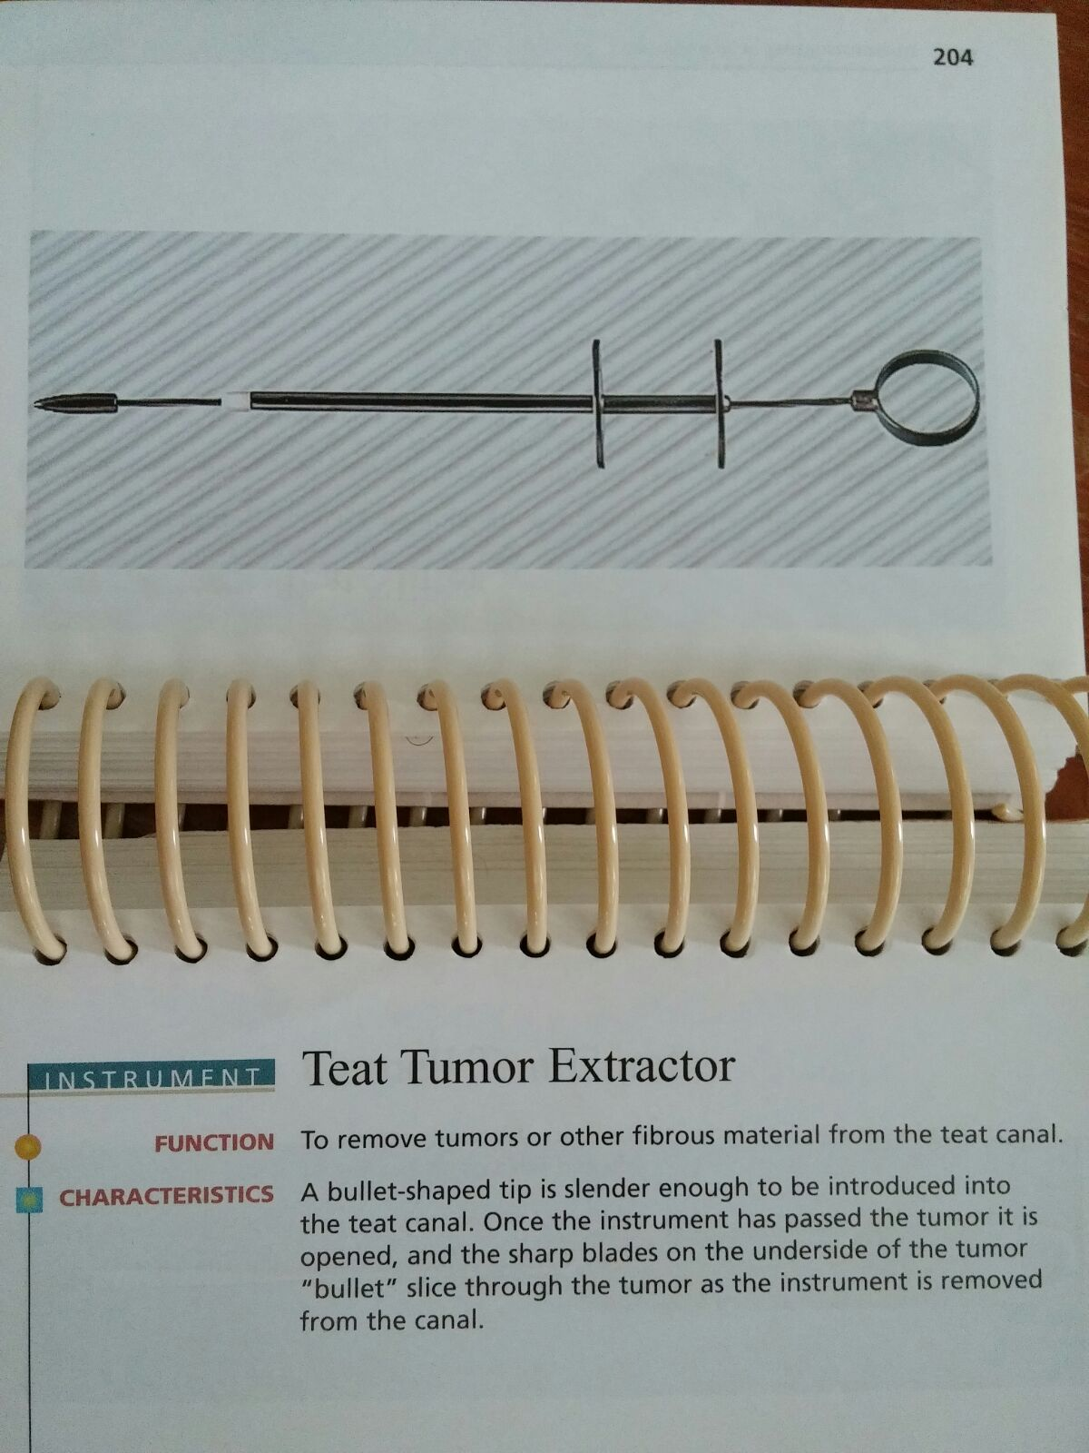

Udder Infusion Cannula
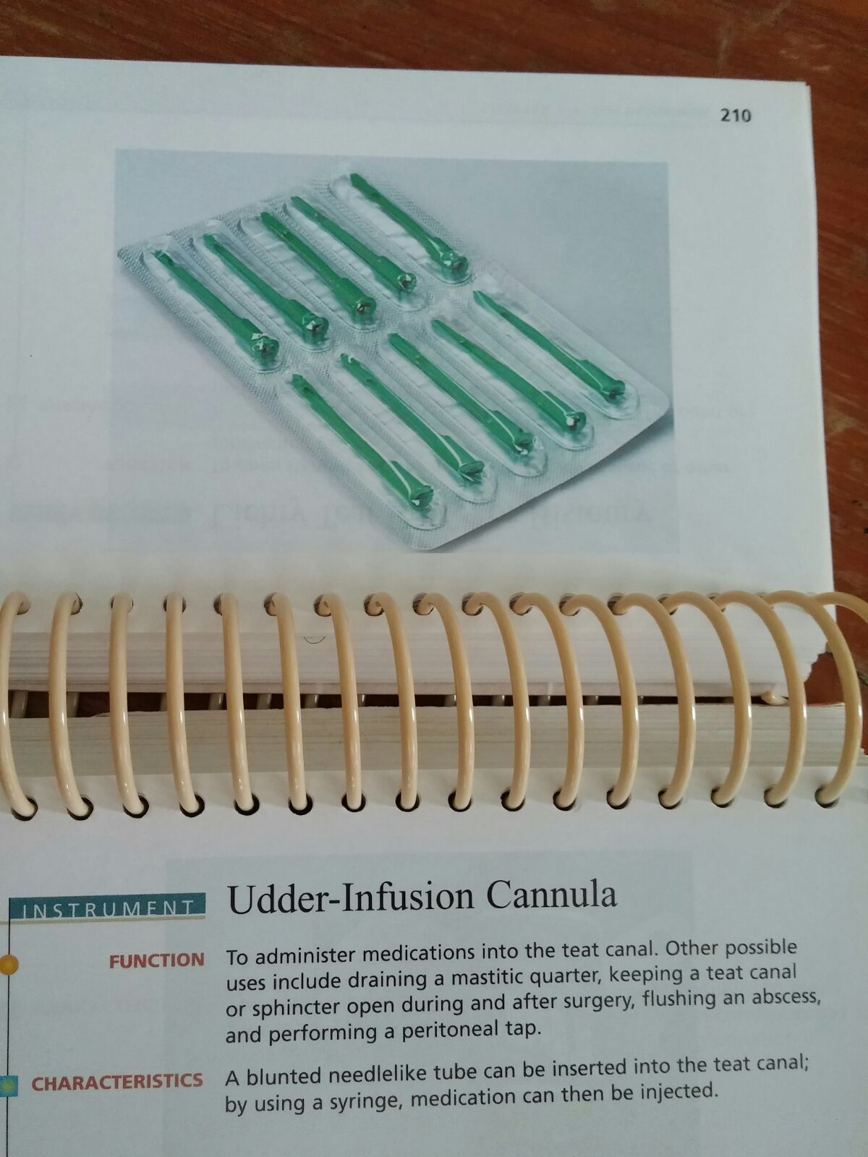

Udder Support
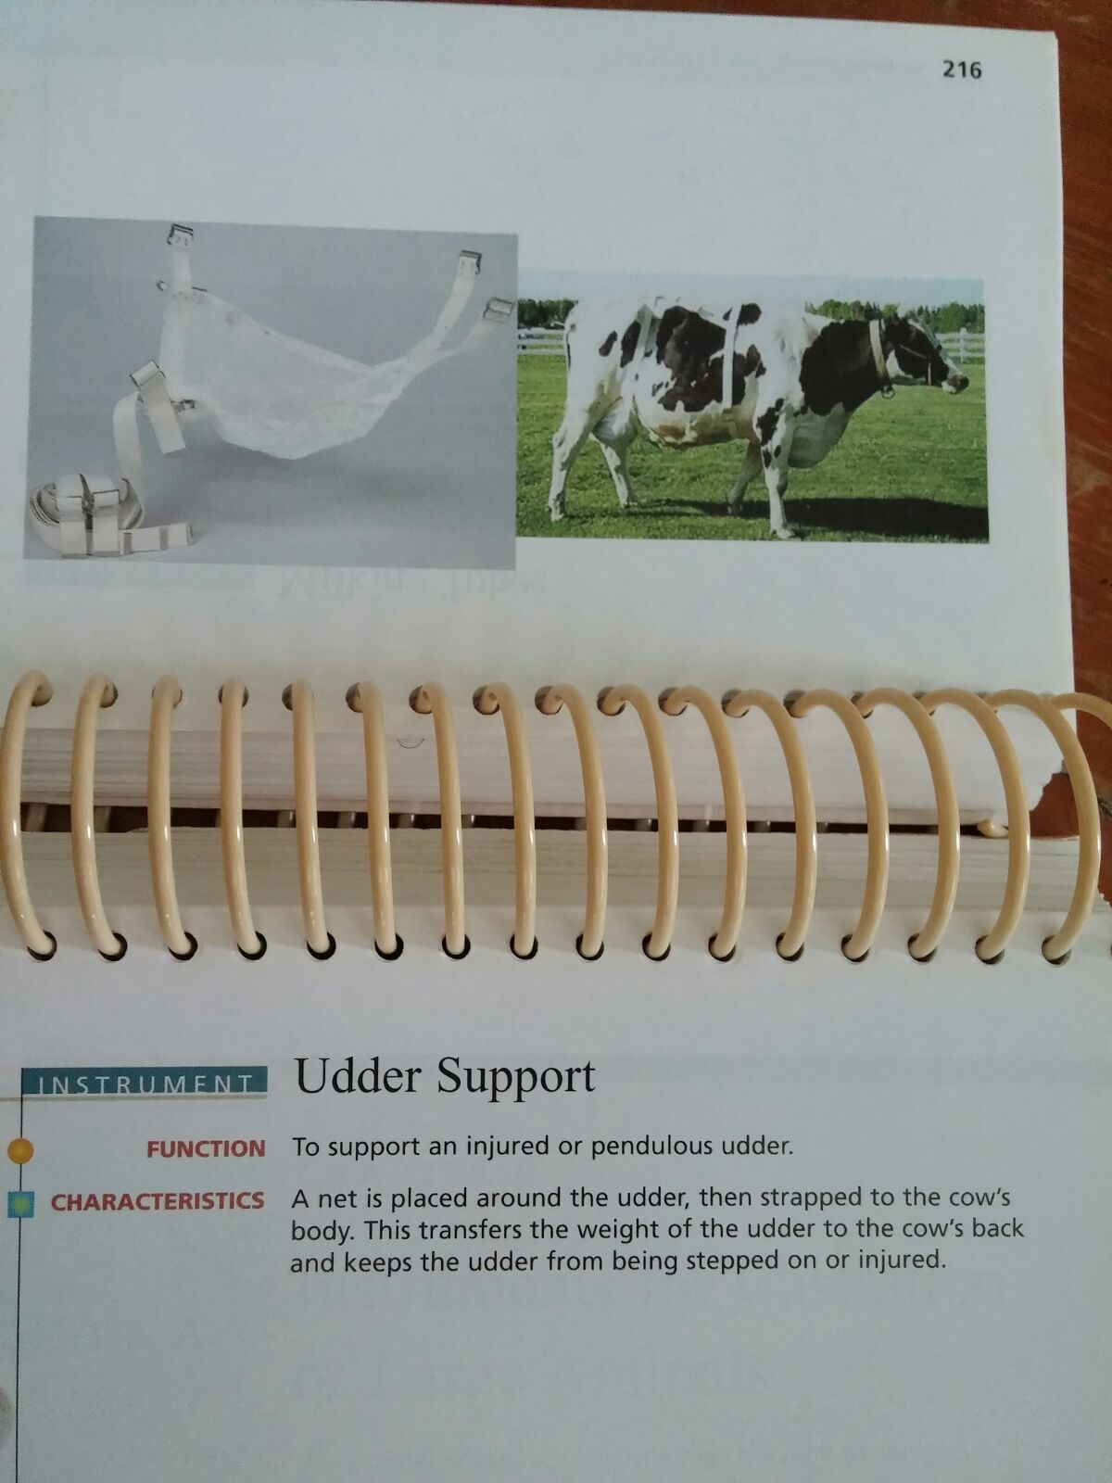

California Mastitis Test Kit
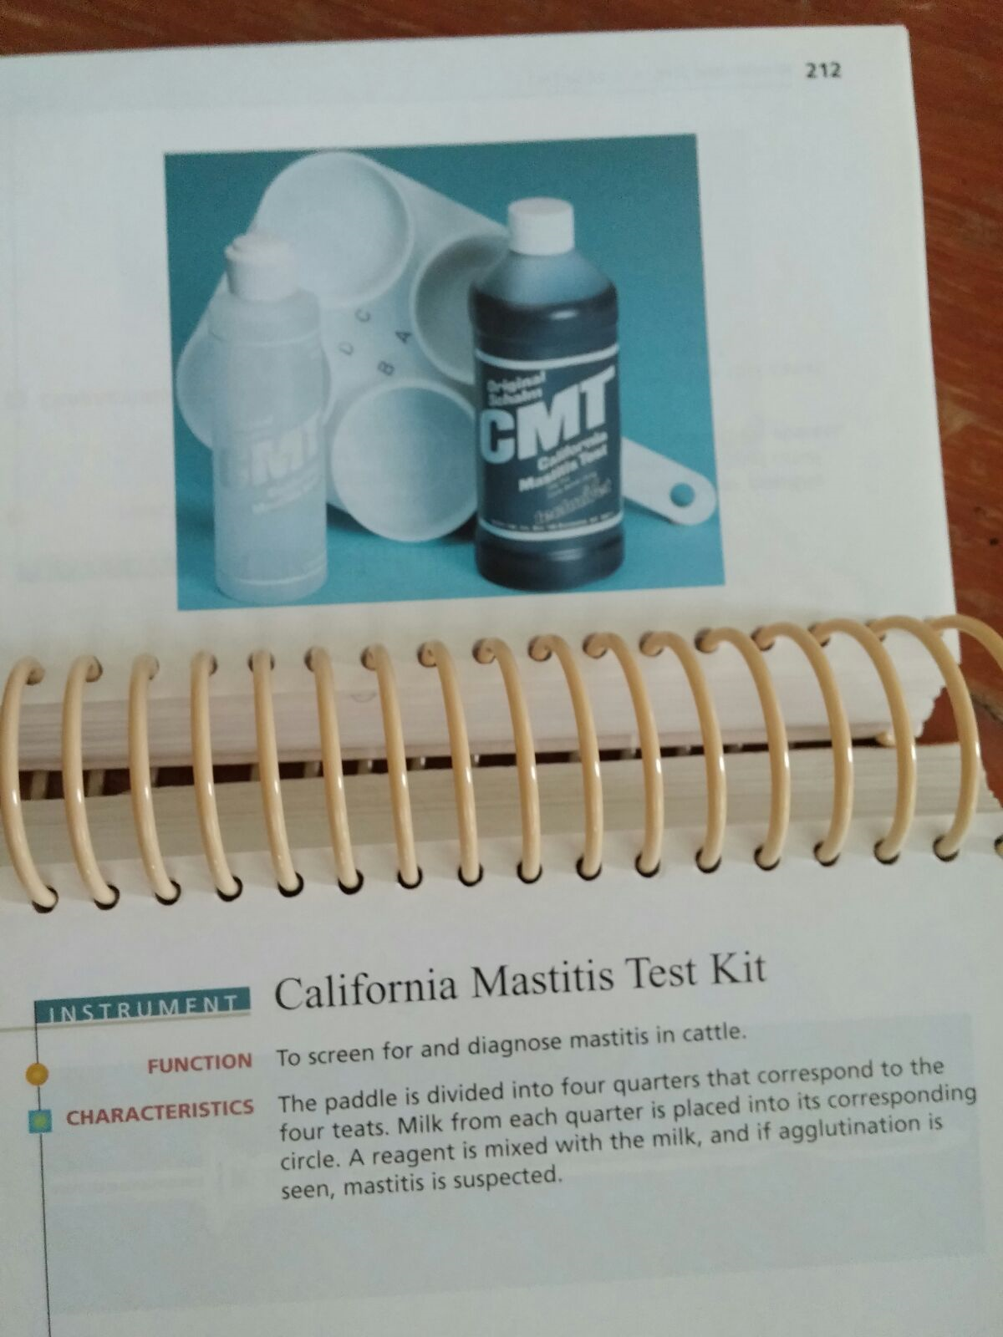

All of the above photos were taken from Veterinary Instruments and Equiptment- A Pocket Guide

Additional Instruments Useful In Teat Surgeries

Doyer Clamp- typically used for intestines but can be useful for clamping the teat for procedures such as teat infusions.
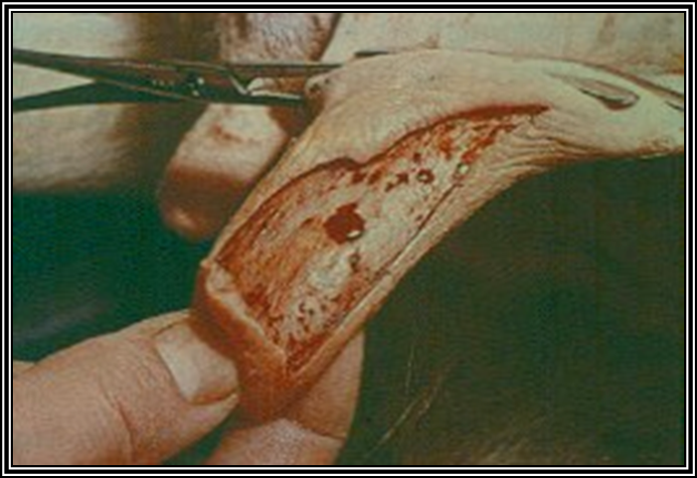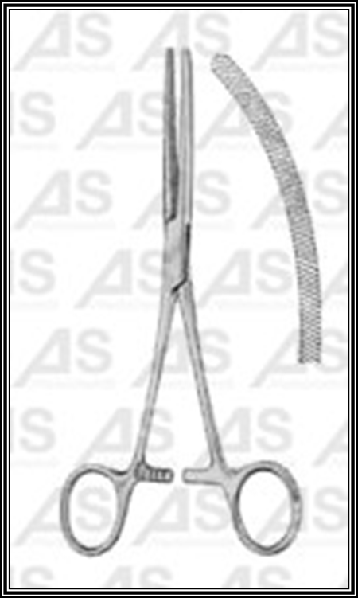
Larson’s Self Retaining Tube- used as a cannula that can be opened and closed when needed
