**INTRA-OP EXPLORATORY LAPAROTOMY**

* The surgeon is first properly gowned and draped using sterile technique after which the necessary surgical tools are laid out in a sequential order for the surgery.
* The sheep is draped at the last rib and at the level of the tuber coxae, to the transverse

processes and then 25 cm from that

* A sharp skin incision is made midway between the last rib and the tuber coxae about 25 cm in length. (Pic below)

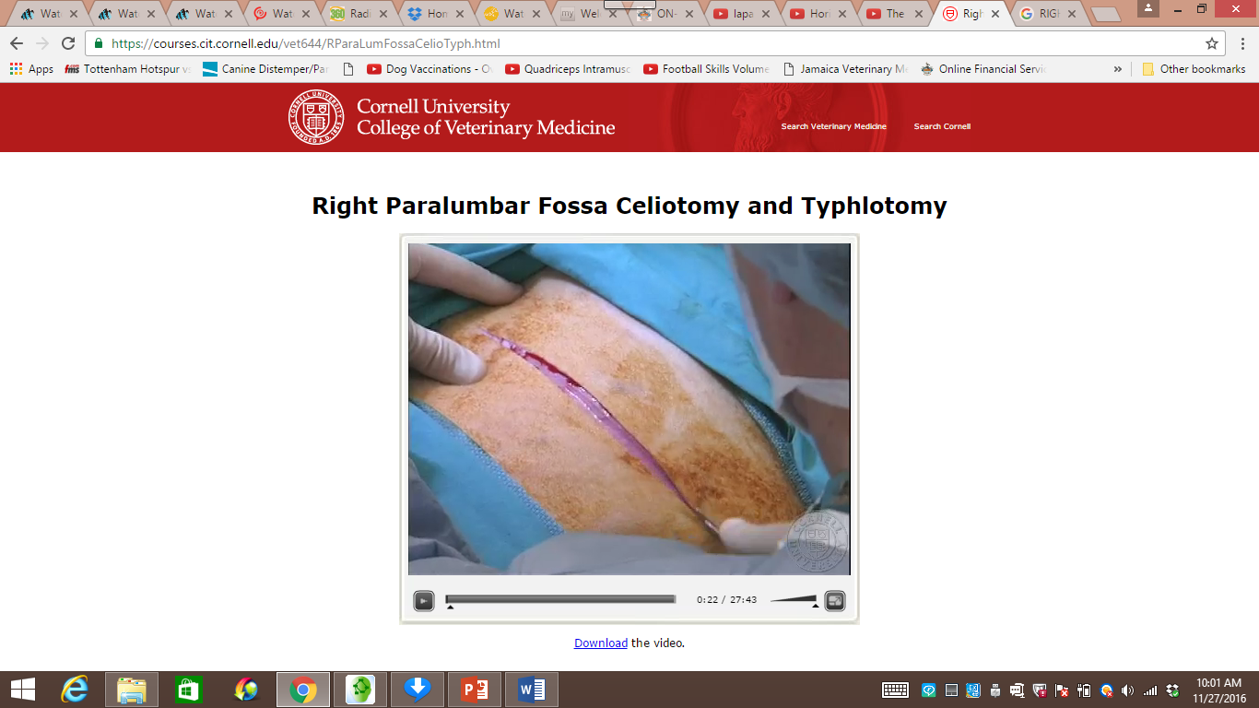

* Sheep have a cutaneous trunci muscle which is the superficial layer of muscle. This is incised carefully usually a forceps as a guide so that no deeper tissues are incised. (Pic below)

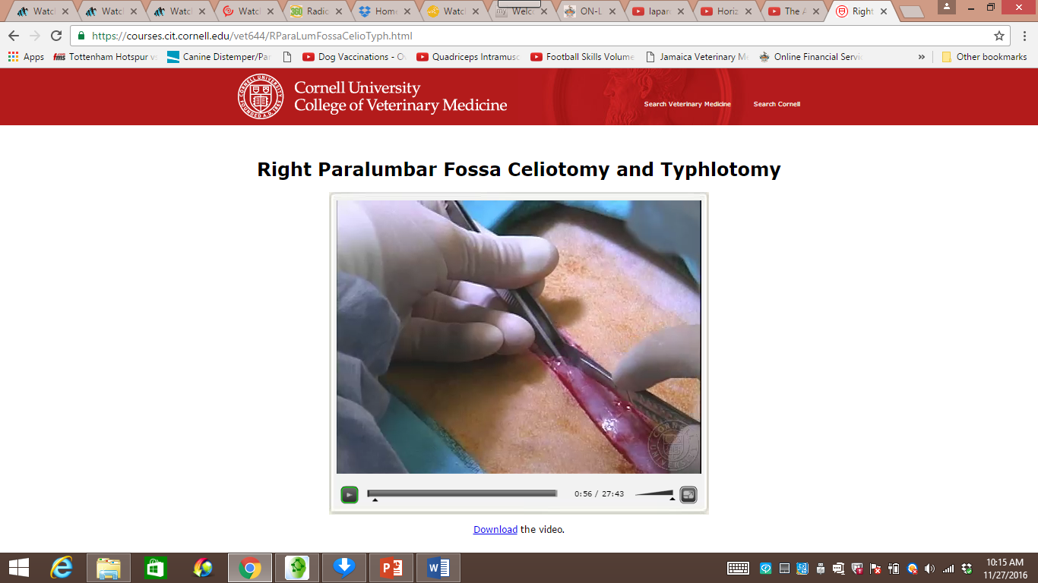

* Vessels that cross the surgical field can be ligated or an incision can be made after which they can be clamped using a hemostat to stop the bleeding.
* The incision is continued to the external abdominal oblique where the fibers run in a caudo-ventral direction.
* The next layer is the internal abdominal oblique layer where the fibers run in a cranio-ventral direction. This is incised and when we are all the way through the internal abdominal oblique, the incision is extended with scissors. (Pic below)

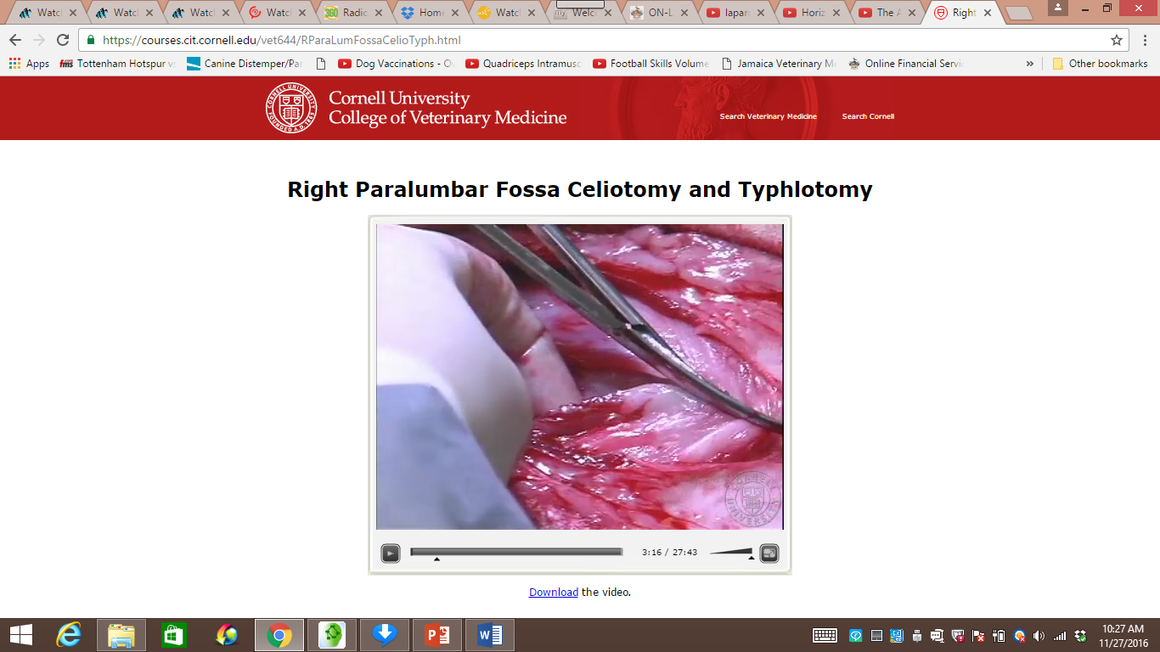

* The next layer is the transverse abdominus where the fibers run transversely. This muscle is tented with a forceps and is teased open with the scissors where the perineum is open incised as well and should feel very slippery when swept with one’s finger. The tenting is done to ensure we do not inadvertently penetrate any structures in the abdomen. (Pic below)

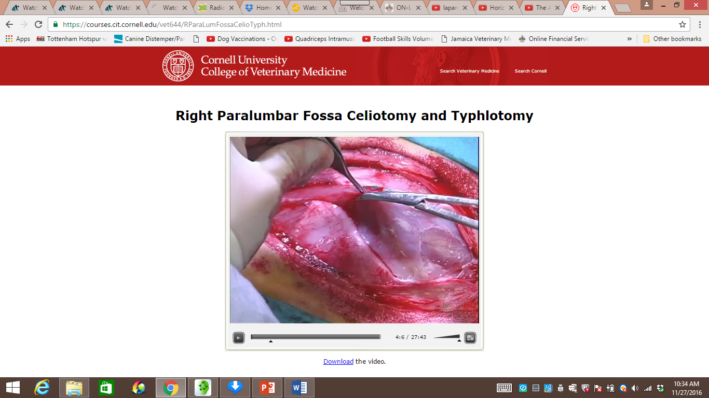

* The incision is extended with scissors, to give sufficient access to the abdomen
* It is then palpated in-situ for any abnormal findings. The lesser and greater omentum is then identified, along with the site for an omentopexy known as the “sow’s ears” (should one be performed). (Pic below)

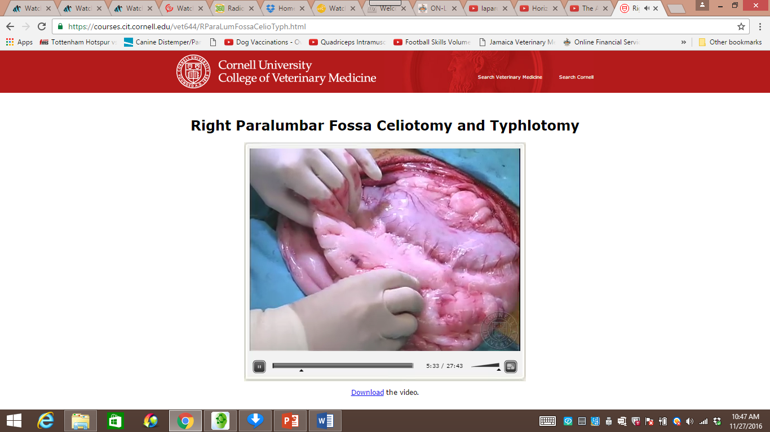

* Impervious sleeves can be put on so that the abdominal area stays dry during exploration. Other structures which can be palpated include the uterus, liver, kidneys, spleen and intestinal tract. Once this is accomplished, viscera can be exteriorized. The cecum is delivered, noting the blind end. (Pic below)

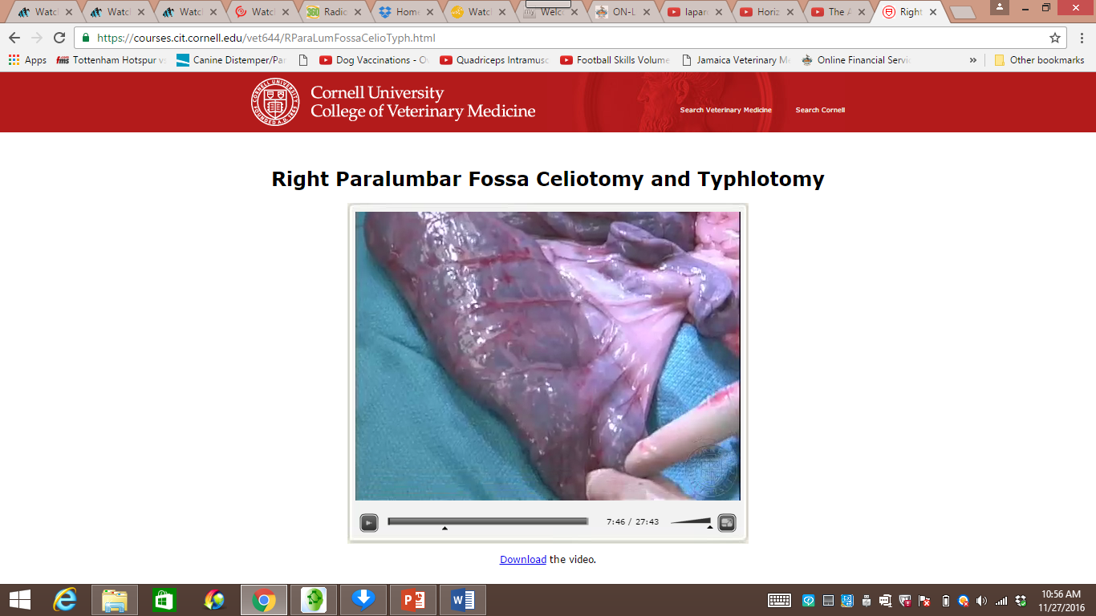

* The rest of the intestines can be exteriorized showing the majority of the small intestines, spiral colon (Pic below) which is laid out and checked for any abnormalities.

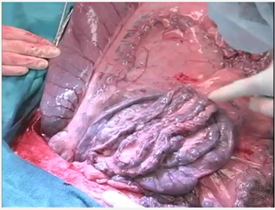

* The blood supply to the ruminant intestinal tract should also be identified, main ones being the cranial mesenteric artery and the co-lateral branch to the cranial mesenteric artery. (Pic below)

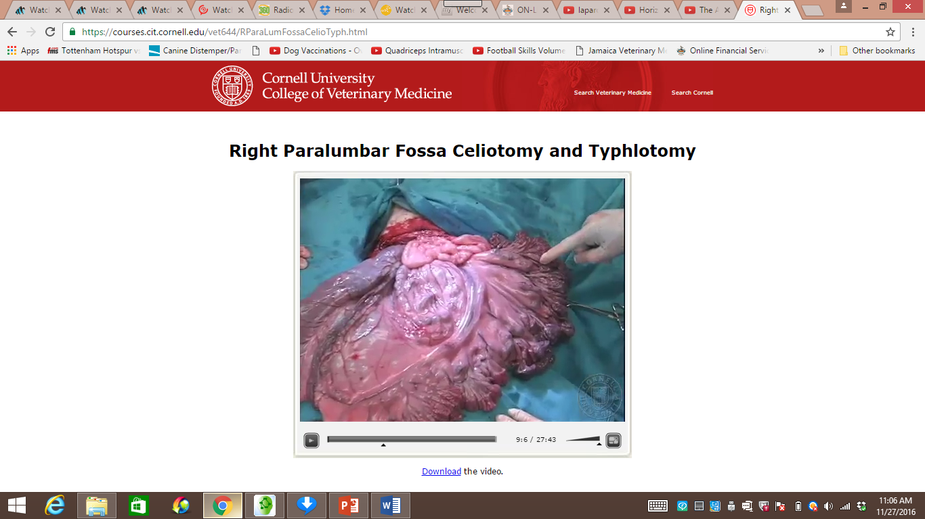

* It is important to keep the viscera moist at all times to prevent intra-abdominal adhesions that result from serosal trauma.
* Once all the necessary structures are identified, They are replaced starting with the cranial portion of the jejunum, followed by the ileum and then the cecum.
* The first layer of closure is a simple continuous with an absorbable suture material incorporating the transverse abdominus and the peritoneum where some omentum will also be included as the suture progresses.
* The other muscle layers are then closed either separately or in one layer using a simple continuous pattern as well. The site is then rinsed and the skin is closed.
* Skin closure is done with a ford interlocking suture pattern. Simple interrupted sutures (3 or 4) are placed at the bottom of the incision should it ever be necessary to establish drainage or if there is a subcutaneous infection. (Pic below)

