**ADMINISTRATION**

BLOOD ADMINISTRATION SET

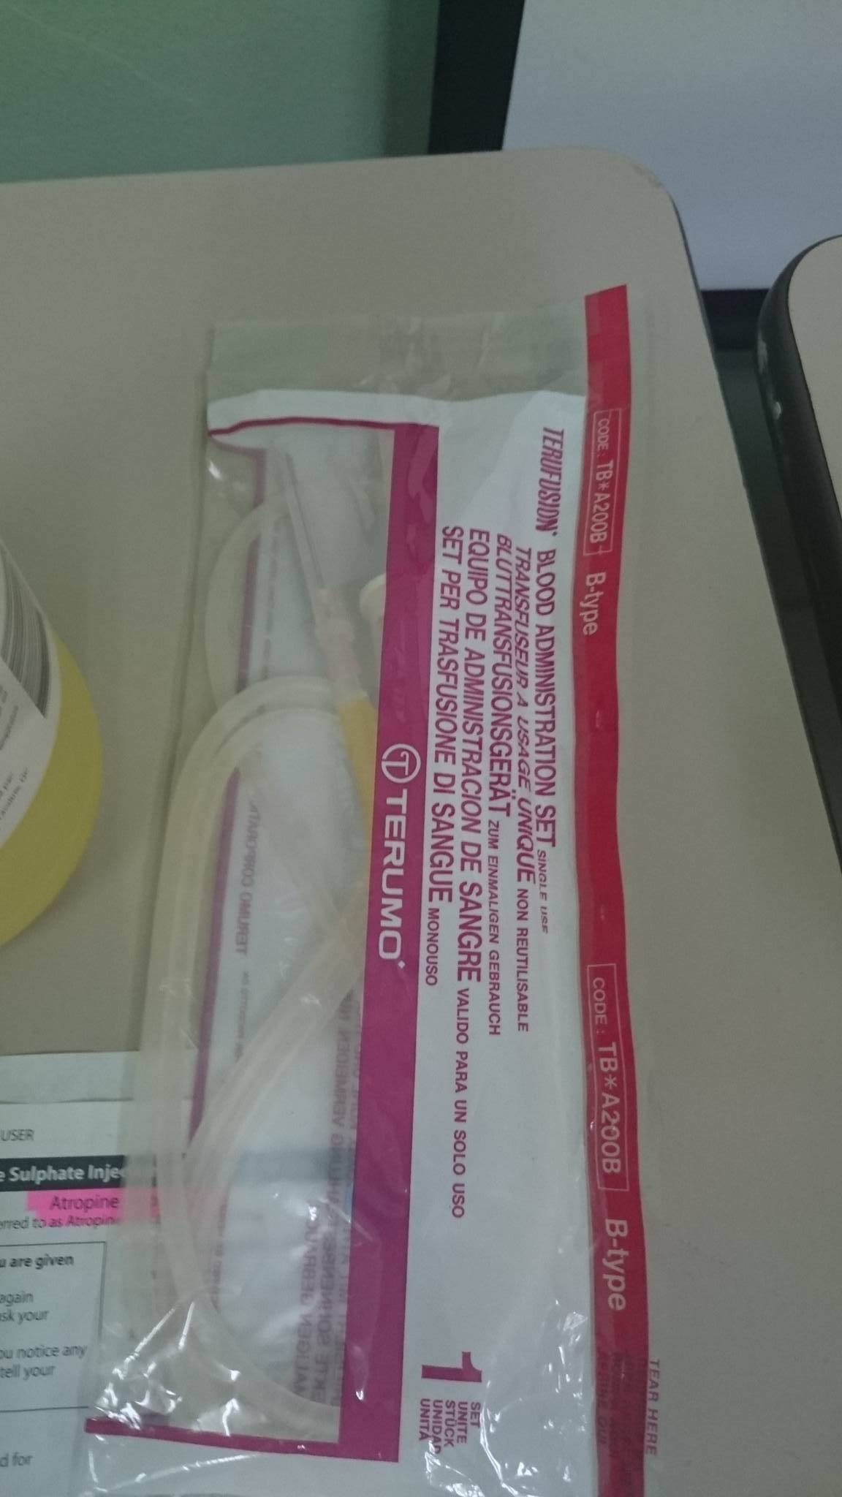

### USE: To filter blood to remove clots and small clumps of platelets and white blood cells that form during collection and storage. Prevents thrombus formation.

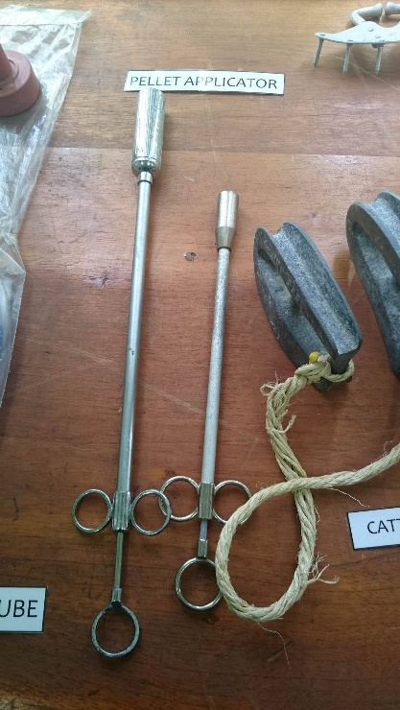PELLET APPLICATOR

**USE:** To administer pellets

BOLUS GUN

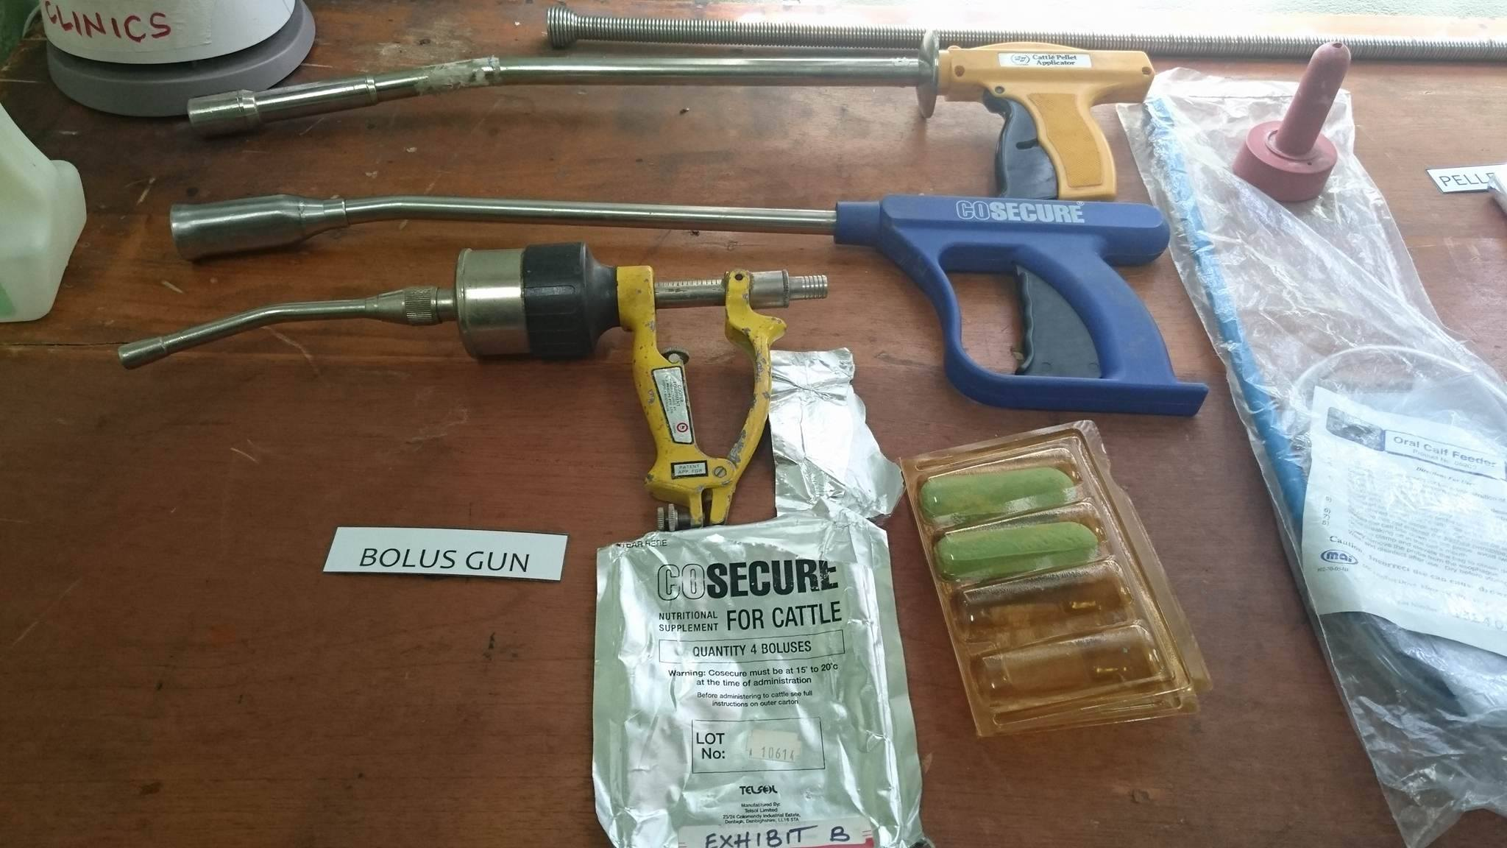

**USE:** To administer bolus capsules into the rumen.

**NUTRITIONAL AND DOSEAGE INFORMATION:**

<https://www.cosecureboluses.com/product-range/cosecure>

**CAPSULE ADMINISTRATION USING A BOLUS GUN:**

<https://www.youtube.com/watch?v=2lS6UX-Go-8>

DRENCHER

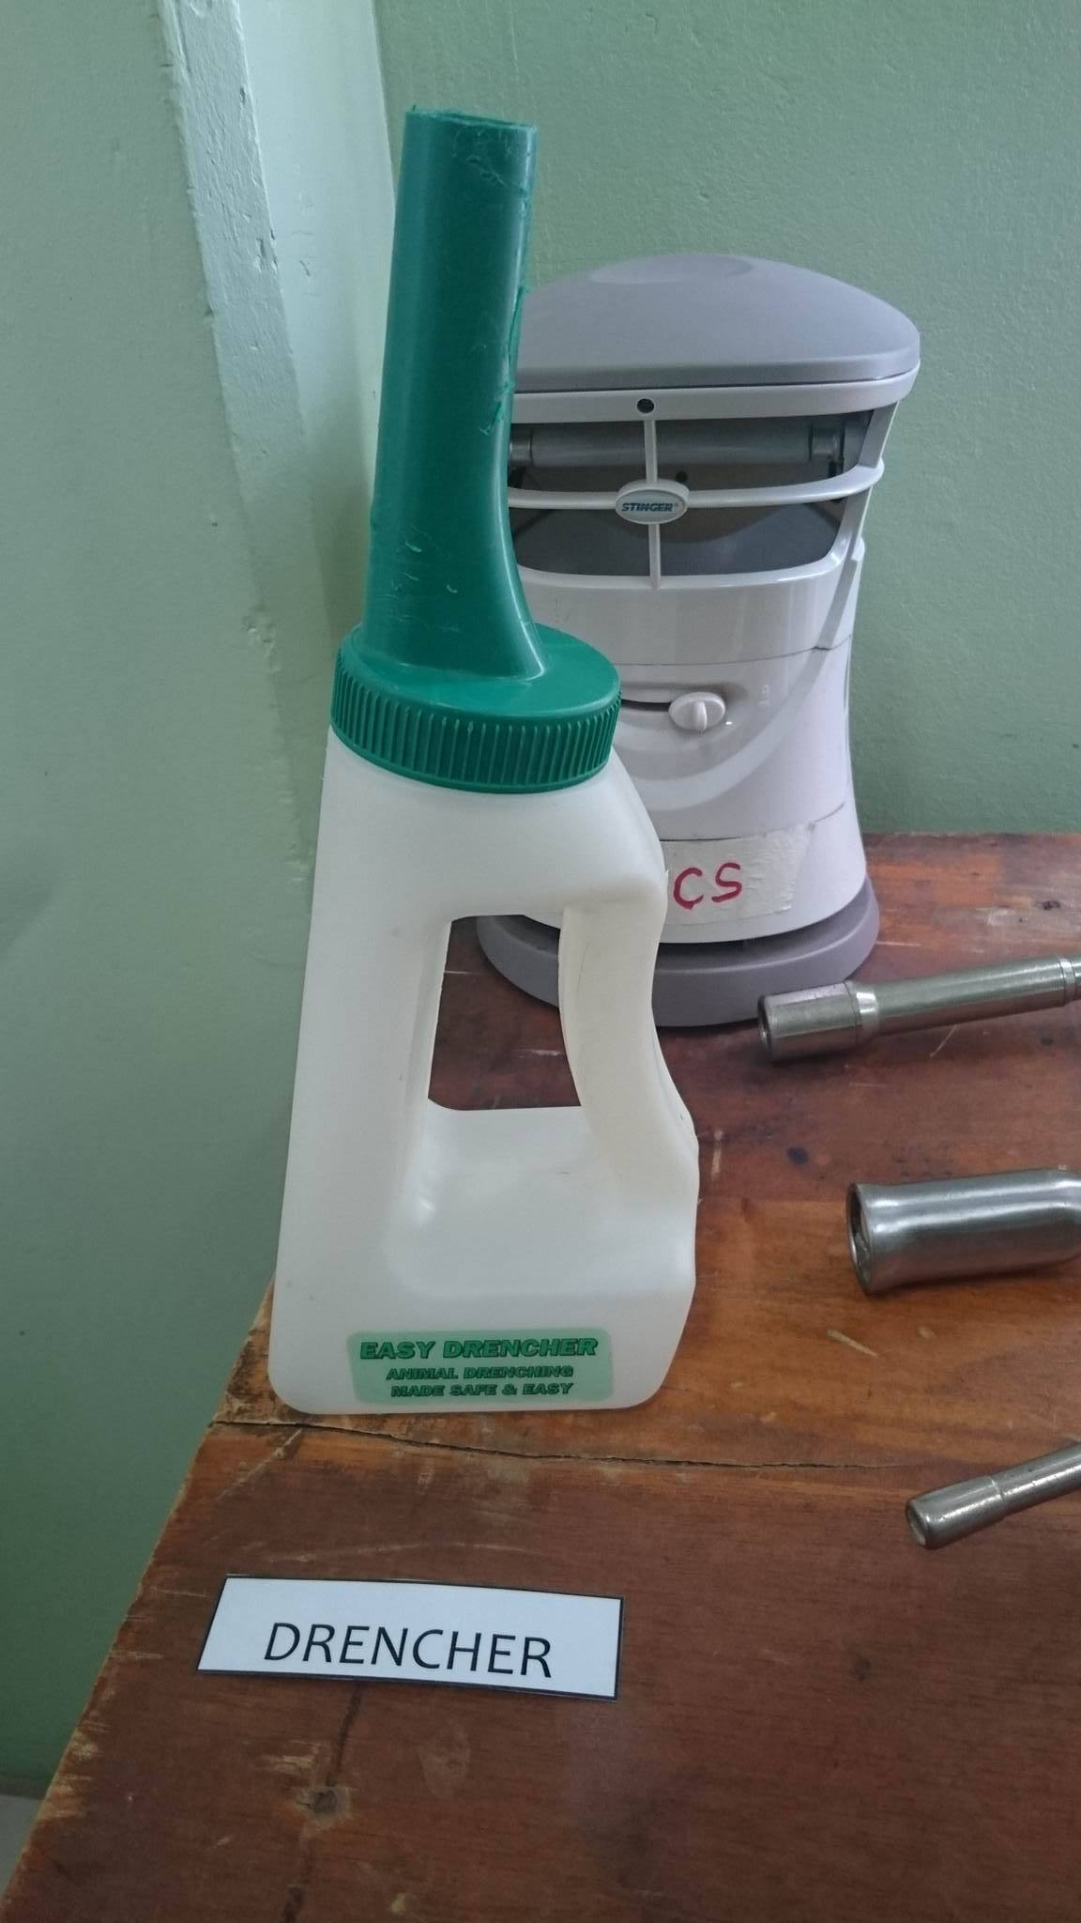

**USE:** Allows safe and easy administration of fluids to cattle and other large animals. Plastic probe is inserted in the side of the mouth to encourage and enable swallowing. Easy-grip handle for one handed use.

STOMACH PUMP AND HOSE

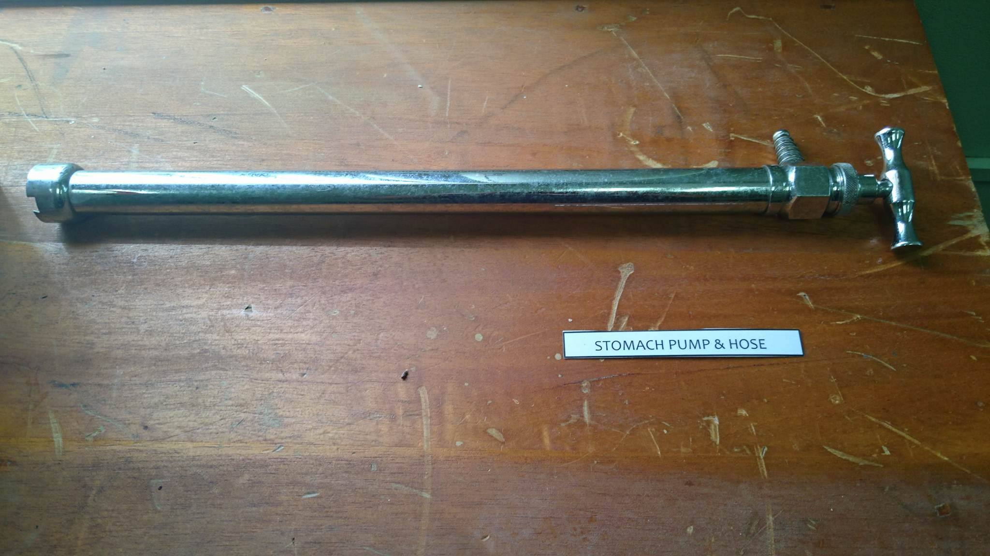

**USE:** To administer large amounts of fluids into the stomach for example, in a dehydrated cow.

**APPLICATION:** <https://www.youtube.com/watch?v=5zPE2A4ocNw>

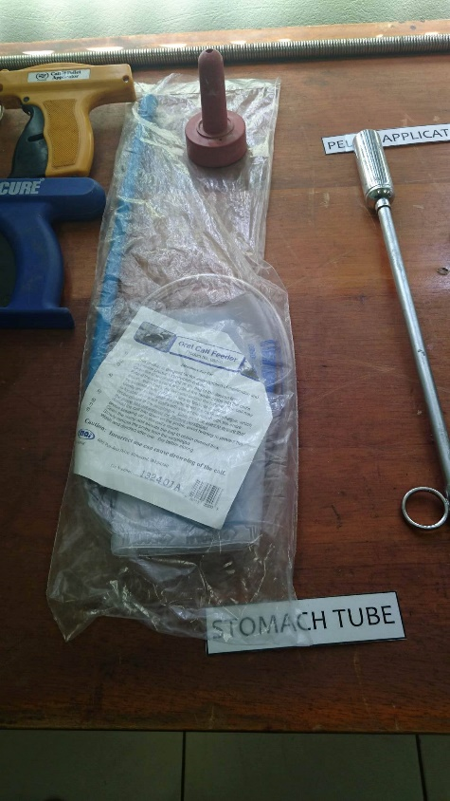STOMACH TUBE

**USE:** To supply nutrition when eating is difficult.

**APPLICATION:** https://www.youtube.com/watch?v=OUDVzX4OJNE