IV regional Nerve Block

**Hind limb**- cranial branch of lateral Saphenous and **Forelimb**- Cephalic or Dorsal common digital vein

Note- procedure in both fore and hind leg are similar

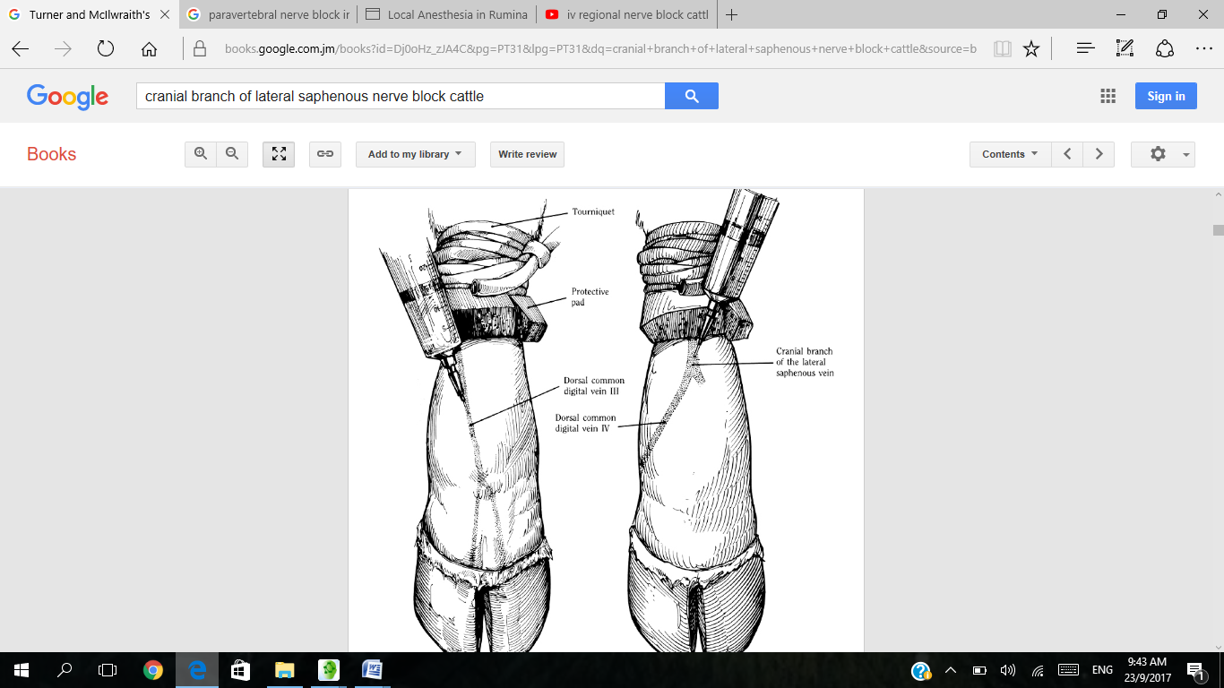

Equipment needed / Chemicals required :

Tourniquet

Local anaesthetic solution: 2% lidocaine without adrenaline.

Syringe

19 gauge needle or butterfly needle.

Procedure:

1. Restrain the animal

2. Clip and disinfect over a convenient prominent superficial limb vein distal to where the tourniquet will be placed.

3. Place tourniquet in the proximal metatarsal or proximal metacarpal region or above the hock or carpus. And note that the tourniquet must be applied tightly

4. Following tourniquet placement, the cranial branch of lateral saphenous vein in metatarsus is identified (dorsal common digitial vein III in the metacarpus [forelimb])

5. Insert a needle (19 gauge) or butterfly needle into an appropriate superficial vein. Needle should be (1.1 mm external diameter) 3.6cm long into the vein, directed distally.

7. Aspirate blood to confirm that the needle is properly positioned within a vein.

8. Inject an appropriate amount of local anaesthetic solution, e.g. 10-20 ml of 2% lidocaine hydrochloride for adult cattle

9. Withdraw the needle and massage the injection site for a few seconds to prevent haematoma formation.

10. Anaesthesia should be complete in five minutes and persist for 1-2 hours if the tourniquet is left in place and analgesia should be in effect after ten minutes.

11. Check after ten minutes whether full analgesia has been achieved: it is important to check the state of analgesia in the deep tissues prior to beginning a surgical procedure involving these tissues. It is particularly important to confirm that the caudal aspects of the interdigital cleft are insensitive as this is often the last area to become fully anaesthetised.

12. Sometimes the skin between the digits is not fully anaesthetised; in such cases inject 5 ml of 2% lidocaine midline on the dorsal aspect of the fetlock and 5 ml midline on the caudal aspect  between the dew claws. Note that Analgesia remains until the tourniquet is removed.

At the end of the operation, the tourniquet should be slowly released within 10 seconds and the limb will regain normal sensation and motor function in approximately 5 mins. Note that the tourniquet may be left in place for up to1.5 hours without ill effect.

Indications for use of this block:

Painful procedures of the distal limb including-

1. Digit removal

2. Granuloma removal from the digital skin.

Note: Initial analgesic effects are not uniform; some areas may be anaesthetised while other areas adjacent or deep to these may still be sensitive.

General notes for local anaesthesia:

1. The analgesic technique chosen should be decided based on the procedure to be undertaken, the facilities available and the skills of the practitioner.

2. Vasopressors such as adrenalin (epinephrine) should not be used in local anaesthetic solution for analgesia of appendages such as the tail, teats or toes as they may produce sufficient circulatory compromise of the appendage to result in tissue necrosis and sloughing.

3. Standard aseptic techniques should be practiced when performing local analgesia, including surgical preparation of the skin, and sterile injection techniques. )

5. Aspiration to check for blood should be carried out prior to injection, to avoid inadvertent intravenous injection.

Complication/ Limitations / Risk

1. It is important to avoid the use of lidocaine with epinephrine because combination may cause regional vasoconstriction and systemic release of epinephrine upon release of of tourniquet which may result in adverse effect. Therefore for intravenous regional anaesthesia of a limb, only preparations without adrenaline should be used

2. Haematoma may occur at the site of injection.

3. If the local anaesthetic solution is injected slowly the animal may kick part way through and the needle becomes displaced from the vein.

4. If the tourniquet has not been applied properly the procedure will not produce full analgesia.

5. This technique does not always result in full analgesia of the skin between the digits; an additional injection of 5 ml of 2% lidocaine midline on the dorsal aspect of the fetlock and 5 ml midline on the caudal aspect  between the dew claws may be required.

Client information:

Procedure cost is inexpensive

Technique is to be done by skilled/ licensed veterinarians