Distal Vertebral Nerve Block

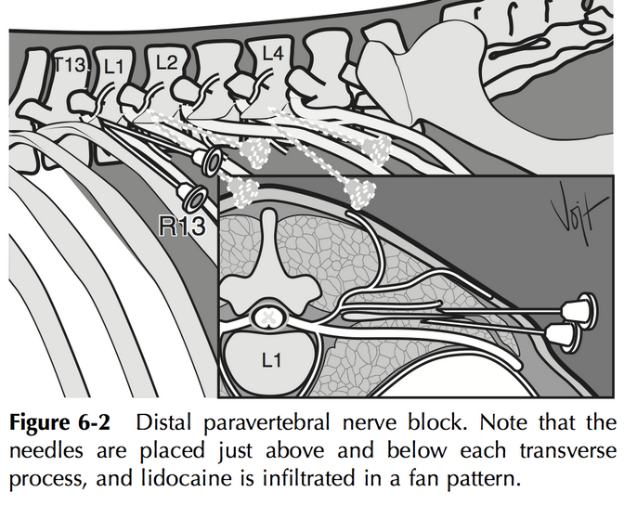

Preparation/ Preop:

Clip and surgically scrub and disinfect the skin over the area where the needles will be introduced

Area blocked:

flank of side on which technique is performed

Nerves blocked:

dorsal and ventral rami of T13, L1, and L2

Site:

distal ends of lumbar transverse processes of L1, L2, and L4 (Fig. 5-3)

Needle: 18-gauge, 7.6-cm

Anaesthetic: 10 to 20 mL of 2% lidocaine at each site

Onset of analgesia: within 10 mins of injection

Duration of analgesia: approximately 90mins

Method: the skin overlying the spinal column on the side to be desensitized is clipped, surgically scrubbed, and disinfected; insert the needle ventral to the tips of the respective transverse process; inject anesthetic (up to 20 mL) in a fan-shaped infiltration pattern; withdraw the needle a short distance, reinsert it dorsal and caudal to the transverse process, and inject approximately 5 mL of the anesthetic.

Complications: none

Indication for this block: Standing laprotomy, C-section, Rumenotomy, Cecotomy, Correction of GI displacement, intestinal obstruction and volvulus

Nerve supplies **t**he thirteenth thoracic and first and second lumbar nerves supply the area of the flank which is bounded cranially by the last rib, caudally by the angle of the ileum and dorsally by the lumbar transverse processes.

Signs of successful block**:**

* Anaesthesia of the skin;
* Increased skin temperature. This occurs due to [hyperaemia](http://wildpro.twycrosszoo.org/S/00Ref/KeywordsContents/h/Hyperemia.htm) resulting from paralysis of cutaneous vasomotor nerves;
* Relaxation of flank muscles;
* Scoliosis (curving of the spine) towards the desensitised side

Advantages:

1. The use of more routine size needles, with noi risk of penetrating major blood vessels

2. Lack of scoliosis minimal weakness in the pelvic limb

Disadvantages

1. Analgesic solution may be injected below fascial sheets and therefore not bathe the nerves.

2. More local anaesthetic is required than for the proximal paravertebral block. larger volumes may be required due to variability in anatomical position of the nerves

Equipment / Chemicals required and Suppliers –

2% Lidocaine solution. For cattle: 10 cm spinal needle; 12 cm may be required for cattle of the Belgian blue or other very heavily muscled breeds

Cost/ Availability-

Drugs required are inexpensive.

Appropriate spinal needles for cattle may not always be readily available.