Drug name | Active ingredient | Time given/onset/ duration | Indication | Contraindication | Dose/route of administration/Withdrawal time | Client information
Xylazin 2%  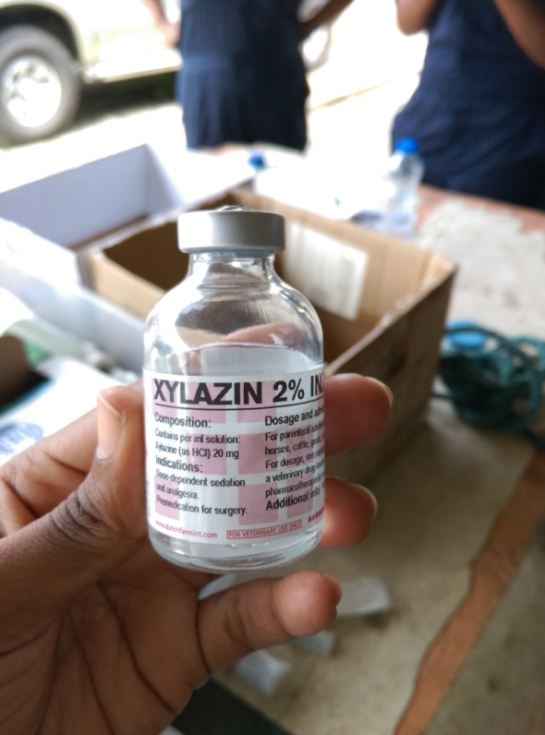 | Xylazine at a concentration of 20mg/ml  NOTE; only this concentration can be used in cattle | Given at 2:24pm  Onset at 2:34pm (10mins)  Duration : 45mins | Used in combination with other agents such as Ketamine for inducing anesthesia | Adverse effects such as : Salivation, ruminal atony,  bloating, regurgitation, hypothermia, diarrhoea, premature partuation and ataxia.  Do not give to ruminants that are dehydrated, debilitated or with urinary tract obstruction | Dose: 0.025mg/kg  Route- IM  Withdrawal:  8days -meat  48hrs –milk  Note :Dose for anxious or unruly cattle should be 0.05-0.1ml/kg of 2% Xylazine based on plumbs drug handbook | Xylazine should only be used by individuals familiar with its use
Ketamin 10%  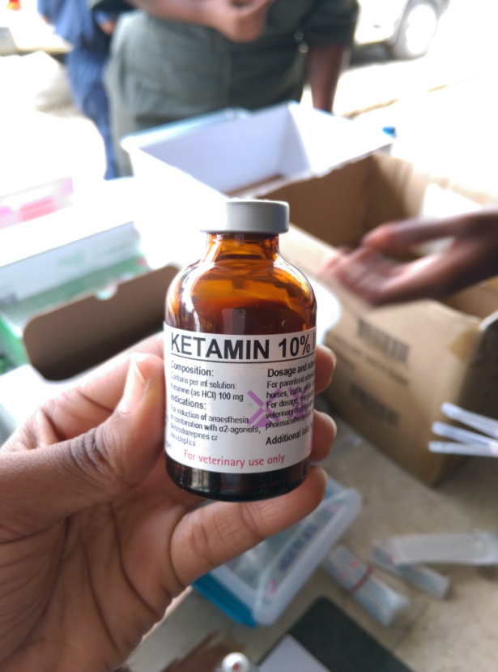 | Ketamine at 100mg/ml | Given at 2:22pm  Onset 2:32 (10mins)  Duration – 1hr | Used in combination with other agents such 2% Xylazine for inducing anesthesia | Respiratory depression  High doses- emesis , vocalization, erratic and prolonged recovery, cardiac arrest, dyspnea, muscular tremours | Dose- 0.05mg/kg  Route: IM  Withdrawal period  Milk- 3days  Meat-3days | Should be administered by individuals familiar with its use.
Lidocaine injection BP 2%  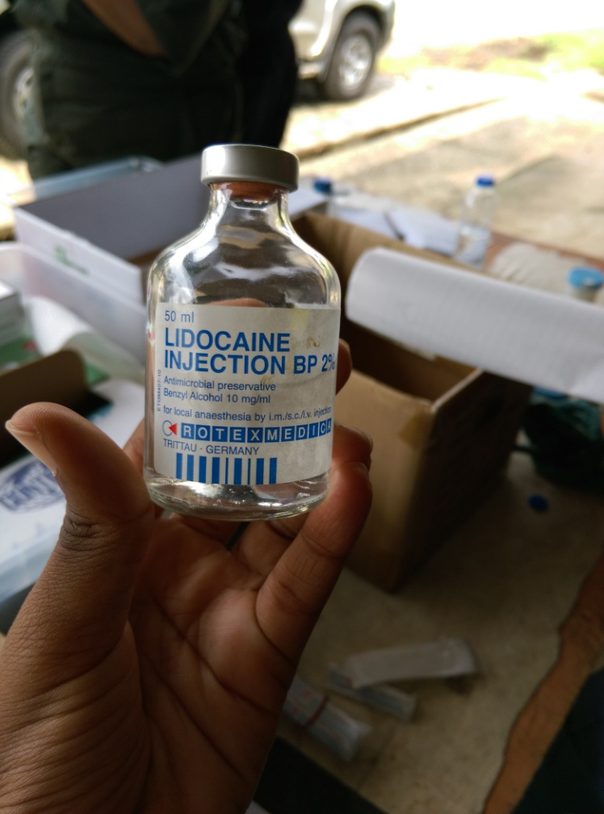 | Lidocaine at concentration 20mg/ml | Given at 2:55pm for epidural  Tail tone lost at 2:57  Onset – 2mins  Duration 10-20mins | Used as local and topical anesthetic agent | Toxicity signs may include: loss of consciousness, drop in blood pressure and respiratory collapse. | Dose- 0.2mg/kg  Withdrawal time-  Milk-96hrs  Meat- 5days | This drug should only be used systemically by professionals familiar with its use and in a setting where adequate patient monitoring can be performed
Tolazine 10%  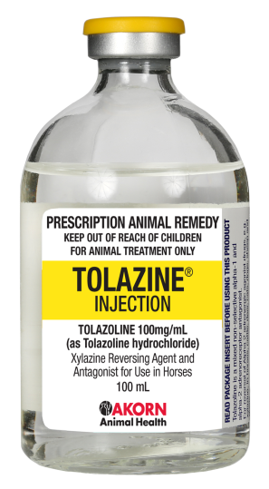 | Tolazoline at 100mg/ml- alpha-adrenergic blocker | Was not administered to animal | indicated for the reversal of effects associated with Xylazine | More sensitive to this drugs than horses. A dose od 1.5mg/kg IV can cause coughing, increased frequency of defecating and mild increases in breathing.  High doses such as 2-10mg/kg IV can cause bright red conjunctival mucous membranes, coughing, nasal discharge, salivation, laboured breathing, CAN depression, straining , head pressing, restlessness, severe diarrhoea , signs of abdominal pain  Rapid IV injection has been reported to cause significant cardiac stimulation, tachycardia, increased cardiac output, vasodilation, gastrointestinal distress | Dose-  2 to 4 times 0.025mg/kg (Xylazine Dose)  Withdrawal time-  milk - 48hrs  meat- 8days | Because of risks associated with the use of Xylazine and the reversal of tolazoline, these drugs should be administered by veterinary professionals only

