**The Auriculopalpebral Nerve Block**

The auriculopalpebral nerve is a branch that comes from the facial nerve (CNVII) and crosses the zygomatic arch of the cow. It supplies the orbicularis oculi muscle in the cow which is used for closing of the eyelids. Due to the difficulty in holding the eyelids apart on a cow, this technique is used to help in eye examination or surgery. This block does not provide pain blockage so if used for surgeries a topical analgesia or other nerve blocks.

**Instruments**

1 10ml syringe  
1 18-gauge, 1-inch needle  
2% Lidocaine solution  
A nose pinch  
A halter  
Cotton soaked in 70% Alcohol

**The Procedure**

The cow was restrained using both sedation using ketamine (0.05mg/kg) and xylazine (0.025mg/kg) injections, and a halter and nose pinch. The zygomatic arch was felt for which is located between the lateral canthus of the eye and the base of the ear. The area was cleaned and a 1-inch, 18-gauge needle was inserted subcutaneously and aspirated to ensure that a blood vessel wasn’t entered. Then 10ml of 2% lidocaine was administered with 5 ml ventrally and 5 ml dorsally to ensure even spread to block the nerve. Unfortunately, due to time constraints, we were unable to observe the time it took the animal to show signs of recovery from the procedure which would be 1 hour. The eyelids showed signs of decreased muscle strength within 5 minutes while full anesthesia would occur at 10 minutes.

**Complications**

1. Orbital hemorrhage
2. Optic Nerve injury
3. Penetration of the globe

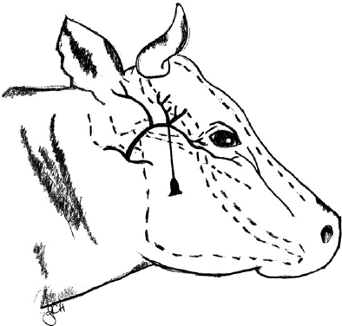

Fig. 1 Needle Placement for Blocking the Auriculopalpebral Nerve