**OBSERVATIONAL POST-OP REVIEW**

Upon distance examinations of both calves, appeared bright, alert and responsive (B.A.R) with normal parameters.

Normal Parameters of calves:

|  |  |
| --- | --- |
| Temperature | 101-103°F |
| Pulse | 100-140 beats/min |
| Respiration | 30-60 breaths/min |

* There was no vocalization which indicated no pain was felt from affected areas.
* There was no abnormal behaviour which indicated the loss of the horns/ buds did not affect the animals.
* There was no excess discharge from the surgical site which indicated the area was properly cauterized and sinusitis was not present.
* There were no flies present on or around the surgical site which indicated there was proper post-op management and the screw worm spray worked effectively.

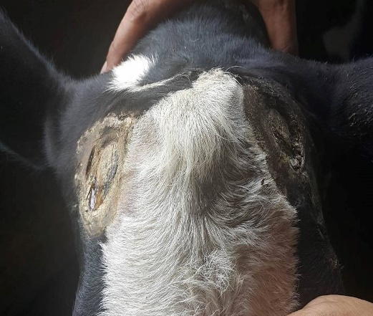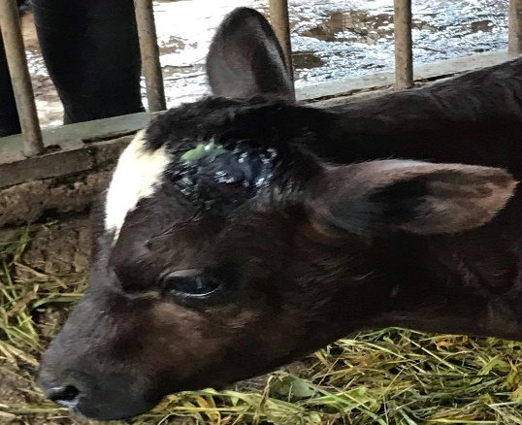

**Peppy after 24 hrs of dehorning**. **Timothy after 24 hours of disbudding.**

**Treatment post-op, for the next few days**:

1. 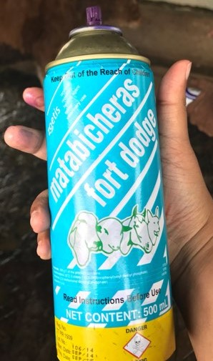Antibiotic cream was applied directly to the affected areas.

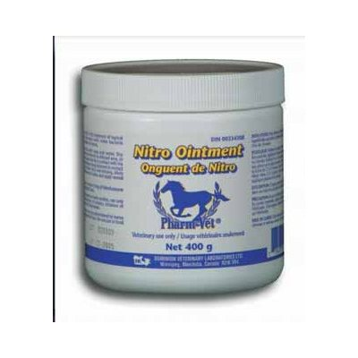

or

<https://www.drugs.com/vet/nitrofurazone-ointment.html> <https://ar.zoetis.com/products/bovinos/matabichera-fd.aspx>

1. Screw worm spray was applied around the affected area.

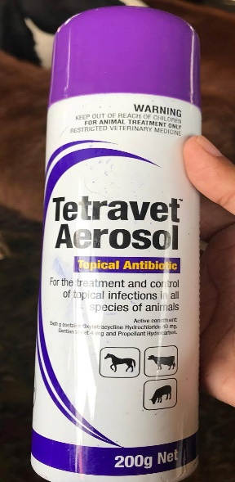

<http://www.takamuljo.com/ItemDetails.aspx?ItemID=31&ProductName>=

Both animals were monitored over a 3-day period and with no indications of complications.

They will continually be monitored.