***Post-Operative Care***

* The horse that underwent colic surgery must be monitored for 24 hours after by a veterinarian post operation.
* Following that should remain at the veterinary hospital for 7 days.
* An individual treatment plan will be made specific for each horse. Catering for the needs of the horse such as diet, pain relief, anti-biotics and on-going diagnostic test.
* Sometimes complications may arise, please refer to the table below:

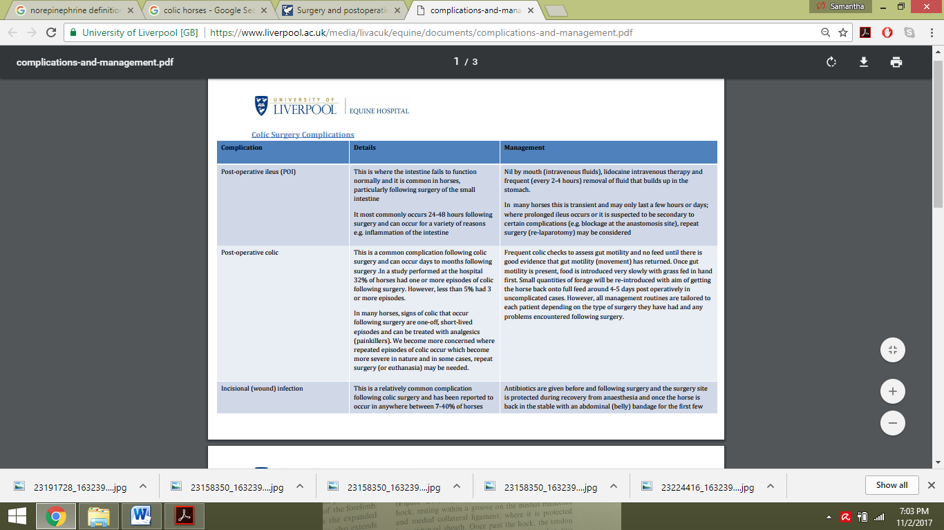

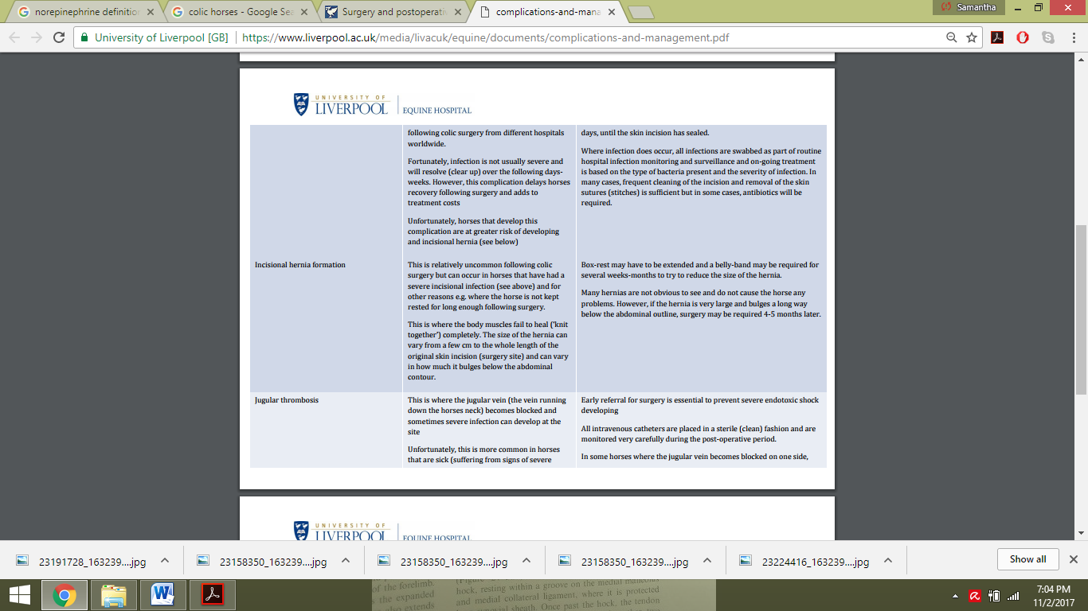

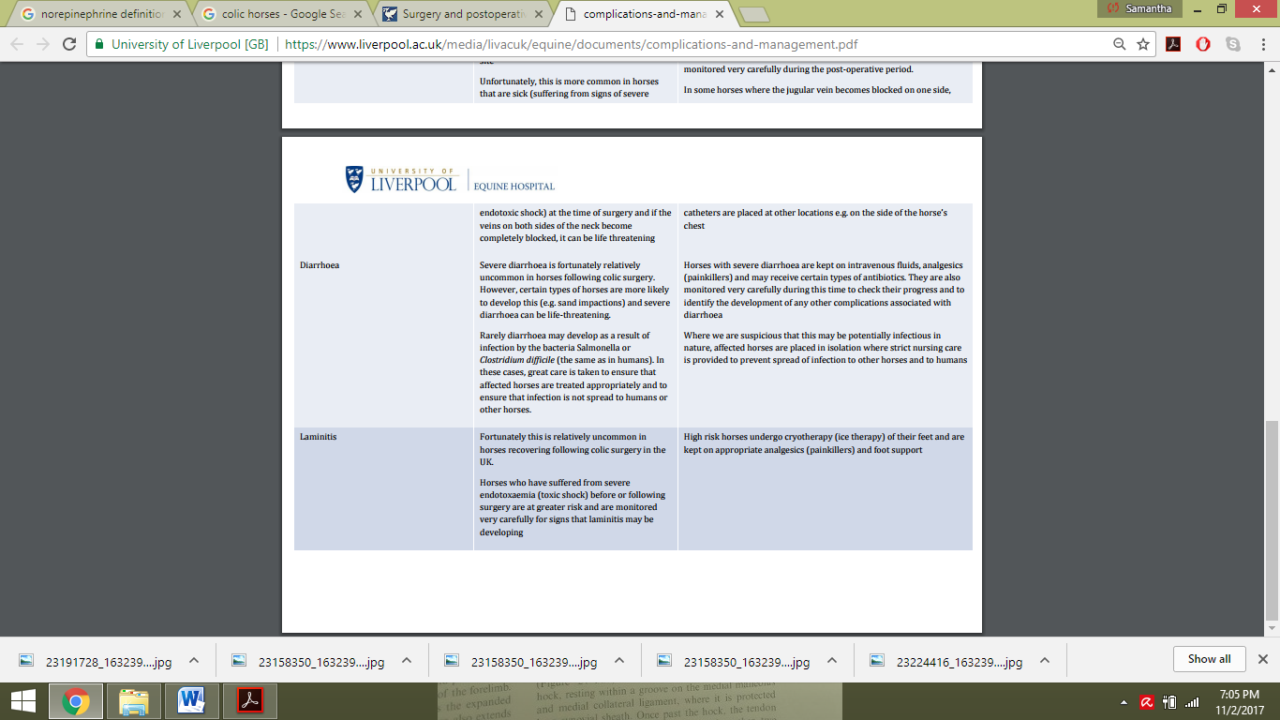

* If no complication arise the horse will be discharged from the hospital however, must be confine to the stable for 4 months to ensure the abdominal incision is healed properly.
* The horse should be allowed to be hand walked every day during this time.
* After 4 months passes with no complications the horse can now resume its normal training activity.