***GI Anatomy of Horse***

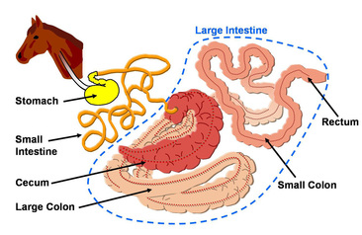

Horses are monogastrics animals, with a relatively small stomach (capacity 8–10 L).

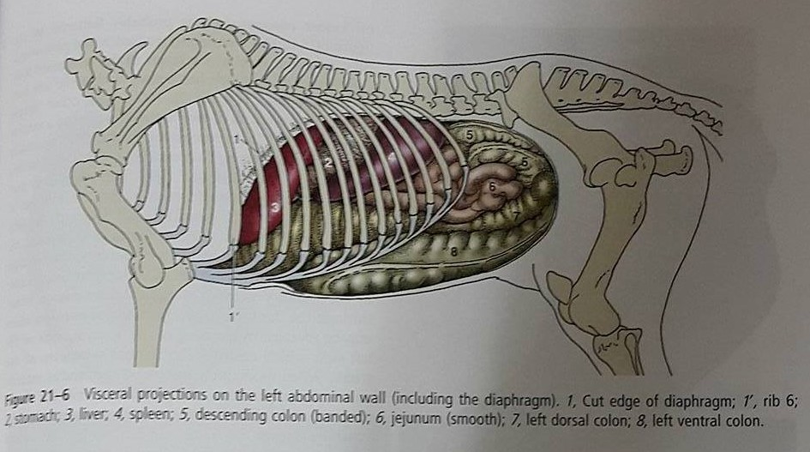

Above shows a left lateral view of the horse’s abdomen. Structures unique to this side are:

1. Stomach
2. Spleen
3. Jejunum
4. Left dorsal colon
5. Left ventral colon.

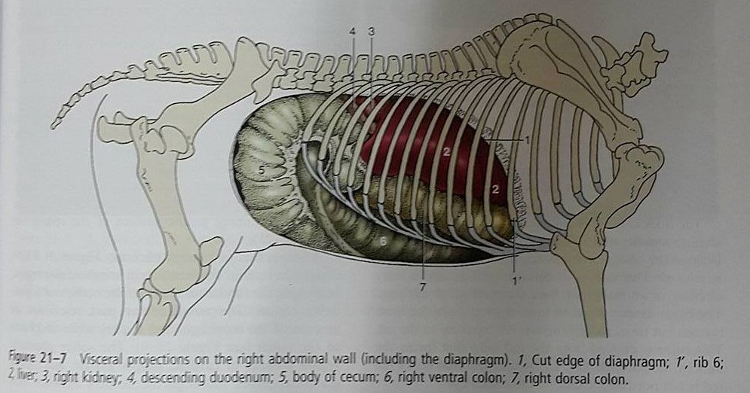

Above picture shows the right lateral view of a horse’s abdomen. Unique to this view are:

1. Right kidney
2. Descending duodenum
3. Right ventral colon
4. Right dorsal colon

