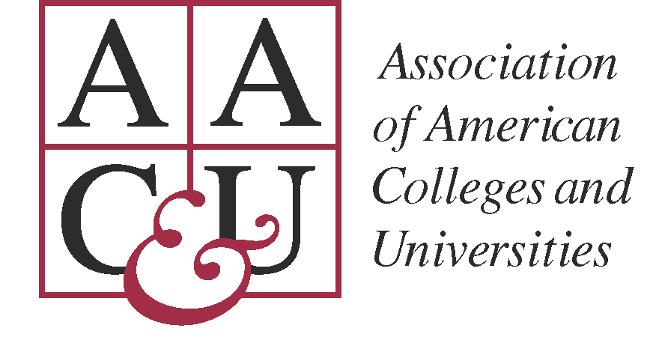 | 2018 Institute on High-Impact Practices and Student Success  Campus Inventory for Pre-Institute Reflection and Institute Use

Please submit the completed Campus Inventory to Vida Rivera at rivera@aacu.org by June 5th.

Dear Campus Team Leader:

The Campus Inventory for Pre-Institute Reflection and Institute Use is designed to:
- help your team reflect on your campus learning environment, the composition of your campus community, student learning outcomes and achievement, equity, and the factors influencing the implementation and sustainability of high-impact practices;
- inform your team’s work to develop a concrete action plan while at the Institute; and
- help Institute faculty understand the context, constraints, and options that shape your team’s work.

We are asking you to collect and review data to inform your work and the faculty liaisons who will be consulting with you. Most of the data suggested for use can be obtained through your institutional research/effectiveness office or assessment director. (Other useful sources include the HERI Freshman and Senior surveys, NSSE, FSSE, CCSSE, and CLA).

It may be beneficial to have a conversation with those who will help you gather the information to ensure the usefulness of the specific data, given your goals for participating in the Institute. Collecting too much information may lead to unnecessary distractions and be less useful to your team and the Institute faculty who will consult with you. It will be most helpful if the data is given to your team in a user-friendly format (e.g., charts, graphs, and/or matrices that may include very brief narratives).

We highly recommend that you meet with your team prior to the Institute to review the campus inventory and to discuss goals and expectations. In our experience, teams that meet in advance of the Institute have more productive interactions within their group, with faculty consultants, and with other campus teams.

Feel free to contact us if you have questions about collecting this information. We are looking forward to working with you and your team members.

Tia Brown McNair, Ed.D.  Vice President, Office of Diversity, Equity, and Student Success  mcnair@aacu.org |  | Siah Annand  Director, Network for Academic Renewal  annand@aacu.org | Vida Rivera  Program Coordinator  rivera@aacu.org
2018 Institute on High-Impact Practices and Student Success
Campus Inventory for Pre-Institute Reflection and Institute Use

ADD YOUR INSTITUTION NAME HERE

I. Purpose and Alignment

Discuss with your team how the work you are doing at the Institute aligns with institutional mission and current academic or strategic priorities. Clarity of purpose is a key component of success at the Institute. If your context or goals have changed since you applied for the Institute, please share updates here.

II. Campus Learning Environment

- High-Impact Practices

- Identify the current high-impact practices that are being employed on your campus in the curriculum and/or co-curriculum.
The following high impact practices are employed on our campus: first year experiences, learning communities, writing intensive courses, undergraduate research, diversity/global learning, service/community-based learning, internships, and capstone courses/projects. Several programs are interested in developing ePortfolios as well.
  - If you currently employ high-impact practices, briefly describe your assessment plan. Are data disaggregated to examine inequities in student participation and achievement? If so, please include data.
    - At this time, we do not have an institutional assessment plan in place other than use of NSSE, which is administered every three years on our campus. We have recently developed a mechanism to identify students enrolled in courses that incorporate HIPs and will be.working with our Registrar’s Office to gather data.This will allow us to disaggregate these data and query them for inequities in student participation and achievement. We are currently developing both direct and indirect assessments for student learning in undergraduate research and service learning experiences but have not yet implemented these at scale.
    - Data to examine inequities in student participation and achievement is provided through NSSE.
  - To what extent are students aware of the intent and expected learning outcomes as a result of participation in high-impact practices? Are data disaggregated on student learning outcomes? If so, please include data.
    - Courses have learning outcomes identified in the syllabus for the class, but it is up to individual instructors and departments to make the connections of High Impact Practices to the learning outcomes for their courses. At this time, there has not been a specific campaign designed to inform the students about high impact practices and their learning outcomes. We suspect that if we asked students at UW-Platteville to identify their participation in a high impact practice experience, they would be unable to do this.

- Faculty, Staff, and Administrators

- Are there institutional or departmental structures for collaboration/coordination for faculty, student affairs, academic affairs, and other campus educators (e.g., librarians, instructional technology specialists) to share responsibility for creating a learning environment that incorporates high-impact practices? If yes, briefly describe the structures.
  - There are opportunities for collaboration and coordination of this type to occur. We are in the process of reviewing and identifying new academic endeavors. This process specifically includes conversations with shareholders from multiple units on campus about high impact practices and how to encourage collaboration and coordination across programs.
  - A faculty and instructional staff community of practice focused on supporting undergraduate research has developed over the past two years, coordinated by the Office of Research and Sponsored Programs and the Teaching and Technology Center and supported by the Deans of the three colleges on campus. This community meets on a monthly basis during the academic year to discuss successes and challenges in mentoring undergraduate research. An annual workshop focused on undergraduate research has been held in January of the past two years, with plans for this to continue. Interest has been expressed in developing a similar community of practice for mentors who incorporate service and community-based learning in student experiences. The Career and Professional Development Office is in the process of coordinating collaboration among supervisors of internships and similar experiences across campus.
First year experience courses are coordinated through Academic Success Programs, which hosts workshops for instructors (a mix of faculty and staff from multiple units on campus). This provides an opportunity for collaboration and coordination among 60 instructors.

- If you offer professional development opportunities related to increasing student engagement and the use of high-impact practices, what proportion of faculty, staff, and administrators have participated? Contingent faculty? What data or evidence do you collect to evaluate the impact with respect to student learning and engagement and faculty adoption of engagement strategies?
i. The Teaching and Technology Center provides opportunities for professional development by offering face-to-face workshops on student engagement and other topics, as requested by departments and programs on campus. Some resources are also offered in an online format to facilitate access by contingent faculty. Additionally, individual programs and other offices on campus (e.g., Provost’s Office, Office of Research and Sponsored Program) have provided professional development related to student engagement and use of HIPs.
In the past year, a model learning community for supporting new instructors initially developed in our College of Engineering, Mathematics, and Science has been expanded to include instructors from all three colleges. Several of the monthly meetings of the combined three groups focused on topics related to HIPs (e.g., undergraduate research, service learning), followed by additional conversation in weekly college-level meetings. It is difficult to estimate proportion of participation, since it varies widely by college. Overall, approximately half of full-time, tenure-track new instructors participated in the New Instructor Learning Community, but participation of faculty, staff and administrators in other on-campus professional development is probably less than 30%.
Data on impact of this professional development is mostly collected through follow-up surveys. There currently is no institutional mechanism to assess the impacts of professional development on student learning and engagement or faculty practice.

III. Institutional Data

Your campus IPEDS, NSSE, FSSE, CCSSE, CLA, and/or CIRP (freshman/senior survey) data may be useful to you in developing your campus action plan. Faculty at the Institute can help guide your interpretation of these data.

Below are suggestions about specific data to collect. NOTE: Your campus institutional research effectiveness or assessment director can help you gather this information. The intent of gathering the data is to provide your team with information about your student body, and faculty that will be relevant to your Institute work.

Please include a brief institutional profile, (e.g. number of students; student demographics; full-time faculty; part-time faculty; admissions profile for most recent cohort;# of transfer students; % of students in developmental education –disaggregated , if possible; retention and graduation rates—disaggregated, if possible, etc.)

IV. Your Campus Team’s Work at the 2018 Institute

Answering the questions below will help prepare your team to work effectively at the Institute. These questions should be discussed prior to the Institute, which can serve several purposes including:

- providing a point of departure for the team’s pre-Institute discussions;
- helping to bring out differences of opinion and perceptions of the task ahead;
- pointing to areas that need attention as you develop your action plan; and
- providing text that your team can draw on for the action plan.

- Describe the supporters and opponents of the work and their reasons for the perspectives they hold. What groups on campus have yet to hear about the work?
  - The UW-Platteville team has the full support of campus leadership. This project was built into our FY18 campus work plan. We have not faced opponents yet as we are in early stages of developing our work. Some concerns have been shared with us about addition to workloads and implementation of an institutional rubric to facilitate conversations about implementation of HIPs.. Concerns about workload relate to major changes occurring to our institutional landscape with the addition of two new branch campuses and associated staffing issues. Concerns about the rubric also relate to workload and some resistance to this assessment method.
At this stage of the process, we have yet to communicate directly with many groups on campus. Deans, academic department chairs, faculty who have attended campus discussion forums, and many support staff are informed of our work and support it. We have also recruited HIPs champions from each of the colleges to join our team and extend conversations about this work to their colleagues..

- Describe the relationship between this work and existing campus programs/policies/structures.
  - In general, this information and work has not been collected in a formal manner. The UW System has made it clear in their 2020Forward initiative that High Impact Practices are a priority. Currently our goal is to be on the forefront of UW Systems requests for information as it pertains to HIPs. Noting this System initiative when rolling out certain steps within the project has helped us to gain support and facilitated our ability to obtain information from sources that might otherwise have been potential roadblocks. The structure of the University as it pertains to experiential learning is complex, as each academic program has specific guidelines and practices they follow with minimal university-wide structure. One of the goals of this group is to develop institutional frameworks that support all faculty and staff in implementation of HIPs.

- Describe the campus resources (financial, human, facilities, communication systems, technological, political) or other supports that will help you implement your goals. What resources do you need to increase the impact of your project and sustain it over time? Do off-campus resources (e.g. grants, community leaders) exist to help support this work?
  - Currently, the Provost’s Office funds much of the work we are doing. In the future we hope that UW System will contribute financial resources as HIPs become a higher priority. We are utilizing human capital from each of the colleges, the Provost’s Office, Office of Research and Sponsored Programs, Academic Support Programs, the Teaching and Technology Center, External Relations, and Career and Professional Development Office (CPDO). We anticipate needing future funding to support this project and sustain it. For example, the CPDO has hired a staff member to input data regarding experiential learning into PCN. This is coming from the CPDO budget at this time. We will continue to need the support of the leadership team; without it this project will not continue as a priority and stop moving forward, as has occurred twice before. Funding from student differential tuition has recently become more diversified, allowing more resources to be devoted to supporting undergraduate research and other HIPs.

- What internal and external factors might enhance or impede the implementation, evolution, and sustainability of your goals? How might your team leverage or address these factors to increase the likelihood of your work’s success and sustainability?
  - The continued support of the University Leadership Team will be essential to the continued success of this project.

