**Mepivicaine**

(commercial name: Carbocaine®)

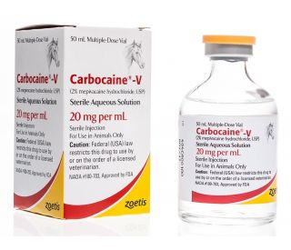

Mepivacaine HCl is a local anaesthetic drug used for various purposes such as caudal and lumbar epidural blocks, local infiltration and peripheral nerve blocks. It achieves local and regional anaesthesia by inducing conduction blockade of sensory neurons by decreasing the influx of sodium ions into cells. It is typically found in 1%, 1.5% and 2% formulations. Its onset is considerably fast in relation to other drugs of the same function with a considerable duration of approximately 2-3 hours.