**Xylazine**

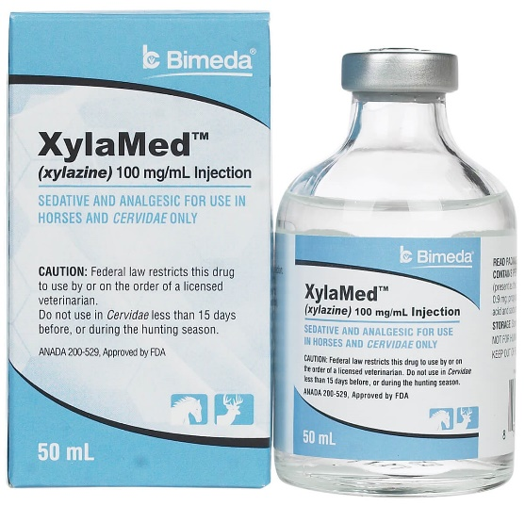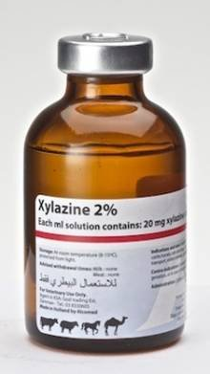

Xylazine is one of the anaesthetic drugs of choice for use in nerve blocks in the limbs of horses. An Alpha2 agonist, it has a relatively fast onset with a shorter duration of action ( compared to detomidine, which belongs to the same group).Care must be taken however, since the negative effects of xylazine (and other alpha2 agonists) include cardiovascular complications such as hypotension, the reduction in insulin release and decrease in gastrointestinal motility.