**Detomidine**

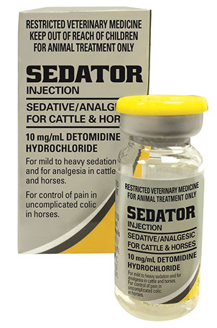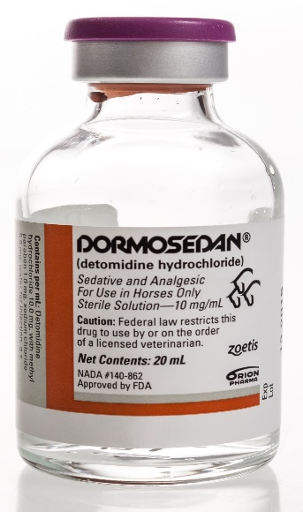

**Detomidine**

Being one of the stronger anaesthetic drugs, detomidine is used with caution as to not cause adverse effects in the patient. The onset is found to be around 2-4 minutes when administered IV, and has a duration of around 30-75 minutes, depending on the dose chosen. It produces desirable effects, having been used in the masking signs of lameness and also, the treatment of laminitis in the forelimb causing severe lameness.