**Indications**

Primarily, an **inferior check ligament desmotomy (ICLD)** is done in order to correct flexural deformity in horses. This is a condition that results from the malposition of a foal in its late developmental stages of gestation, leading to an inability to properly extend the affected hoof. In older horses, flexural deformity can arise secondarily due to excessive hoof trimming of a steeply angled hoof to achieve balance. In both cases, it must be corrected as soon as possible to prevent the onset of long term pathology that can lead to the horse’s performance.

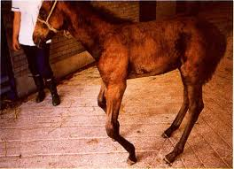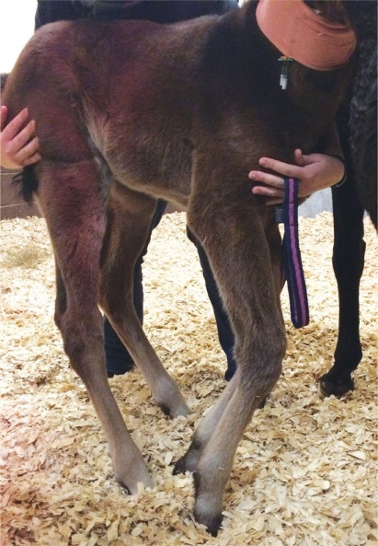

If left untreated in young racing thoroughbreds can develop chronic intermittent lameness, severely affecting performance. It can also lead to unilateral laminitis doe to trauma to the lamina in the toe region of the hoof. There is also marked rotation of the third phalanx (P3, coffin bone).

ILCD results in an increase in length of the digital flexor tendon, allowing the hoof angle to be lowered. This would also aid in the correction of the hoof-pastern axis and permit changes to take place with the hoof capsule.