**Skin Grafting**

In horses, skin grafts are most often used for limb wounds where primary closure is not possible, or second intention healing is delayed or not occurring. Grafts may also be considered for large wounds of the trunk, as grafting will decrease healing time. With free skin grafts, the donor skin is severed from its blood supply and relocated to a wound.

When it is impossible to close a wound by either suturing or contracture and epithelisation, then skin grafting may become an option. “Pinch” grafts are the type of graft most commonly employed and are usually performed on wounds below the knees or hocks.

The grafts are often harvested from the neck or chest and a “pinch” of skin is removed from the donor site and embedded into a healthy bed of mature granulation tissue. Skin grafting can improve cosmetic outcomes and shorten healing time but is not suitable for regions of high mobility such as over joints.

**Free skin graft options**

Free skin grafts are categorized by thickness and type. Full-thickness grafts include epidermis and the entire dermis. Split-thickness grafts include epidermis and a portion of dermis. Full- and split-thickness grafts can be either sheet grafts or island grafts. Sheet grafts are applied to the surface of a wound, and island grafts are embedded in the wound. Island graft techniques include punch, pinch, tunnel and modified meek grafts. The advantage of island grafts is that the failure or loss of one graft does not affect other grafts in the wound.

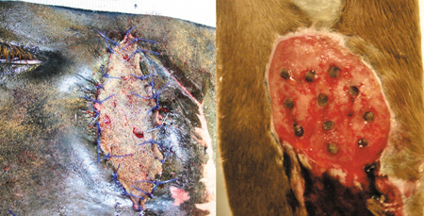

Figure 1: On the left, a full-thickness sheet graft applied to the face, caudal to the lateral canthus of the eye. On the right, a punch island graft after implantation in a distal radial wound.

**Initial wound preparation**

Fresh wounds accept grafts better than mature granulation tissue. Granulation tissue should be trimmed level to the skin edge. With chronic wounds, mature tissue should be trimmed below the skin edge. Allow a few millimetres of new granulation tissue to grow, creating a better source of capillaries before grafting.

Surgical scrubs and alcohol are cytotoxic to cells and increase graft and wound susceptibility to infection. Instead, cleanse the wound before grafting with saline solution. The graft donor skin should be rinsed thoroughly before harvest with saline solution, after surgical preparation.

**Donor site harvesting**

Keep in mind that standing procedures are easier on the horse, but the veterinarian and the grafts are near the ground. If this horse is anesthetized, preparation of both the wound bed and grafts are easier and cleaner but costlier with the added risk of anaesthetic recovery.

Graft donor locations include the ventral abdomen, the ventral thorax, the pectoral region, under the mane and the perineal region. If the grafting is performed in the field or on a standing patient, then under the mane, the pectorals and the perineum are the easiest donor sites to access for local anaesthesia and follow-up wound care. Subcutaneous tissue should be removed before graft implantation. Trimming of island grafts at or just after harvest can be tedious. Instead, a sheet graft can be taken and trimmed of subcutaneous tissue, and grafts can be cut from the sheet.

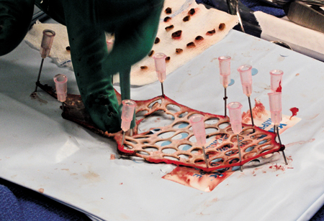

Figure 2: A sheet graft taken from the pectoral region, stripped of subcutaneous tissues and used to make punch island grafts.

**Punch grafts**

Punch grafts involve the use of a punch biopsy instrument. Grafts are created with a punch tool a few millimetres larger than the punch tool used to create recipient sites in the wound. The wound recipient sites are created first. Sterile cotton-tipped applicators are inserted into the sites to stop haemorrhage.

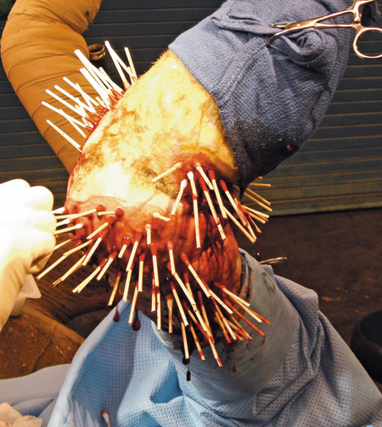

Figure 3: Sterile cotton-tipped applicators inserted into graft recipient sites to control haemorrhage.

Grafts are inserted into the sites with thumb forceps or a haemostat:

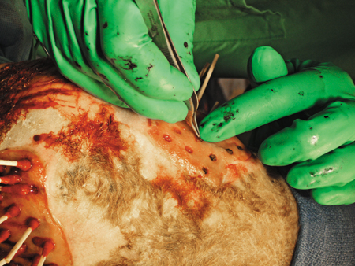

Figure 4: Punch grafts are inserted into premade biopsy sites with thumb forceps. Note that haemorrhage from the biopsy sites in the wound bed has stopped.

After implantation, the wound should be dressed with a nonadherent dressing, such as Telfa (Covidien), foam or gel-impregnated dressing. Immobilization of the region with a Robert-Jones bandage or a cast will decrease risk of graft failure from motion. Dressing changes should be minimized in the first week to prevent graft loss with dressing removal.

**Graft healing**

The graft is vascularized by day 5. Lymphatic circulation is established by day 7. The graft is completely adhered to the wound by day 10. The epidermis of the graft may become hyperplastic and die, exposing pink dermis that is often mistaken as granulation tissue but tends to be paler. Pigmentation of the graft begins about a month after transplantation, with hair appearing in four to six weeks.

**Graft failure**

Infection and chronic inflammation are the two most important factors in graft failure; however, nonadherence because of blood or serum interfering with fibrin attachment and excessive motion are factors as well. Chronically inflamed wounds—even if they are not considered infected—produce purulent exudate, interfering with graft attachment.

Methods to overcome these factors include trimming excessive granulation tissue, which also removes surface bacterial and inflammatory debris. Topical antimicrobial therapies and limited-use (one to two days of a single daily application) topical corticosteroids decrease infection and inflammation. Fluid interference should be minimized by halting haemorrhage before graft placement and clearing graft beds of clots and serum prior to graft placement.

Client Communication: Grafting is a time-consuming process. Successful grafting entails proper preparation of the wound and graft sites but also follow-up wound and graft care. Educate owners about the time and monetary investment. With time and patience, a more cosmetic and functional outcome can be obtained.

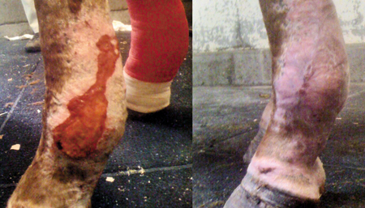

Figure 5: On the left, the lateral aspect of a distal metacarpus before a punch graft. On the right, complete epithelialization about 50 days after graft implantation.