**Indication for Splint Bone Removal**

There are two main conditions which affect the splint bones. The term "*splints*" commonly refers to an ***inflammatory condition*** and a calcium lump on the bone, while the term "*broken splint bone*" refers to a ***fracture*** of the splint bone and a calcium lump where it is trying to heal. When lameness in this area occurs, the above conditions may be confused and need to be differentiated.

The ligament (interosseous ligament), tying the splint bones to the cannon bone, is quite elastic in young horses; however, as the horse ages, the ligament ossifies and is replaced by bone and the three bones fuse.

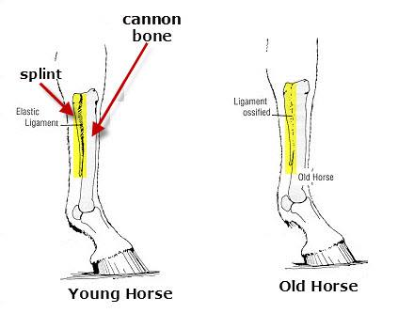

The suspensory ligament is a critical structure, and damage to it can seriously impact the long-term soundness of a performance horse. Because of the significance of the health of the suspensory ligament, and close-by flexor tendons, their evaluation with ultrasound scanning is indicated when a splint-bone fracture is diagnosed.

"*Splints*" are the direct result of an ***injury to the periosteum*** (tissue covering the bone) or an ***injury to the interosseous ligament*** (tissue tying the splint bone to the cannon bone). These injuries to the horse may be the result of ***direct trauma***, such as a kick or ***a concussion type trauma*** resulting from jumping, running or working. As the horse matures, the interosseous ligament slowly calcifies, fusing the splint bones to the cannon bone, allowing it to better withstand the concussion type trauma of working and the horse is therefore less likely to develop "splints". Most often, the forelimbs are affected; rarely do "splints" occur in the hindlimbs.

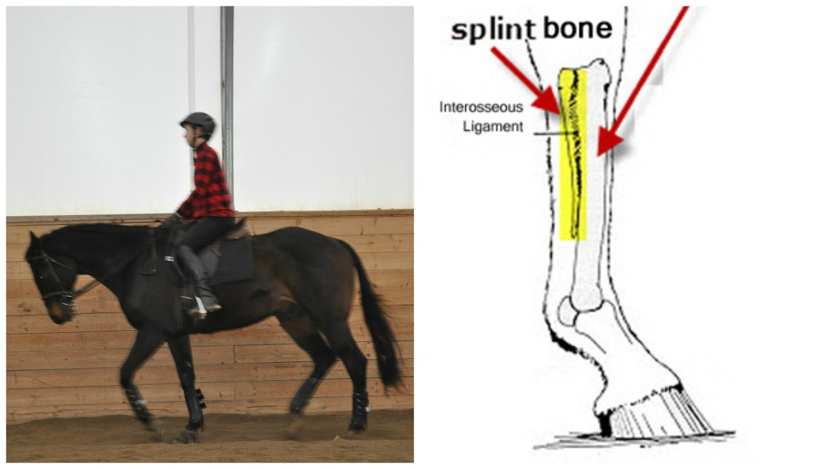

**Most splint problems** occur in the **medial side** (inside) of the **forelimbs**. The medial splint bone is the one usually affected because it has a **flat surface next to the knee**. The lateral (outer) splint bone has a more slanted surface. When the weight is transmitted to these bones, the medial splint bone probably bears more weight than the lateral splint bone; therefore, the ligament between the medial splint bone and the cannon bone is subjected to more stress than the outer ligament.

***Fractures*** of the splint bones can occur anywhere along their length but are **most commonly located at the lower third**. Heat, pain and swelling will occur over the fracture site. The more acute the fracture, the more severe the swelling.

Fractures of the splint bones can occur because of ***external trauma***, such as a kick from another horse or from the horse interfering with itself. ***During racing, excessive forces*** may also cause fractures.