**Anatomy**

The splint bones run down the back or posterior edge of the cannon bone on each side of the suspensory ligament and flexor tendons. On each side of the cannon bone is a long narrow bone known as the splint bone. The splint bones start at the knee and taper as they descend on either side of the cannon bone, each ending in a small knob about two-thirds of the way to the ankle.

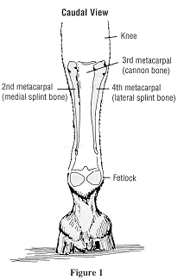

**Figure 1: Caudal view**

The proximal half or two-thirds of the splint bones are attached to the cannon bone by ligamentous tissue. The splint bones are remnants from the time horses had five toes. At the base of the knee, the splint bones are about the size of the end of your thumb and are part of the lower knee joint. As they go distally they become smaller so at their distal end, about three inches above the fetlock.