**Techniques of Performing Splint Bone Removal Surgery**

After this, all the equipment necessary for the surgery must be organized:

**Equipment**

* 22-gauge needle
* Absorbable suture & Needle
* Needle holder
* Forceps
* Penrose drains
* Gauze
* Tetanus antitoxin
* Antibiotics
* Local anaesthetics
* General anaesthetics
* Surgical staples
* Oscillating Saw
* 5 mL syringe
* Operating table
* Endotracheal tube
* Tourniquet
* Wound drape
* Scalpel blade
* Wound distractors
* Chisel (Osteotome)
* Mallet

**Technique of Splint Bone Removal Surgery**

* Surgery is performed under general anaesthesia.
* The horse is in lateral recumbency with the affected splint bone up. The leg is fixed onto leg support of the operating table.
* Hemostasis is achieved by a tourniquet. The surgical area is prepared aseptically and covered with a sterile disposable plastic wound drape.
* The skin incision is made dorsal to the splint bone and extended distal-parallel. It exceeds the fracture side or the exostosis and the splint bone buttons.
* The skin is dissected dorsal and palmar/plantar from the underlying subcutaneous for about 2 cm. The subcutaneous tissue and the fascia is sharply incised, and the wound is held open by the help of wound distractors.
* The interosseous ligament is sharply detached starting from the location of amputation distal to the buttons. Major vessels and nerves are avoided.
* For the amputations of group I an oscillating saw a was used with a blade a of 6 mm width, 26 mm length and a cutting edge of 0.6 mm thickness.
* About 1 cm proximal of the fracture or exostosis a periosteal elevator or a scalpel blade (size 21) is inserted into the interosseous ligament. This protects the particular cannon and helps preventing upon amputation.
* The splint bone is cut through with the oscillating saw in an angle of 90° transversely to the longitudinal axis of the bone. During sawing rinsing with a sterile Ringer-solution helps to prevent overheating of the bone.
* After complete transverse dissection of the splint bone the distal portion is detached and removed, either sharp with a scalpel, or a chisel b and a mallet.
* For the amputation in group II an osteotome c was used. Approximately 1 cm above the fracture or the exostosis the splint bone is cut through. The amputation plane is as small as possible to reduce the surface for secondary periosteal generation.
* At the end of each amputation the amputation space of the splint bone stump is checked for small bony fragments followed by excessive lavaging with Ringer solution. If small fragments are left back, this can initiate uncontrollable ossification processes. Very proximal amputations, can lead to instability of the remaining connection between the splint bone and the cannon bone. In these cases, the splint bone stump is fixed to the cannon bone with either one or more 4,5 mm cortical screws in neutral fashion. In case of a chronically desmitis of the suspensory ligament, a longitudinal splitting is done simultaneous.
* For wound closure neither periost nor fascia is sutured. The subcute is closed with absorbable suture material. In case of infected wounds, a Penrose drain was placed for 3 consecutive days. The skin was stapled with skin staple device. The wound is covered up with sterile gauze and a padded bandage is put applied, which as a rule staid on for one week. The horses were medicated with tetanus prophylaxis and if needed with parenteral antibiotics. Staples were removed 10 days after surgery. The horses were kept in a stable for 3 weeks. After this a period of 3 weeks walk in hand twice daily is followed by 3 weeks of riding walk. All horses were re-checked after 0-4 days and 2-3 month after surgery.

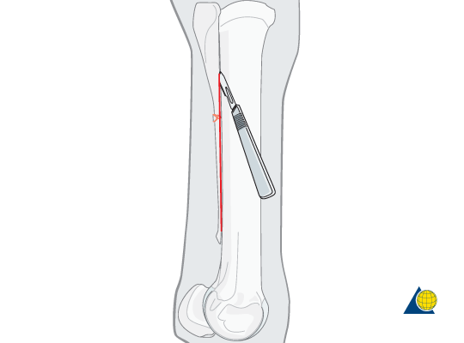

A straight longitudinal skin incision is made over the affected splint bone. The subcutaneous tissues and fascia are incised sharply down to the periosteum.

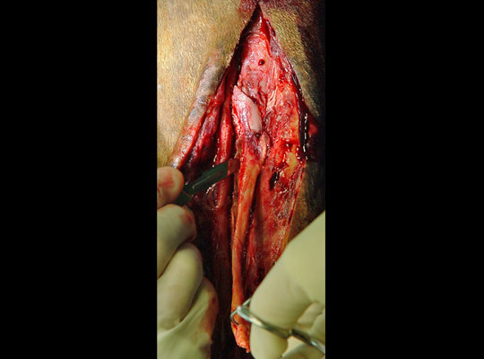The distal fragment and the fracture callus are separated from the third metacarpal/metatarsal bone. Depending on the degree of ossification of the intermetacarpal/-tarsal ligament, a scalpel or an osteotome must be used.

Remember to avoid injury to the dorsal metatarsal artery.

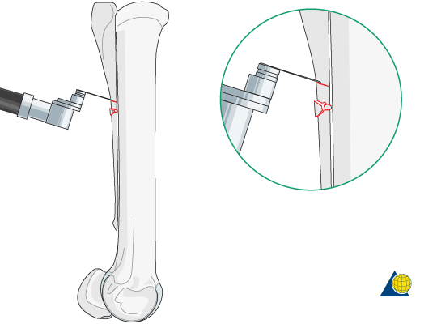

**Transection of the splint bone**

The splint bone is transected either obliquely or horizontal with an oscillating saw or osteotome approximately 1 cm proximal to the most proximal aspect of the fracture.

An oscillating saw is preferred to avoid microfissures, which can occur when an osteotome is used.  
Avoid damage to the third metacarpal/metatarsal bone either with the osteotome or the oscillating saw.

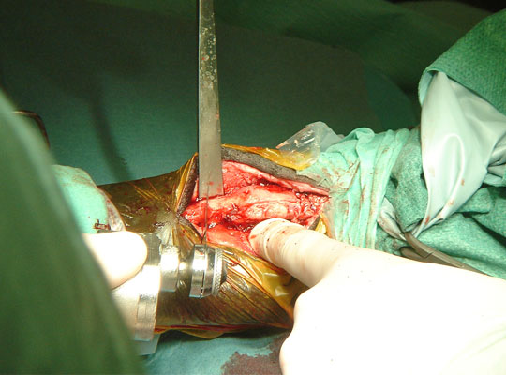

Use of an osteotome to amputate the most distal 1cm of the proximal stump of the fractured splint bone.

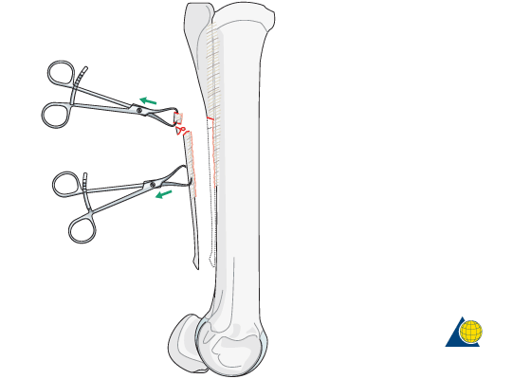

## **Removal of the fragments**

The distal fragment together with its periosteum, any callus present, and the most distal aspect of the proximal fragment are removed.

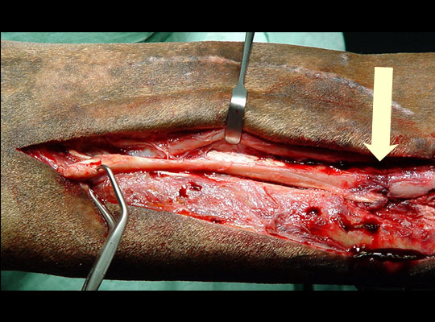

Intraoperative view of a fractured splint bone. The fracture site is identified by the arrow.

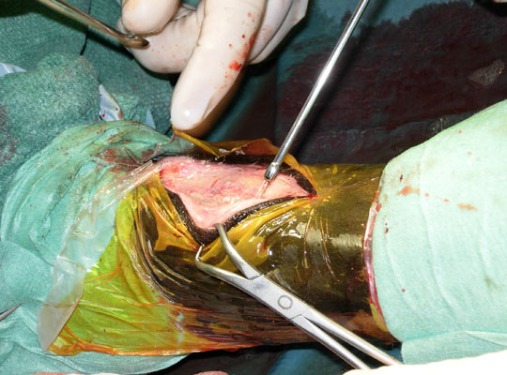

## **Lavage**

The surgical site is extensively lavaged to remove any debris and bone fragments. Special attention is paid to hemostasis.

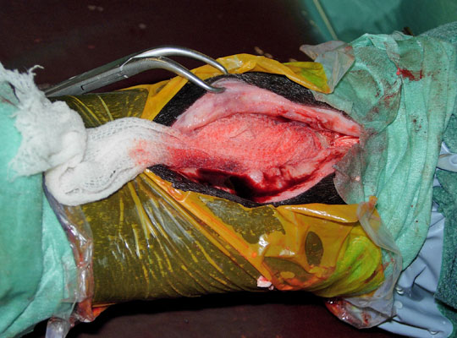

## **Closure**

In open fractures, a drain is placed in the wound for 3-4 days. The exit wound of the drain normally heals on its own after drain removal. This treatment assures quick recovery of the horse and return to previous use.

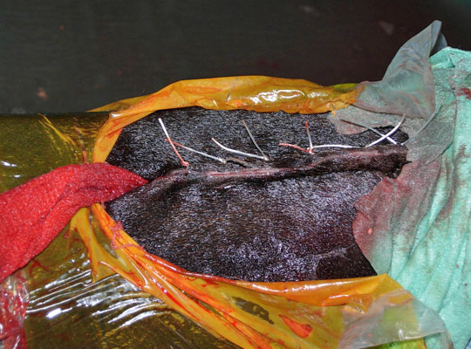

The surgery wound is closed in 2-3 layers applying routine technique. A pressure bandage is applied.