**Prognosis**

In all cases of ultrasonographic examination of splint bone fractures, the status and integrity of the adjacent suspensory ligament is assessed carefully. The results of this assessment will play a major part in formulating the horse’s prognosis for future soundness.

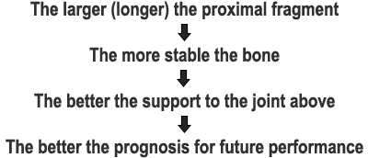

Splint bone fracture results in 2 or more fragments. Regardless of the number of fragments, there is usually just one proximal fragment (i.e. one piece that still communicates with the joint above). In lieu of the relationship between proximal fragment size and future prognosis, the size of the proximal fragment becomes the primary point of concern when dealing with splint bone fracture.

The second point of concern, is with regard to the specific splint bone that is involved; some splint bones are more important than others:

With all splint bones excluding MT4, preservation of the articular component on the bone is usually necessary to maintain soundness in the limb. Although the fourth metatarsal bone (i.e. the lateral pelvic splint bone or MT4) is the largest of the splint bones, it actually has the smallest articular component and is therefore considered the least important of the four. *In fact, this bone has been completely removed in many cases with no resulting long-term lameness.*

Of course, the more functional (i.e. more important) the splint bone, the larger the remaining proximal fragment must be to maintain limb soundness. If there is not enough proximal splint bone fragment size to maintain joint stability, then the bone must be stabilized surgically (via internal fixation). This can be a challenging endeavour, especially when working with an open (infected) wound.

In cases in which there exists ample (intact) proximal splint bone, the distal fragment(s) are simply removed. Again, when considering MT4, very little if any splint bone is required to maintain overlying joint stability.

Overall: Good Prognosis