**Surgical procedure of the annular desmotony**

* The procedure can be done in a cooperative standing horse with local anaesthesia (forelimbs only) or during a short period of general anaesthesia with the horse in dorsal or lateral recumbency. And can also be done either the opened or closed approach with a tenotomy knife and the tenoscopic guided approach

**The closed approach:**

1. A 2cm incision is made over the proximal out-pouching of the digital flexor sheath and using Mayo scissors a subcutaneous tunnel is created distal to the distal extremity of the annular ligament
2. The Mayo is then positioned so that arm is in the subcutaneous tunnel and one within the sheath and, with appropriate care to avoid the palmar or plantar vessels and nerve, the annular ligament is incised. Attention is also paid not to sever tendinous tissue within the sheath and one must know the limits of the annular ligament.
3. The digital sheath can be distended with saline and a stab incision can be made through the skin and into the sheath. A blunt tenotomy knife can be inserted into the sheath and turned 90 degrees angle to the annular ligament to facilitate transection the skin alone is closed using 2-0 synthetic nonabsorbable suture material

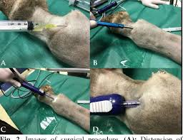

**The opened approach:**

1. After the horse is prepared for aseptic surgery, a 2-cm skin incision is made that is centre between the proximal border of the PAL and the ergot on the palmar–plantar midline.
2. Sharp dissection is continued through the subcutaneous tissue down to the transverse fibres of the PAL with a scalpel.
3. Careful, sharp dissection is continued through the PAL until the division between the PAL and longitudinal fibres of the SDF tendon is identified through a 5-mm incision in the PAL.

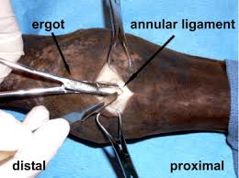

1. A mayo forceps is directed through the incision in the PAL and tunnelled under the distal half of the annular ligament to verify the dissection plane and serve as a guide for transection. The Kelly forceps are opened several millimetres, and the scalpel blade is inserted between the jaws of the forceps with the cutting edge toward the annular ligament and advanced to incise the ligament.
2. The forceps may have to be repositioned further distally to complete the distal transection.
3. The forceps are then redirected proximally, and the proximal half is transected in the same manner to complete the PAL release.
4. In most cases, the attachment of the flexor sheath on either side of the midline can be seen in the surgical field.
5. By placing a finger into the skin incision and palpating the incised PAL, one can verify the complete release of the PAL.
6. The subcutaneous tissue is closed in a continuous pattern by using absorbable suture material, and the skin is closed by using nonabsorbable suture material in an interrupted pattern.
7. Depending on the preoperative assessment, other procedures (e.g., superior check desmotomy or tendon splitting) may be done simultaneously.

Perioperative broad-spectrum systemic antibiotics and anti-inflammatory medication are routinely given and continued for 3–7 days. The leg is maintained for 3 weeks in a snug bandage, which is changed as necessary. A sterile dressing is placed on the incision under the bandage for the first 7 days. Hand walking is initiated in 5 days, with additional exercise prescribed based on the presence and severity of other lesions. Ten normal cadaver forelimbs from ten adult horses of various breeds were obtained from our necropsy service. Measurements of the PAL width on the midline and extrasynovial space between attachments of the flexor tendon sheath to the Superficial digital flexor tendon at the proximal border, middle, and distal border of the PAL were recorded from gross dissections of the ten limbs.