**Anatomy**

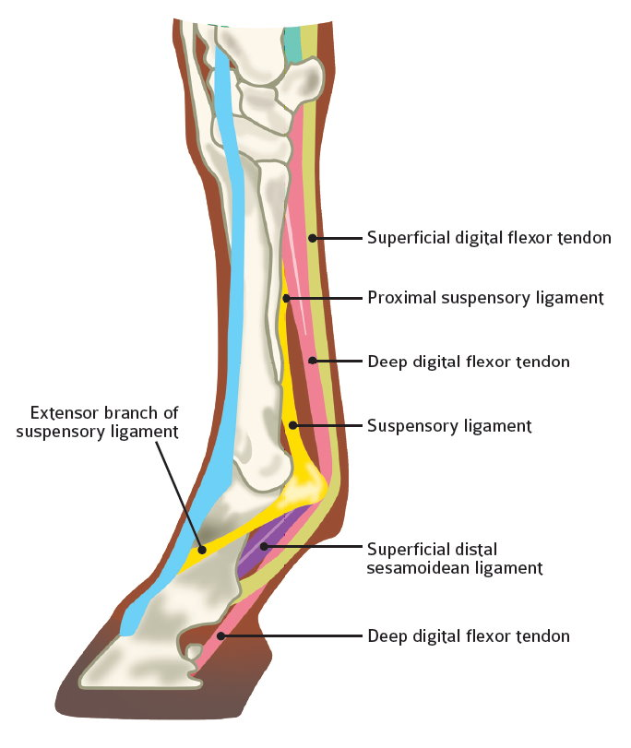The **deep digital flexor tendon** leaves the medial humeral epicondyle and inserts into the distal phalanx (P3). It begins as three separate portions and fuses together to form one tendinous structure just proximal to the carpus on the caudal aspect of the limb. The tendon passes through the carpal canal within the carpal sheath. It is closely adhered to the inferior check ligament which provides additional support for its function of flexing the distal phalanx. At the level of the fetlock, it crosses over the manica flexoria and through the sesamoid groove.

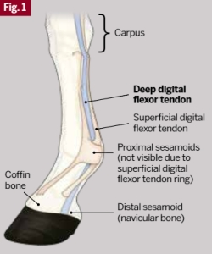It passes between the two branches of the superficial digital flexor tendon and over the distal sesamoid bone, inserting into the flexor cortex of the distal phalanx.