The patient is first sedated, and it is done on a standing patient.

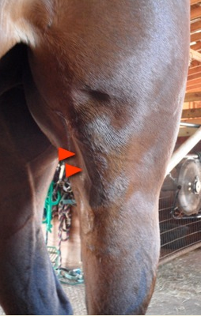

Medial patellar ligament is found on the medial aspect of the stifle. It is easily palpable is a standing horse.

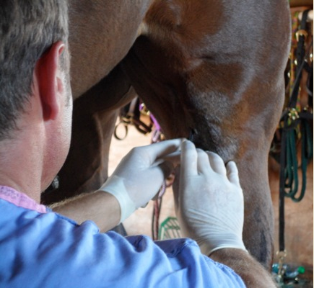

The tissue adjacent to and beneath the medial patellar ligament is aseptically prepared (scrubbed) and locally anesthetized.

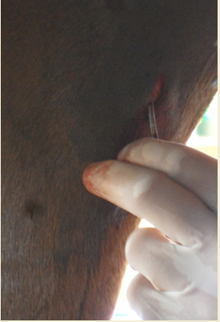

An incision is made along the medial aspect of the medial patellar ligament and the incision is adjacent and parallel to ligament.

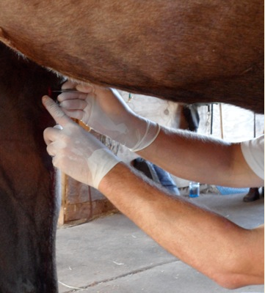

The medial patellar ligament is isolated using a pair of hemostats and partially exteriorized from incision. Once capture of all ligament fibres is confirmed, the ligament is transected (in horizontal plane).

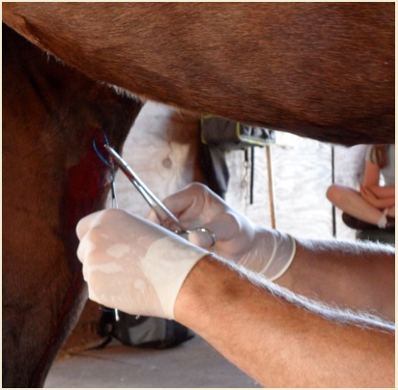

After ensuring that the ligament is completely transected, the incision is closed using 3-4 interrupted sutures.