**Complications that can occur during monitoring** 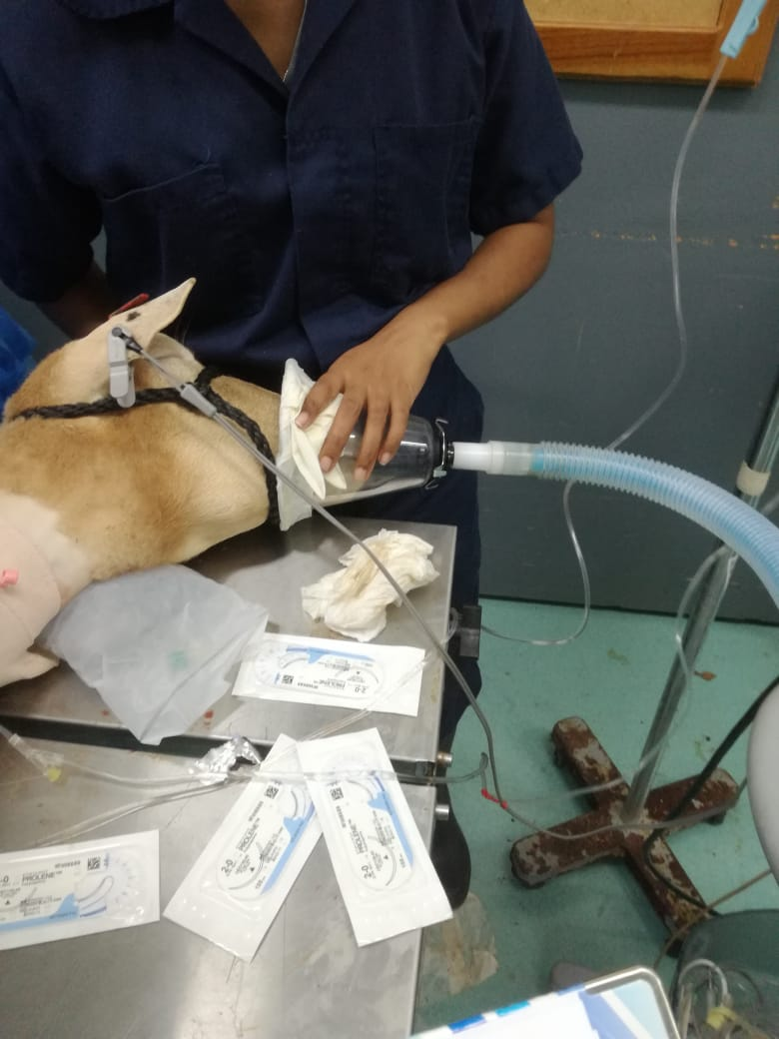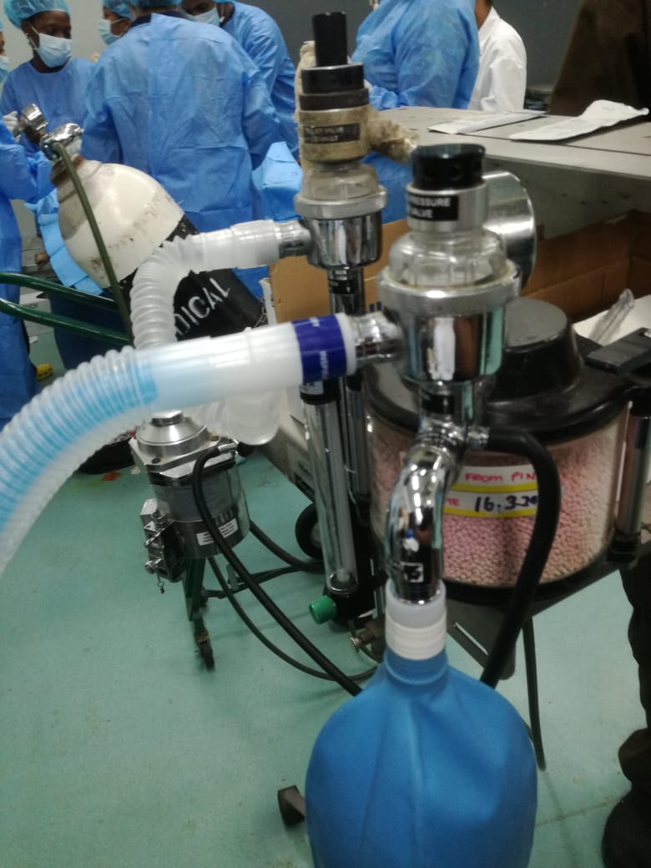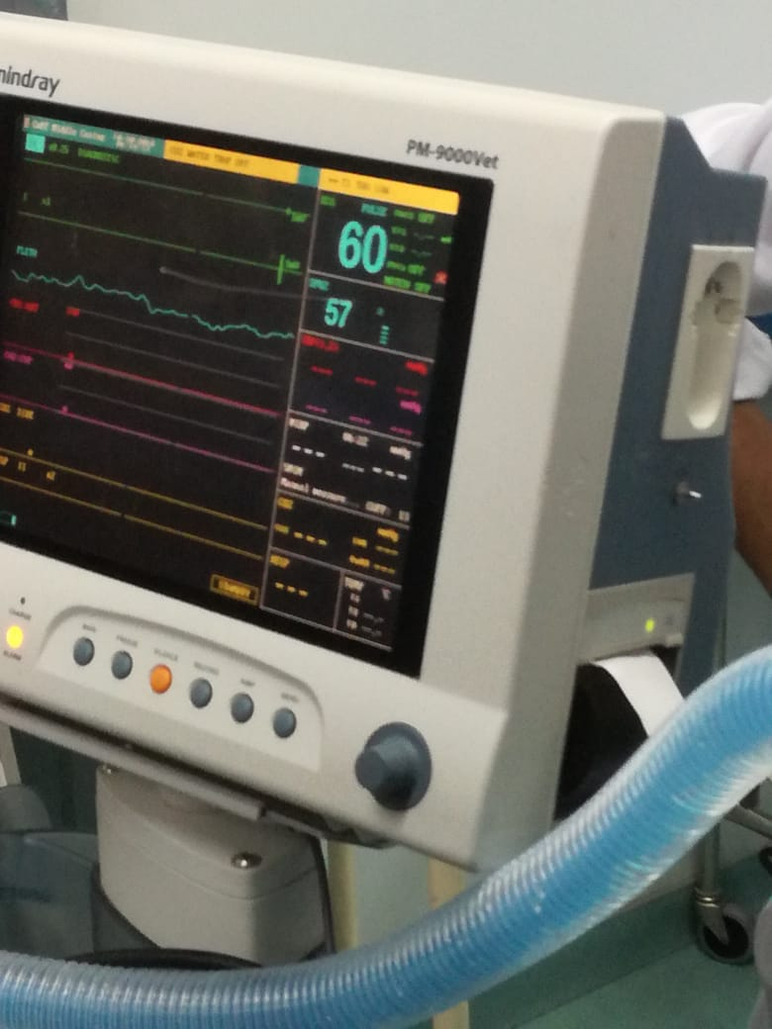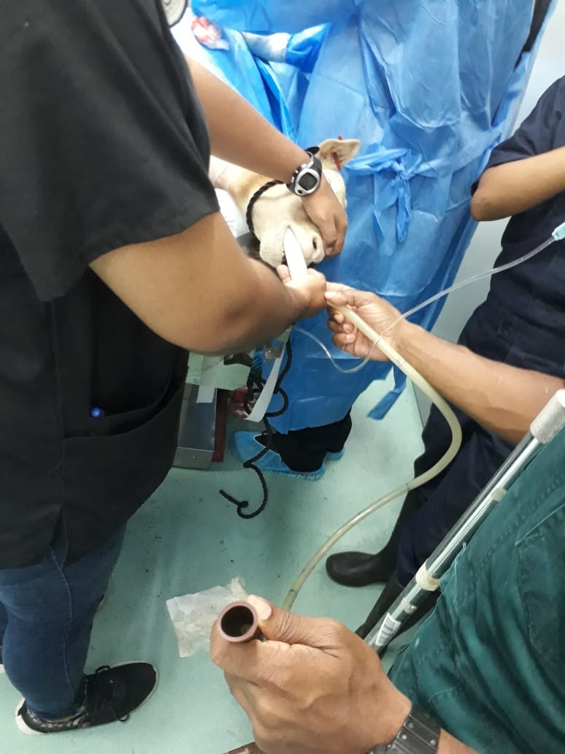

**Ruminants are not good subjects for general anaesthesia.**

* The danger of regurgitation and inhalation of ingesta is much greater in these species compared to other common domestic species.
* Their docile temperament allows majority of surgical procedures to be carried out by local anaesthesia (± sedation) without much difficulty, and many techniques are available
* Gross distension of the rumen becomes a hazard if anaesthesia or recumbency is prolonged

and regurgitation can follow from this

* The weight of the abdominal viscera and their contents prevents the diaphragm

from moving freely on inspiration and ventilation becomes shallow, rapid and inefficient for

gas exchange within the lungs.

* In unfortunate circumstances, the aspirated regurgitations can obstruct the airway, cause asphyxia, and bring the patient to death within 24 hours of developing the complication.
* The danger of regurgitation can be minimized by:
  + Starvation prior to anaesthesia
  + Water deprivation prior to anaesthesia
  + In lateral recumbency, elevating the neck to avoid easy regurgitation and positioning the head sloped down to facilitate drainage of saliva (large amount produced) and other intraoral materials.
  + Passing down a stomach tube to allow drainage of ruminal materials (and accumulated gas) during the recumbency

**Pre-anaesthetic preparation**

* **Xylazine**- May cause hypoxemia and hypercapnia and pulmonary oedema (this is most notable/ predictable in small ruminants, particularly in the sheep)

**Anaesthetic Induction:**

**Ketamine-Xylazine:**

* Often, ET intubation can be performed soon after the xylazine injection and before ketamine is given and whenever possible this should be done, as ketamine appears to produce copious salivation or an inability to swallow the normal saliva volume
* Hypoxia due to hypoventilation during the use of this combination has also been reported. For this reason, supplemental oxygen is recommended.